
Scrambled Eggs
Learn more at scootercity.com.au
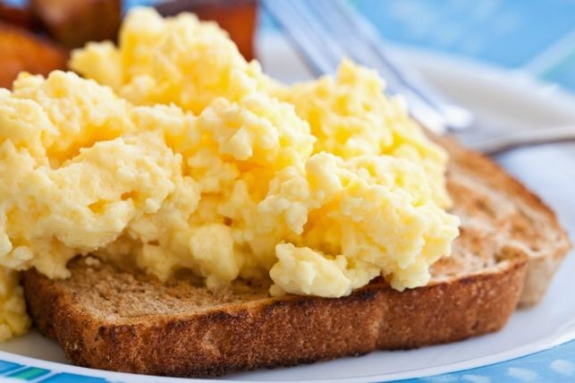

Recipe source: Kidspot

Fresh from the garden: Fresh herbs (parsley and chives).
Eggs from our chickens.

- Whisk  - Bowl  - Non-stick pan  - Wooden Spoon | Ingredients:  - 2 free range eggs  - 1/4 cup cream  - pinch salt  - 1 tsp butter  - Handful of washed chopped herbs
  Equipment:

What to do:
- Whisk eggs, cream and salt until light and fluffy.

- Add the chopped herbs.

- Heat a non-stick frying pan over medium heat and melt the butter.

- Pour in egg mixture and allow to cook for about 20 seconds until the edges are starting to set.

- Use a wooden spoon to push the egg on the outside into the middle all the way around the pan.

- Cook for another 20 seconds, repeat the ‘pushing’ motion.

- The eggs will be almost set, remove from heat.

- Serve eggs with hot buttered toast and a smile!

