
Southern Indian Vegetable Curry

Season: Winter

Type: Vegetable Dish

Difficulty: Easy

Serves: 20 tastes in the classroom or 4 at home

Fresh from the garden:

Recipe source: Jamie Oliver

Volunteer information: Please double quantity!

Equipment:  * knives  * bowl  * wooden spoon  * measuring cups  * chopping boards  * serving dishes | Ingredients:  - 2 fresh green chillies  - 2 onions  - olive oil  - 1 teaspoon mustard seeds  - 1 bunch of curry leaves  - ½ teaspoon ground coriander  - 1 pinch of ground cumin  - ½ teaspoon garam masala  - ¼ teaspoon ground turmeric  - ¼ teaspoon chilli powder  - 6 ripe tomatoes  - 2 sweet potatoes  - 2 potatoes  - 1 aubergine  - 100 ml coconut milk  - 1 handful of okra  - 1 handful of French beans  - 1 handful of peas

What to do:
- Deseed the chillies and peel the onions, then finely chop both.
- Heat 2 tablespoons of oil in a large frying pan over a medium heat, add the mustard seeds and fry for 2 to 3 minutes, or until they start to pop.
- Add the chillies, curry leaves, onions, coriander, cumin seeds, garam masala, turmeric, and chilli powder to the pan, and cook for 5 to 10 minutes, or until the onions are soft.
- Meanwhile, roughly chop the tomatoes, and peel and cube the sweet potatoes, regular potatoes and aubergine.
- Stir in the chopped tomatoes, potatoes and aubergine, then pour in the coconut milk and cook until the potato is tender, stirring occasionally.
- Slice the okra and trim the beans, then add to the pan with the peas for a further few minutes, until tender, but still with a bit of bite.
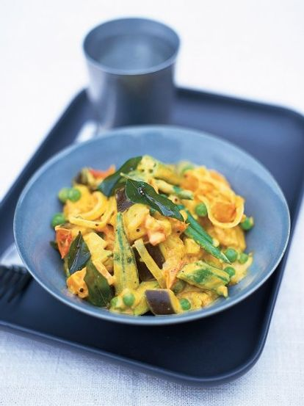
- Taste and season to perfection with sea salt and black pepper, then serve with some fluffy rice.

