LANGWARRIN PRIMARY SCHOOL CANTEEN MENU

TERM 1- 2025

# Gluten Free

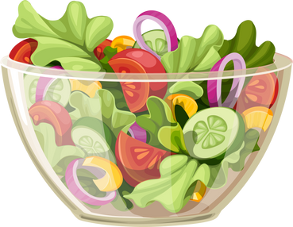

Salad Bowls

**Garden Salad - $5.50** Lettuce, tomato, carrot and cucumber

**Add:**

Ham, Chicken or Tuna to your salad for $1.50

French dressing or mayonnaise

|  |  |
| --- | --- |
| Bolognaise Pasta | $7.00 |
| Cheese Sandwich | $4.20 |
| Ham + Cheese Sandwich | $4.20 |
| Chicken Nuggets | $1.20ea |
| Beef or Chicken Noodles* | $4.80 |

Sandwiches Snacks

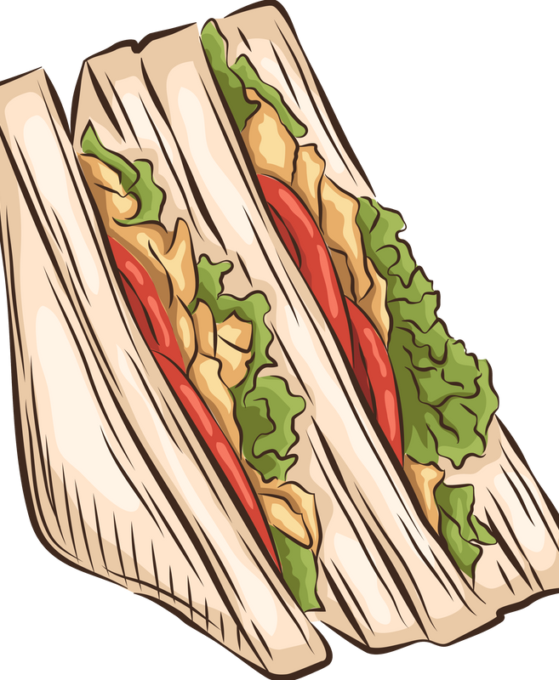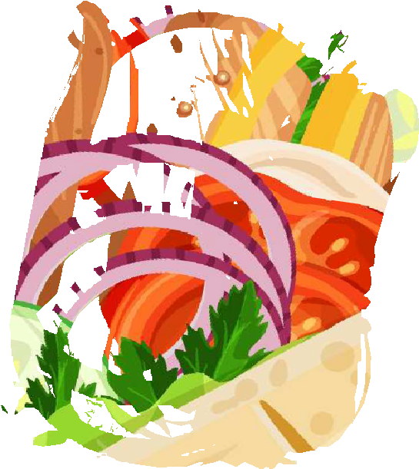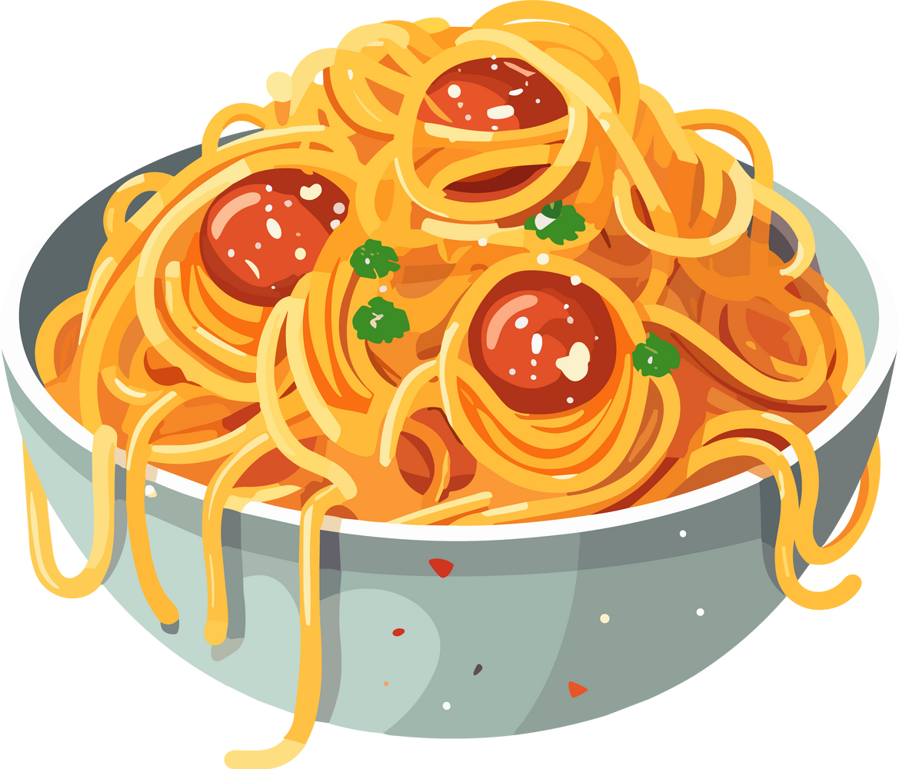

Cupcake $2.00

|  |  |  |  |  |
| --- | --- | --- | --- | --- |
|  | Sandwich | Wrap | Roll | Toastie |
| Strawberry Jam | $3.00 | N/A | $3.50 | N/A |
| Honey | $3.00 | N/A | $3.50 | N/A |
| Vegemite | $3.00 | N/A | $3.50 | N/A |
| Tasty Cheese | $3.20 | $3.70 | $3.70 | $3.70 |
| Cheese and Vegemite | $3.50 | $4.00 | $4.00 | $4.00 |
| Cheese and Tomato | $3.70 | $4.20 | $4.20 | $4.20 |
| Ham and Cheese | $4.20 | $4.50 | $4.50 | $4.50 |
| Ham/Cheese/Tomato | $4.50 | $4.70 | $4.70 | $4.70 |
| Salad Sandwich | $4.50 | $5.00 | $5.00 | N/A |
| Ham and Salad | $5.00 | $5.50 | $5.50 | N/A |
| Chicken and Salad | $5.50 | $6.00 | $6.00 | N/A |

Homemade Muffin $4.00

Piece of Fruit (seasonal) $1.20

Fruit Skewer $3.50

(seasonal fruit and marshmallow)

Chicken/Lettuce/Mayo $5.50 $6.00 $6.00 N/A

|  |  |  |  |  |
| --- | --- | --- | --- | --- |
| Tuna and Salad | $5.50 | $6.00 | $6.00 | N/A |
| Egg and Lettuce | $5.00 | $5.50 | $5.50 | N/A |

Fruit Salad Jelly

Cheese and Crackers Dips and Crackers Mini Muffin

Truffle

$3.00

$2.00

$5.00

$5.00

$0.50

$1.00

Choc Chip Cookie $3.00 Honey Joy & Chocolate Crackle $0.50

# Hot Lunch

Pretzels* Pop Corn* Yoghurt Tub*

Caramel Slice*

$1.50

$1.50

$1.00

$1.00

|  |  |  |  |
| --- | --- | --- | --- |
| Soup | $3.50 | Hedgehog Slice* | $1.00 |
| Hotdog (Add cheese $0.50c) | $4.50 | Chocolate Brownie* | $1.00 |

Bulla Vanilla Icecream Tub* (GF) $2.00



Cheeseburger with sauce Sweet Chilli Chicken Wrap

$5.00

$6.00

(Chicken tenders, lettuce and sweet chilli sauce)

Chicken Sub

(Chicken tenders, lettuce and mayo) Margarita Pizza

$6.00

$4.50

Beef Pie

Homemade Sausage Roll or Vegetable Pastie $5.50 Party Pie $1.50

Steamed Dim Sim $1.20

Party Sausage Roll x3

$4.50

***Birthday Bag $3.00

(Party Bag and Cupcake) and then add the items you would like for lunch.

***Extras - Tomato Sauce Sachet $0.30 Brown Paper Bag $0.10

# Drinks and Icy Treats

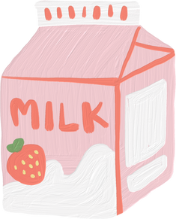

|  |  |  |  |
| --- | --- | --- | --- |
| Hawaiian Pizza Chicken Burger  (Chicken burger, lettuce, cheese) Chicken Nuggets / Fish Fingers and Salad  Small - 3 nuggets / fish fingers | $5.00  $6.00  $4.50 | Chocolate / Strawberry Milk Water  Juice Box Up n Go | $2.50  $2.20  $2.50  $3.00 |
| Large - 5 nuggets / fish fingers | $6.00 | Frozen Yoghurt | $1.00 |
| Pasta | $6.00 | (Vanilla, Berry or Mango) |  |
| (Bolognaise, Mac + Cheese, Lasagna) | $5.00 | Moozie | $2.00 |

(Chocolate, Strawberry, Banana or Blue Heaven) Frozen Fruit Cup $1.50 (Apple, Orange or Apple + Blackcurrant)

|  |  |  |  |
| --- | --- | --- | --- |
| Hash Brown* | $1.00 | Mini Calippo | $2.00 |
| Beef or Chicken Noodles* | $3.00 | Zooper Dooper | $1.00 |
| Frankfurt's (5 per cup) | $2.50 | Icy Twist | $2.20 |

Hot Chocolate $2.50

**PLEASE NOTE:**

*Items in RED marked with * are sold over the counter ONLY*