**CAREER NEWS** **Friday 7 February**

 **Dates to Diarise in Term 1**

* **Victorian Careers and Employment Expo** – 20 to 22 March 2025

**Kick off your Career in Sport with Melbourne City Institute  
*Kick-off your career in sport with the Melbourne City Institute of Sport & Business in partnership with Federation University*  
  
*Melbourne City Institute of Sport & Business in partnership with Federation University***is offering a 12-month **Diploma of Business & Sport** which combines theory and hands-on industry training in the elite environment of Melbourne City FC’s state-of-the-art facility, the City Football Academy, Melbourne Campus.

​

The course is designed to develop core business skills and specialised sports knowledge, and students will gain the tools to thrive in the sports industry.

From management principles and marketing to sports event planning and athlete development, each subject is tailored to prepare students for a dynamic career in sports.

In addition to obtaining the Diploma qualification, students who successfully complete the program are automatically awarded a full year of academic credit toward multiple Federation University articulation pathways, including a Bachelor of Business, allowing students to continue seamlessly into a second year if they choose to pursue further study.

**Find out more at** [**Diploma of Business & Sport**](https://www.mcisb.com.au/course-details#msdynmkt_trackingcontext=2404111d-1362-49a6-abda-e471b6423bc4)**, including details of an information session on 15 February 2025.**

 **Melbourne Gap Year Information Session**

*Experience a Gap Year like no other with the Australian Defence Force*.  Speak with current serving personnel about their own experiences and advice.  
  
**Date:** Wednesday 19 February 2025  
**Time:** 6:00pm – 8:00pm  
**Venue:** Jasper Hotel, 489 Elizabeth Street in Melbourne 3000  
  
**Register to attend at** [**Melbourne Gap Year Information Session**](https://www.adfcareers.gov.au/events/events-detail/dw5opox)

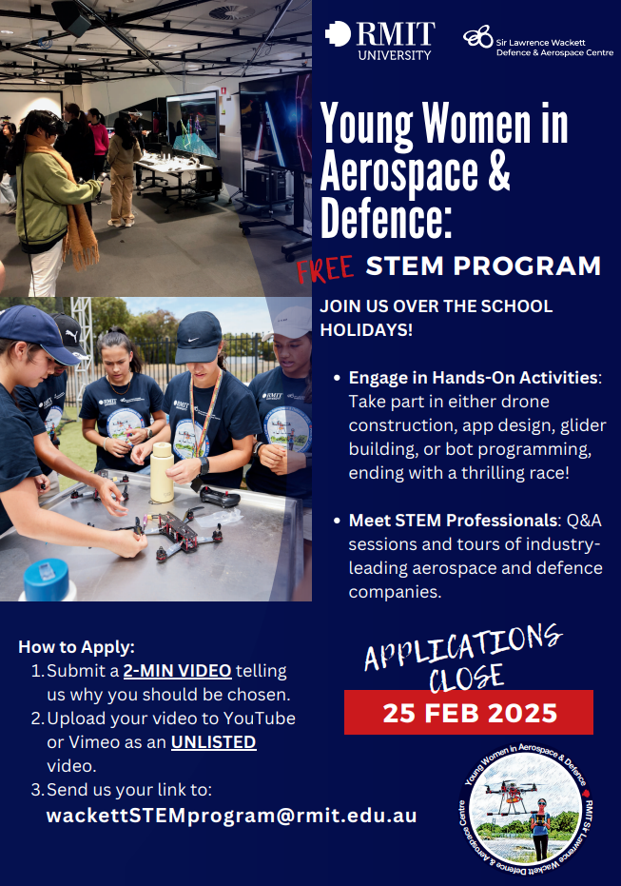

** The Hansen Scholarship 2025  
*Each year we recognise talented students from around Australia who have demonstrated resilience to adversity, and a commitment to supporting others.***

The ***Hansen Scholarship Program*** was first introduced in 2020, and it offers talented students from around Australia a generous package of accommodation, financial support, mentoring and pastoral care. Valued at up to $108,000, the Hansen Scholarship Program aspires to nurture and significantly expand the horizons of Australian students who may otherwise struggle to access a high-quality university education.

**Selection is based on:**

* Track record of academic excellence and a commitment to academic success in university studies
* Demonstrated ability to achieve success in the face of adversity and overcome obstacles
* Demonstrated ability to apply skills and strengths towards activities which benefit others
* Demonstrated ability to work effectively in a team and lead those around you
* Likelihood of thriving as a Hansen Scholar and actively contributing to the Hansen Scholarship Program

**Benefits of the scholarship include –**

* freeaccommodation for a three-year undergraduate degree at Little Hall residence in Lincoln Square South;
* an allowance to support your living expenses. In addition to your accommodation and living allowance, awardees will have access to a one-time grant of up to $4000 for an approved development activity such as an international exchange or internship;
* access to a mentoring program, pastoral care, and development programs available to all students at Little Hall as well as a tailored program of mentoring and support exclusively for Hansen Scholars;
* students who meet the requirements for the Melbourne Chancellor's Scholarship will receive the Melbourne Chancellor's Scholarship Guaranteed Commonwealth Supported Place in one of the [professional master degrees](https://scholarships.unimelb.edu.au/about-scholarships/melbourne-chancellors-scholarship/graduate-course-guarantees) for students who meet the prerequisite course and entry requirements for the master degree.

Applications open on 3 February 2025, and close in March 2025.

**Find out more, including answers to FAQs, information about the program patron, and current Hansen Scholar profiles, at** [**The Hansen Scholarship Program**](https://study.unimelb.edu.au/study-with-us/hansen-scholarship-program)**.**



***Calling all students in Years 8–12 who are curious about STEM!***  
  
*Ever wondered how to launch an out-of-this-world career? Celebrate the International Day of Women and Girls in Science with us and take part in an inspiring free online Q&A featuring incredible women from our space industry!*  
*Don’t miss this chance to be inspired and explore endless possibilities!***Date:** Tuesday 11 February 2025  
**Time:** 4:00pm – 5:00pm AEST (3:30pm – 4:30pm ACDT)  
  
**Register** [**here**](https://www.trybooking.com/events/landing/1343752) **to participate.**

**Veterinary Science Degrees in 2025**

Included in this matrix is a range of courses specific to *Veterinary Science* or *Veterinary Technology* or *Veterinary Medicine* on offer across Australia.

Veterinarians diagnose, treat and help to prevent disease and injury in animals. They advise on measures to prevent the occurrence or spread of diseases and on ways to improve the health and productivity of animals and supervise safety standards on food supplies. (Good Careers Guide).

Veterinary Science and Veterinary Medicine are similar fields – both involve working with animals, however careers in veterinary medicine focus on hands-on animal care, while veterinary science careers tend to focus more on research and instruction (Indeed Careers Guide)

|  |  |  |
| --- | --- | --- |
| **INSTITUTION** | **COURSE** | **ENTRY REQUIREMENTS** |
| **Charles Sturt University** | [Bachelor of Veterinary Biology / Bachelor of Veterinary Science](https://study.csu.edu.au/courses/animal-vet-sciences/bachelor-veterinary-biology-bachelor-veterinary-science) | Assumed knowledge: Maths Methods, Chemistry  **An ATAR of 90.00+** *Supplementary Application, Work Experience, Interview* |
| [Bachelor of Veterinary Technology](https://study.csu.edu.au/courses/animal-vet-sciences/bachelor-veterinary-technology) | Assumed knowledge: Chemistry, Maths Methods **An ATAR of 70.00+** |
| **James Cook University** | [Bachelor of Veterinary Science (Honours)](https://www.jcu.edu.au/courses/bachelor-of-veterinary-science-honours) | Assumed knowledge: An English, Maths Methods, Chemistry  Biology recommended **An ATAR of 90.00+** *JCU Application Form* ­­ |
| **Murdoch  University** | [Bachelor of Science / Doctor of Veterinary Medicine](https://www.murdoch.edu.au/course/undergraduate/b1402) | An English An ATAR of **94.00** minimum, but closer to **98.00+** *Casper* |
| **Southern Cross University** | [Bachelor of Veterinary Technology](https://www.scu.edu.au/study/courses/bachelor-of-veterinary-technology-3007400/2025/) | Recommended studies: An English, Maths, Biology, Chemistry **An ATAR of 65** |
| **University of Adelaide** | [Bachelor of Veterinary Technology](https://www.adelaide.edu.au/degree-finder/bvt_bvettech.html) | Prerequisite: Maths Methods **An ATAR of 75.00+** |
| [Bachelor of Science (Veterinary Bioscience)](https://www.adelaide.edu.au/degree-finder/2024/bscpv_bscaspv.html) / [Doctor of Veterinary Medicine](https://www.adelaide.edu.au/degree-finder/dvetm_drvetmedi.html)  Note: Students must complete the [Bachelor of Science (Veterinary Bioscience)](https://www.adelaide.edu.au/degree-finder/2024/bscpv_bscaspv.html) before going on into the Doctor of Veterinary Medicine | Prerequisites: Chemistry OR Biology OR Maths Methods Physics recommended **An ATAR of 90.00+** *Complete a questionnaire and sit the Casper* |
| **University of Melbourne** | [Bachelor of Science / Doctorate of Veterinary Medicine](https://study.unimelb.edu.au/study-with-us/guaranteed-undergraduate-to-graduate-study-pathways/graduate-degree-packages/veterinary-science)  Note: Students complete the B Sci (with major in Veterinary Biosciences) before going on into the Doctorate of Veterinary Medicine | Prerequisites: Units 3 and 4: a study score of at least 30 in English (EAL) or at least 25 in English other than EAL; and a study score of at least 25 in one of Maths: Mathematical Methods (any) or Maths: Specialist Mathematics; and a study score of at least 25 in one of Biology, Chemistry or Physics. --OR-- Units 3 and 4: a study score of at least 30 in English (EAL) or at least 25 in English other than EAL; and a study score of at least 25 in both of Maths: Mathematical Methods (any) and Maths: Specialist Mathematics.  **An ATAR of 89.00 for BSci or 98.50 for guaranteed package** |
| **University of Queensland** | [Bachelor of Veterinary Science (Honours)](https://study.uq.edu.au/study-options/programs/bachelor-veterinary-science-honours-2378#overview) | Prerequisites: Units 3 and 4: an English, Maths Methods, Chemistry, and one of Physics OR Biology An **ATAR of 98.25+** and the *Casper Test* is used for selection |
| [Bachelor of Veterinary Technology](https://future-students.uq.edu.au/study/programs/bachelor-veterinary-technology-2387) | Prerequisites: Units 3 and 4: an English, General Maths or Maths Methods. Biology, Chemistry and/or Physics are recommended  **An ATAR of 75.00+** |
| **University of  Sydney** | [Bachelor of Veterinary Biology / Doctor of Veterinary Medicine](https://www.sydney.edu.au/courses/courses/uc/bachelor-of-veterinary-biology-and-doctor-of-veterinary-medicine0.html) | Units 3 and 4: Maths Methods, Chemistry, and Biology. Physics is highly recommended **An ATAR of 98.00+** *Casper and ‘Commitment to Veterinary Science' form* |

**https://gallery.mailchimp.com/5a3dba52497443f22016ede43/images/f8e3e518-4395-4d53-91cb-887e2ff9255a.jpg Snapshot of The Australian National University (ANU) in 2025**

* Although the main campus is based in Canberra in the ACT, ANU is Australia's only national university. It has [campuses](http://www.anu.edu.au/about/campuses-facilities) in ACT, NSW, and the NT.
* ANU ranks 4th in Australia and 30th in the world in the [QS World University Rankings 2025: Top Global Universities | Top Universities](https://www.topuniversities.com/world-university-rankings?countries=au) and ANU counting six Nobel Laureates among its staff and alumni. It also has one of the highest average academic staff to student ratios among Australia's leading universities according to the Good Universities Guide.
* Students wishing to [study](http://www.anu.edu.au/study/study-options) at ANU can choose from a range of disciplines and degree structures, from single, double and research undergraduate and postgraduate programs.
* ANU has a number of academic colleges:  
  [College of Arts and Social Sciences](http://cass.anu.edu.au/)

[College of Asia and The Pacific](http://asiapacific.anu.edu.au/)

[College of Business and Economics](https://cbe.anu.edu.au/welcome-cbe)

[College of Law, Governance & Policy](https://law.anu.edu.au/)

[College of Science and Medicine](https://science.anu.edu.au/)

[College of Systems and Society](https://cecs.anu.edu.au/)

* At ANU the [Doctor of Medicine and Surgery (MChD)](http://medicalschool.anu.edu.au/study/degrees/mchd) is a postgraduate, four-year degree - students cannot study medicine as an undergraduate degree at ANU. Further information on the admissions process and how to apply is available on the [School of Medicine and Psychology](https://medicine-psychology.anu.edu.au/) website.
* Students looking for an undergraduate pathway to medicine without sitting the GAMSAT, might like to consider the  [Bachelor of Health Science](https://health.anu.edu.au/study/bachelors/bachelor-health-science).
* ANU students are encouraged to enhance their learning experience and take advantage of national and international [global study opportunities](http://www.anu.edu.au/students/careers-opportunities/global-programs) which can count credit towards their degree.
* Prospective and current ANU student have access to many [scholarships](https://study.anu.edu.au/apply/domestic-undergraduate/scholarships) to support with the cost of their studies.
* ANU offers a broad range of [accommodation](http://www.anu.edu.au/study/accommodation) choices for students, within a diverse and vibrant community.

