**Travel Education Framework**

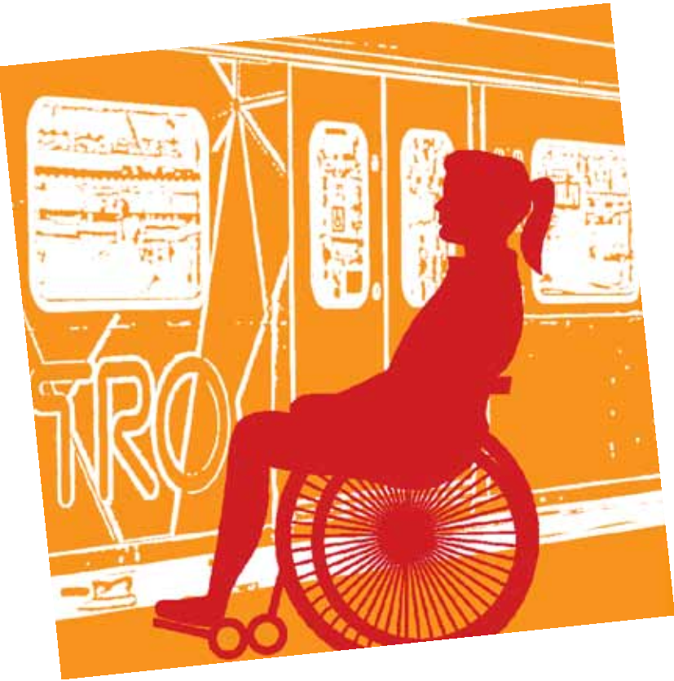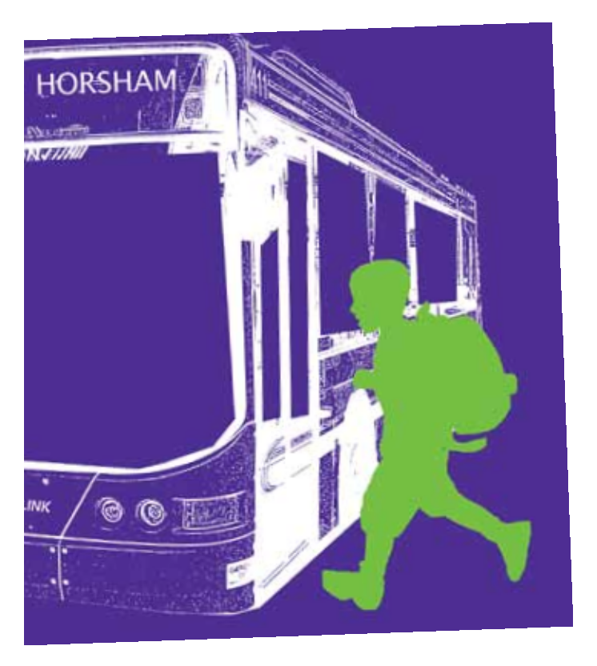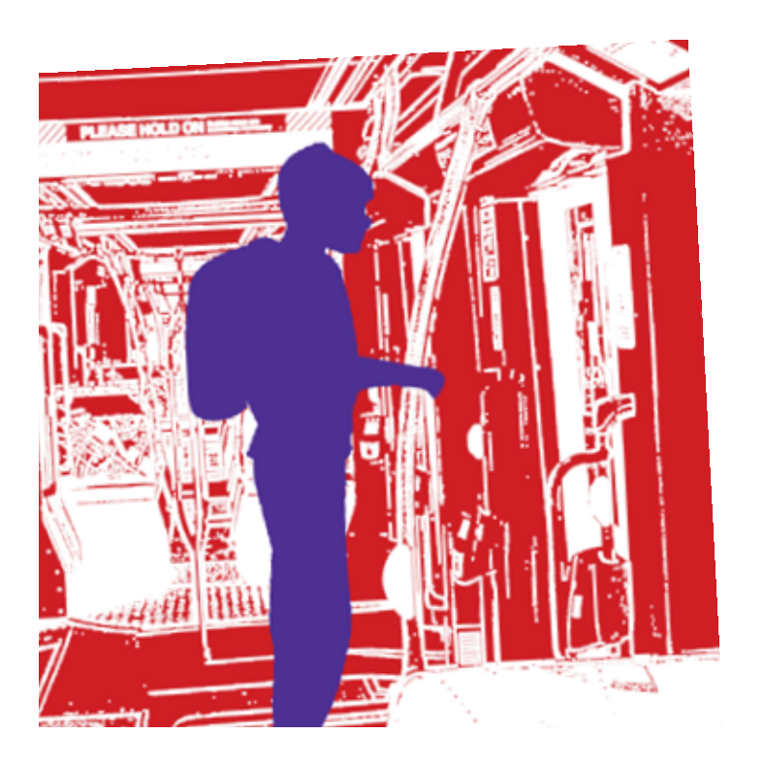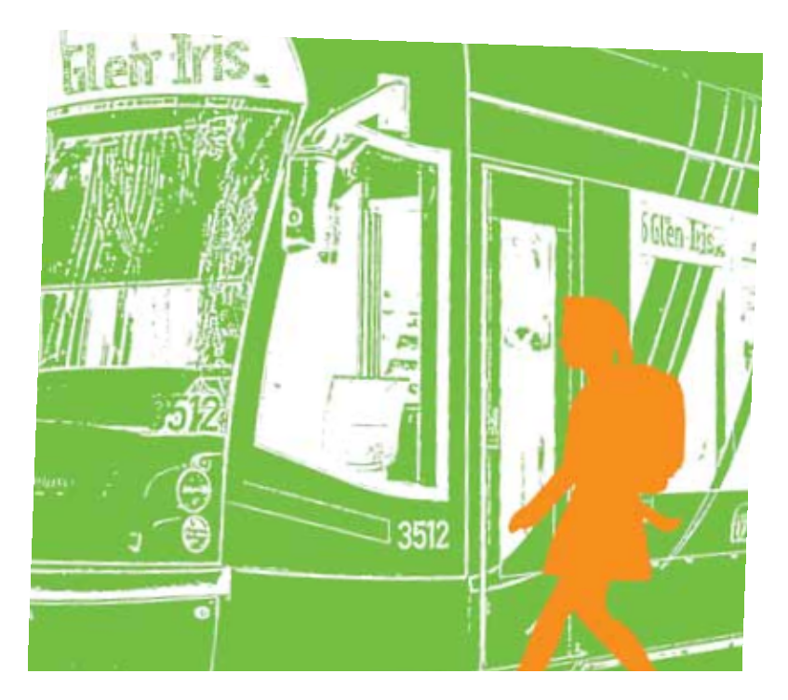

Student Transport and Family Allowances Branch

© State of Victoria (Department of Education and Training) April 2016.

The copyright in this document is owned by the State of Victoria (Department of Education and Training), or in the case of some materials, by third parties (third party materials). No part may be reproduced by any process except in accordance with the provisions of the Copyright Act 1968 the National Education Access Licence for Schools (NEALS) (see below) or with permission.

An educational institution situated in Australia which is not conducted for profit, or a body responsible for administering such an institution, may copy and communicate the materials, other than third party materials, for the educational purposes of the institution.

Authorised by the Department of Education and Training, 2 Treasury Place, East Melbourne, Victoria, 3002. This document is also available on the internet [http://www.education.vic.gov.au/studenttranspor](http://http://www.education.vic.gov.au/studenttransport)t

Thank you to the contributors who so generously gave their time, expertise and resources to help in the development of the Travel Education Framework.

The Travel Education Framework (TEF) 4

Contents

Why prepare students for independent travel? 4

Selecting students to participate in travel education 5

Timing and instructional practice 6

Mitigating risk 11

Student competency assessment register 11

Environmental risk assessment register 13

Problem solving register 15

Worry register 17

Behaving appropriately 19

Staying safe 20

Assessment during travel education 21

Final assessment and sign-off 23

Post-travel education monitoring 23

Other strategies for success 24

Travel education sample letter templates 25

Promoting travel education to parents 30

Resources 32

# The Travel Education Framework (TEF)

The benefits of travel…[education]…are **long term** as the training often results in lifelong changes in behaviour among learners. This is one of the reasons why travel…[education]… is most effective when received before adulthood, in order to maximise the long term benefits.1

The framework is a resource to assist specialist schools with planning a sequential developmental program that gives students the knowledge, skills and confidence to successfully travel independently between home and school using public transport.

The TEF proposes beginning travel education in upper primary and moving through to Year 12 with a graduated program where students progressively gain skills, knowledge and confidence. While the entry point at beginner level may well be common to all students, progression through the program will depend on each student’s own rate of development. Only students identified with the appropriate physical, cognitive and emotional capacity will progress to advanced travel education and be taught to become an independent traveller. It is hoped most students will achieve independent travel some time during their secondary years of schooling; however it is understood that not all students may achieve this goal and will require ongoing training post school.

When applying the TEF, each school needs to consider implementation within the context of the needs of its students, its curriculum and structures, and the resources at its disposal. The TEF should be adapted accordingly to meet the school’s needs.

All travel education referred to in this document only relates to the return journey between a student’s home and school using a predetermined route and agreed modes of transport.

# Why prepare students for independent travel?

Travel education gives students independence and an invaluable skill for life beyond school, including the ability to travel for employment, further education and social purposes.

The student may experience:

* Increased independence, confidence and improved self-esteem
* Improved engagement and therefore improved educational outcomes
* Increased opportunities for accessing further education, training and employment
* Increased access to health and other public services and facilities
* Increased opportunities to participate in social, community and leisure activities, and generally broadened horizons.

Parents may experience:

* A reduction in care responsibilities and tasks as their child’s independence increases
* Increased confidence in the future options for their child.

The school may experience:

* Motivated students who require less support
* Improved student engagement and therefore improved educational outcomes
* Increased demand from students and families wishing to participate in travel education.

1. Travel Training: Good Practice Guidance, Department for Transport, UK <https://www.gov.uk/government/publications/travel-training-good-practice-guidance>

# Selecting students to participate

The TEF has three learning tiers – beginner, intermediate and advanced. A student undertaking independent travel education is taught under the advanced tier of the framework.

The decision to participate in travel education is a joint decision between parents, the school and other relevant professionals and, in later years, the student themselves. The pace and extent to which a student moves through the stages of travel education is a decision for each student’s support group (SSG[1]), which is best placed to decide what is in the best interests of the student.

### Who decides?

* The school may identify students who have developed the skills required to move towards advanced travel education.
* A student may identify her/himself. This suggests a degree of self-confidence that is important for the success of travel education. While it is possible to under-estimate what a student can achieve, care should be taken to ensure an over-confident student is not placed in a situation they are not ready to manage.
* Parents may request independent travel education because they believe their child is ready to take this step or their child is nearing the end of their secondary education and is in transition to further education and training or employment. It should be noted that parental request alone is insufficient to determine participation and their request should not be given greater weight than others involved in the selection process.

Classroom activities and school excursions are opportunities for upper primary school year students to learn and develop basic skills about public transport. The practical learning in a group situation provides the foundation for the intensive one-to-one teaching that is required for a student to become an independent traveller. As a student progresses, their parents and school’s detailed knowledge, coupled with professional opinion, becomes more important when determining their ability to travel independently. Deciding on when a student is ready to commence advanced travel education should be considered by the SSG and included in the student’s individual learning plan.

In all cases careful planning, including a risk assessment, needs to be undertaken before one-to-one advanced travel education can begin. The SSG, parents and students must be included in the decision making. Parents may need support and assistance from the school to understand the program and see that the long-term benefits for their child outweigh any immediate reservations they may have. Some parents will readily agree to their child undertaking advanced travel education whereas other parents may be harder to persuade or not agree to it at all. Meetings with parents should be planned and structured to step parents through the how, when and what their child will learn to become an independent traveller. Parent queries and concerns should be anticipated and responses developed. Teachers and principals need to ensure education support staff feel comfortable and are confident in liaising with cautious or challenging parents.

# Timing and instructional practice

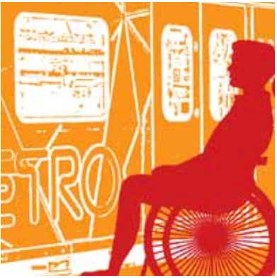

At the beginner level all travel education students undertake some learning about the different types of transport as well as using public transport. Travel education can be undertaken in the context of small supervised group excursions and be linked to other parts of the curriculum. School excursions are a chance to provide practical instruction on basic road safety and travel procedures.

At the intermediate level classroom activities provide background knowledge, which is reinforced in small supervised group excursions using different forms of public transport where students can observe, experience and practice their learning in action.

At the advanced level classroom activities focus on the student acquiring knowledge related to their specific route between home and school. The student will spend time practicing the pre-approved route they will take travelling to and from school and the required competencies (problem solving and appropriate behaviour) for independent travel. The route is practiced with the direct assistance of school staff until the student is deemed ready to complete the route unassisted; at this point the student is shadowed by a staff member who observes the student at a distance.

While initial activities can be carried out in small groups, it is recommended the advanced level of independent travel education is conducted one-to-one where the student will receive guidance on their travel route and supervision as required.

A range of teaching practices should be used in advanced travel education including discussion and role plays, which allow students to practice their problem solving and learn from each other from the safety of the classroom. Structured online activities enable students to explore information about the public transport system, including learning to navigate online timetables, which can vary regularly, and is a useful long-term skill to have. Research activities using print and online resources also support literacy development while mapping activities help students develop their understanding of the spatial relationships between features of the physical environment around them.

#### The TEF is organised into four themes:

1. Journey planning - Students learn about transport in general, public transport and how to plan and prepare for the journey.
2. Getting about - Students learn about the mechanics of using the public transport system.
3. Behaving appropriately - Students explore and come to understand appropriate conduct and social norms in the context of travelling on public transport.
4. Staying safe - Students learn how to avoid problems and manage unexpected situations.

Learning in each of these themes occurs in the classroom setting or in the community while actually travelling. Some topics within a theme are repeated, reinforced or further developed over successive years to ensure students have internalised the information and practices and become confident in them.

### Travel education framework - practical

|  |  |  |  |  |  |  |
| --- | --- | --- | --- | --- | --- | --- |
| **Beginner** | | | | | | |
| **Context** |  | **Journey planning** | **Getting about** | **Behaving appropriately** | **Staying safe** |
| Classroom activities provide background knowledge. When students are out on supervised, small group excursions the opportunity is present to provide practical instruction on basic travel procedures. | **In the classroom** | * What is transport? * Transport for different purposes (e.g. to move people, cargo, freight) * Different reasons why people use transport (e.g. to get to school/work, social reasons, holidays) * Different modes of transport * Public and private transport * Road signs. |  |  | * What to do if… |
|  | **In practice** |  | * Identify bus and tram stops and train stations * Identify different modes of public transport and different models of vehicles/carriages * Efficient boarding/ alighting * Touch on/off with Myki * Left, right, straight ahead. | * Where to stand/sit at the stop or on the platform * Where to sit/stand in the vehicle/carriage * Placement of bags and other items being carried * How and when to interact with the driver * How to interact with other passengers * Courtesy to elderly or other passengers with special needs * How to respond to anti-social behaviour. | * Basic pedestrian skills (e.g. crossing roads, waiting at lights, observing signs and warnings, direction of travel, street layout) * Stranger Danger * Where/how/from whom to seek help. |

Note: For the purposes of this framework the term “mode of transport” refers to the different transport services available such as bus, tram train, taxi, car etc. For the purposes of this framework the term “model of vehicle or carriage” refers to the different designs of vehicles or carriages within a mode of transport such as the different types of bus or classes of trams (eg low floor or W-Class) vehicles or different types of train carriages.

### Travel education framework – practical (continued)

|  |  |  |  |  |  |
| --- | --- | --- | --- | --- | --- |
| **Intermediate** | | | | | |
| **Context** |  | **Journey planning** | **Getting about** | **Behaving appropriately** | **Staying safe** |
| Classroom activities provide background knowledge that is reinforced in supervised, small group excursions using different modes of public transport where students can observe, experience and practice their learning in action | **In the classroom** | * Types of public transport * Different types and models of vehicles * Public transport in your city and local area * Reading maps and plans * Reading information in tables * Telling the time * Road signs * Determining travel routes | * Pedestrian skills in detail * Identifying different buses, trams, trains * Layouts of different types of vehicles/ carriages (e.g. entrances/exits, emergency exits, journey information on board, stop requests, emergency stop button) |  | * What to do if… |
|  | **In practice** |  | * Follow a pre-determined route * Read real-time information displays * Efficient boarding/ alighting * Touch on/off with Myki * Layout of vehicles/ carriages (e.g. entrances/exits, emergency exits, journey information on board, stop requests, emergency stop button) * How to use waiting time | * Where to stand/sit at the stop or on the platform * Where to sit/stand in the vehicle/carriage * Placement of bags and other items being carried * How and when to interact with the driver * How to interact with other passengers * Courtesy to elderly or other passengers with special needs * How to respond to anti-social behaviour | * Pedestrian skills * Understanding road layout and street signs * Stranger Danger * Where/how/from whom to seek help * The role of Protective Service Officers. |

### Travel education framework – practical (continued)

|  |  |  |  |  |  |  |  |  |  |
| --- | --- | --- | --- | --- | --- | --- | --- | --- | --- |
| **Advanced** | | | | | | | | | |
| **Context** |  | | **Journey planning** | | **Getting about** | | **Behaving appropriately** | | **Staying safe** | | |
| Classroom activities are focussed on the student acquiring the background knowledge related to their specific route between home and school.  The major emphasis is on real-time practice of the predetermined and approved route the student will take when travelling from home to school in the morning and from school to  home in the afternoon. This is initially done under the guidance of an escorting teacher or teacher’s assistant and progresses to the student travelling both routes semi-independently with the teacher or teachers assistant shadowing and observing from a distance. Students only travel independently once parents and the school agree the student is competent to do so. | **In the classroom** | | * Public Transport Victoria website * Planning alternate * routes between home and school * Accessing and reading public transport timetables and schedules * Calculating departure, travel and arrival times * Reading route maps * Acquiring and topping up a Myki card * Making a travel information card * Preparing and using a mobile phone for travel * Learning about services for passengers with special needs. | |  | | * Where to stand/sit at the stop or on the platform * Where to sit/stand in the vehicle/carriage * Placement of bags and other items being carried * How and when to interact with the driver * How to interact with other passengers * Courtesy to elderly or other passengers with special needs * How to respond to anti-social behaviour | | * What to do if… * Risk assessment and management plan * Emergency procedures * Travel by day and by night * Deciding on appropriate clothes for travelling (e.g. weather and light conditions) * The role of Protective Service Officers. | | |
| **In practice** |  | | * Learning the route from home to nearest transport stop/station * Learning the route from school to nearest transport stop/station * Learning the route between transport stops/stations if transit is required * Identifying useful landmarks on your route * Identifying required stops/stations * Learning the layout of vehicles or carriages (e.g. entrances/exits, emergency exits, journey information on board, stop requests, emergency stop button) * Learning how to use waiting time * Learning to signal you want the next stop * Reading information displays * Practicing in real-time while escorted and shadowed * Having competence assessed * Having independent travel monitored * Layout of train stations. | | * Where to stand/sit at the stop or on the platform * Where to sit/stand in the vehicle/carriage * Placement of bags and other items being carried * How and when to interact with the driver * How to interact with other passengers * Courtesy to elderly or other passengers with special needs * How to respond to anti-social behaviour. | | * Review pedestrian skills * Risk assessment and management plan * What to do if… * Safety features on platforms, tram/ bus stops and in vehicles/carriages * Emergency procedures * Where/how/from whom to seek help * Travel by day and by night | | |

Staffing the Travel Education Framework  
When implementing the Travel Education Framework, a school may choose to build a team led by a member of the teaching staff and supported by Education Support team members. While the ultimate responsibility for the Framework and the student’s educational program rests with the teacher, Education Support staff can support the implementation of the Framework, by, for example, implementing the advanced travel component of the Framework by travelling on public transport or undertaking other activities with students (without the direct supervision of a teacher).

Schools must consider duty of care obligations when deciding which Education Support Staff members are tasked with implementing the practical components of the Framework without a teacher’s supervision or away from school. Among other things, Principals should ensure that the relevant Education Support team members are appropriately trained, and have the appropriate experience to implement the practical components of the Framework without direct supervision.

Principals should also ensure appropriate planning and risk management plans have been prepared prior to the practical activities commencing. To assist in mitigating risk, this document provides for the preparation of risk management plans, and also provides for the Framework to only be implemented with parent consent and where the Framework is planned in consultation with the Student Support Group. More information about risk management and required planning steps schools should take is provided in the ‘Mitigating Risk’ section on the following page.

# Mitigating risk

Of paramount importance is the safety of students undertaking the practical component of travel education. When a school adopts and implements the Travel Education Framework, the school needs to manage the potential risks associated with running it, as part of discharging its duty of care to students. This duty requires that schools take reasonable steps to reduce the risk of reasonably foreseeable injury. While risk can never be entirely eliminated it can be mitigated through thorough appropriate risk identification and assessment and the development of well-planned, documented and monitored risk mitigating strategies. For each student participating in the practical component of travel education, a formal and thorough risk assessment must take place to identify all reasonably foreseeable risks of injury and to consider how these risks might be minimised. The risk assessment process requires completion of the following four registers:

* Student competency assessment register
* Environmental risk assessment register
* Problem solving register
* Worry register.

Once completed, these registers from the student’s risk management plan are designed to support the student as safely as possible through the practical component of their travel education. Examples of the risk assessment registers are provided in this document.

When meeting with parents it is suggested that schools go through the different risk registers to help them understand how their child’s safety is being managed. The registers are an opportunity for parents to provide input and can be a mechanism for schools to provide feedback to parents.

If you require further information or advice about risk management, visit the Department’s Risk Unit eduGate site or email the Risk Unit at [portfoliorisk@edumail.vic.gov.au](mailto:portfoliorisk@edumail.vic.gov.au).

## Student competency assessment register

This register assesses whether a student possesses or is capable of acquiring the appropriate physical, cognitive and emotional skills to participate in the practical component of travel education. The student competency assessment register should be completed by the Student Support Group and can be completed in conjunction with the environmental risk assessment register.

Once completed, a plan to improve the student’s weaker competencies must be developed, documented and approved by the student’s support group and then implemented as part of the student’s travel education program.

On the next page is a sample of a student competency assessment register, which is not exhaustive and can be adapted to meet the needs of the student.

### Sample student competency register

|  |  |  |  |
| --- | --- | --- | --- |
| Student name: | | | |
|  | **Comment** | | **Strategy, if required** |
| 1. How well does the student retain new learning? |  | |  |
| 1. Is the student keen to undertake independent travel? |  | |  |
| 1. Does the student have a medical condition which could affect travel? |  | |  |
| 1. Is the student capable of managing her/his personal possessions while travelling? |  | |  |
| 1. Does the student have adequate time keeping skills? |  | |  |
| 1. Is the student able to problem-solve when under pressure? |  | |  |
| 1. Does the student understand emergency procedures? |  | |  |
| 1. Is the student able to stay attentive to the task at hand? |  | |  |
| 1. Does the student articulate problems or concerns and ask for help? |  | |  |
| 1. Are there any physical issues that limit or impede the student’s mobility? |  | |  |
| 1. Is the student able to speak and communicate clearly with unfamiliar people? |  | |  |
| 1. Are there any known triggers that will cause the student to become disoriented or distressed? |  | |  |
| 1. Has the student’s family been involved in assessing the student’s competency for undertaking the program? |  | |  |
| 1. Is the family able to provide support and assistance to help the student practice their independent travel skills? |  | |  |
| **With consideration of the risks, and the strategies put in place, is it recommended that the student participate in the program? Y  N**  Further Comments: | | | |
|  | | | |
|  | | | |
| Signed | | Date | |
| Signed | | Date | |

## Environmental risk assessment register

The environmental risk assessment register documents any physical hazards, the topography (i.e. inclines) and other reasonably foreseeable external factors that may present a risk to a student’s wellbeing and prevent them from achieving independent travel.

The environmental risk assessment should occur both prior to and during the first escorted journey the student undertakes on her/his agreed route to and from school. Carrying the assessment out during the course of the journey ensures that as many potential risks as possible are identified. The environmental risk assessment process also provides an opportunity for students to articulate any personal risks that may not be evident to others and assists with their understanding of the risks. Each risk should be explained to the student in language that is meaningful to them.

Once specific risks have been identified, a plan to manage them must be developed, documented and approved by the SSG and then implemented as part of the student’s travel education program.

On the next page is a sample of an environmental risk assessment register. This list is not exhaustive and schools may include risks for assessment that are relevant to their context and needs of the student.

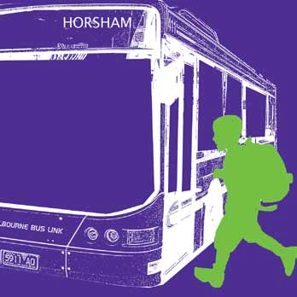

### Sample environmental risk register

| Student name: Johnnie Brown | | | |  |
| --- | --- | --- | --- | --- |
| Year level: 7 | | | |  |
| Date: 25/7/14 | | | |  |
| **Risk factor** | **Y/N?** | **If yes, detail risk** | **Proposed solution** | **Does strategy reduce risk to acceptable level? Y/N** |
| 1. Will any journey take place before sunrise or after dark (in winter)? | No |  |  |  |
| 1. Will weather conditions create any safety concerns? | Yes | Student does not cope well in very high temperatures | Parent will collect the student from school on days over 30 + degrees. Parent to monitor weather conditions and advise the school | Yes |
| 1. Does the route involve any changes of transport mode? | No |  |  |  |
| 1. Is there an extended walk? | No |  |  |  |
| 1. Are there any steep inclines or uneven surfaces to be walked? | Yes | There is a steep incline from Johnnie’s home station to the top of his street. It is an issue on his homeward journey | The route has been walked and points along the way identified where he can safely stop and rest if he needs to. | Yes |
| 1. Does any of the route carry high vehicle/bicycle traffic? | Yes | Busy arterial route must be crossed to get from the station to the school. | Johnnie’s proposed route will see him only cross at the lights. | Yes |
| 1. Are there any uncontrolled or unmarked road crossings to be managed? | No |  |  |  |
| 1. Does the route take in areas frequented by groups of other young people? | Yes | Students from the local high school gather at the station. There are no such problems at his home station. | Johnnie is to stay and wait for the train at the northern end of the station near the ticket office. The station manager has been advised of Johnnie’s travel times and staff will keep an eye on him. | Yes |
| 1. Is the public transport being used regular and reliable? | Yes |  |  |  |
| 1. Is there any station or stop on the route that services multiple lines or routes? | No |  |  |  |
| 1. Are there particularly crowded stops or areas that the student will have to navigate? | No |  |  |  |
| 1. Other risks? |  |  |  |  |
| Signed | | Date: | |  |

## Problem solving register

The problem solving register lists a series of scenarios students may face while travelling to and from school. Students undertaking travel education must know how to respond to these, often unforseen, situations and keep a cool head while doing so. Preparing students for the unexpected will support the development of confidence and minimise their risk when the unusual occurs. Students must demonstrate good problem solving skills and this should be captured in the problem solving register before they can be deemed competent to travel independently.

Once the scenarios have been listed, a plan for how the student should respond must be developed, documented and approved by the student’s support group and then implemented as part of the student’s travel education program.

On the next page is a sample of a problem solving register. This list is not exhaustive and schools may include additional scenarios that are relevant to their context and the needs of the student.

### Sample problem solving register

| Student name: Johnnie Brown | | | |
| --- | --- | --- | --- |
| Year level: 7 | | | |
| Date: 25/7/14 | | | |
| **Risk factor** | | **Possible response/solutions** |
| 1. The bus/tram/train is late | | Remain on the platform and listen for announcements |
| 1. You are late and miss the bus/tram/train | |  |
| 1. You get on the wrong bus/tram/train | |  |
| 1. You miss your stop | |  |
| 1. The bus/tram/train is crowded | |  |
| 1. You have an accident or sustain an injury | |  |
| 1. You feel ill | | Call mum or dad using my mobile phone |
| 1. You feel upset | |  |
| 1. You feel tired or sleepy on the bus/tram/train | |  |
| 1. You forget your Myki card at home | |  |
| 1. You forget your Myki card at school | |  |
| 1. You lose your Myki card | |  |
| 1. Your Myki card doesn’t touch on or off successfully | |  |
| 1. You lose something while travelling | |  |
| 1. You leave something behind on the bus/tram/train | |  |
| 1. You leave something behind at the bus stop /tram stop /train station | |  |
| 1. You lose your way | |  |
| 1. A road is too busy to cross | | I will walk until I find a crossing and cross at the lights |
| 1. You are approached by a stranger | | Ignore them and head for somewhere there will be people |
| 1. Another traveller says or does something inappropriate to you | | If it happens on the way to school, report it at the train station and tell the school once I arrive. |
| 1. You have something stolen | |  |
| 1. You are frightened or worried by something | |  |
| 1. You cannot find anyone to ask | |  |
| 1. People cannot understand you | |  |
| Further Comments | | |
|  | | |
|  | | |
| Signed | Date | |
| Signed | Date | |

## Worry register

It is suggested that schools take the time with students and where relevant, their parents/carers, to complete a worry register for the student. The worry register details a student’s feelings and/or concerns about any aspect of travel education and is separate to the other registers, which assess external factors. The worry register will assist schools in developing a plan to reduce or eliminate the student’s worries as they progress through their travel education.

The table on the next page indicates a range of worries that have been brought up by students about to undertake advanced travel education. Not all students will have concerns and the register is not meant to create issues where there are none. Schools are free to change the name of the register if the suggested name is too emotive.

Schools should take students through the list and use language that is meaningful to the individual student.

Once a student’s worries, if any, have been identified, a plan should be made using the environmental risk assessment register or problem solving register plans as a base to reduce or eliminate the student’s concerns.

This worry register plan should be addressed by the SSG and responded to as part of the student’s travel education program. This list is not exhaustive and students may have additional concerns.

### Sample worry register

| Student Name: Johnnie Brown | | | | |
| --- | --- | --- | --- | --- |
| **Worry** | **Starting travel education** | **During travel education** | **Near completion of travel education** |
| Date |  |  |  |
| No money on my Myki |  |  |  |
| Losing my Myki or concession card |  |  |  |
| Meeting the ticket inspectors | 3 | 1 | 0 |
| Missing my train, bus or tram |  |  |  |
| Crossing the road |  |  |  |
| Travelling by myself |  |  |  |
| The other passengers |  |  |  |
| Meeting a stranger |  |  |  |
| Being late to school |  |  |  |
| Cannot use my phone properly |  |  |  |
| Getting lost | 2 | 1 | 0 |
| The train not stopping |  |  |  |
| Students from other schools | 3 | 3 | 3 |
| Getting help if there is a problem |  |  |  |
| Insert other worries, if relevant |  |  |  |
|  |  |  |  |
|  |  |  |  |
|  |  |  |  |
|  |  |  |  |
| **Totals** |  |  |  |

##### How worried are you about these things?

**0** = not at all

**1** = a bit

**2** = quite a lot

**3** = really worried

|  |
| --- |
| Teacher’s comments or actions |
|  |
|  |
|  |
|  |
|  |

# Behaving appropriately

Another competency students undertaking travel education are required to demonstrate is appropriate behaviour while travelling, which needs to be taught explicitly.

The school’s student engagement policy and rules apply to the student while travelling and should be reinforced as part of the practical experience. In addition, students need to understand:

* An awareness of personal space and that of others and how this might be different on public transport depending on how crowded it is.
* Where to stand/sit at the stop or on the platform.
* Where to sit/stand in the vehicle/carriage. On buses and trains, students to be encouraged to sit as near to the driver as possible.
* Placement of bags and other items being carried.
* How and when to interact with the driver.
* How to interact with other passengers.
* How and who to ask for information or assistance.
* Courtesy to elderly or other passengers with special needs.
* How to respond to anti-social behaviour.

Consequences for inappropriate or unsafe behaviour while travelling independently will be consistent with the school’s student engagement policy.

Observing the behaviour of other passengers and discussing this with the student can provide useful models for students about what is and is not appropriate behaviour and the social norms on public transport.

# Staying safe

In addition to the risk mitigation registers other tools to help keep students safe while they are being travel educated are a mobile phone and travel information card.

### Mobile phones

It is preferable that all students participating in advanced travel education have a working mobile phone; however it is understood that not all parents are able to provide one. It is a school-based decision as to whether a mobile phone is a requirement for participation in advanced travel education.

For students that do have a mobile phone, it should be carried by them at all times when travelling independently. In the event of an emergency or unforseen situation, the student can contact the school, parents or other carers or emergency services.

Parents should ensure:

* Their child’s mobile phone has sufficient credit.
* Their child can use the phone effectively.
* Relevant family contact numbers are programmed into the mobile phone.

Schools should ensure:

* Students are able to use the phone effectively.
* The school’s number and other relevant emergency numbers are programmed into the mobile phone.
* Relevant public transport apps from the Public Transport Victoria (PTV) website are [(http://ptv.vic.gov.au](http://ptv.vic.gov.au/)/ ) downloaded to smart phones.
* Students are shown how to describe where they are e.g. street signs, landmarks, when communicating on their mobile phone.

Students should:

* Have their mobile phone and ringer on while travelling.
* Not use their mobile phone while walking.
* Not have earphones in while walking.

Once a student is travelling independently, it is advisable, particularly in the early stages, for the student to phone a parent upon arrival at school and the school upon arrival at home. It is also useful for students to know how to make emergency and reverse charge calls from public payphones.

### Travel information card

It is suggested that students carry a card that contains the following information:

* Student’s name and the school attended
* The student’s travel route and modes of transport
* Relevant emergency telephone numbers.

This card can be made in class by the student themselves. It should be small enough to fit into their purse or wallet and be laminated. It will need to be updated if any of the information changes.

In case of an emergency, the student can hand the travel information card to someone to assist them.

# Assessment during travel education

For the duration of travel education, a student’s developing competencies should be regularly assessed via the SSG and against the student’s learning plan and goals.

On the next page is a sample observation travel record and competency sheet that is used to observe and track a student’s progress to acquire the level of competency needed to travel independently. While practicing the journey, staff should assess the student to ensure he/she is reaching their anticipated milestones. If a student is struggling to meet milestones, then the observation travel record can be used to adapt strategies to assist the student to become competent. Schools should also update parents of their child’s progress.

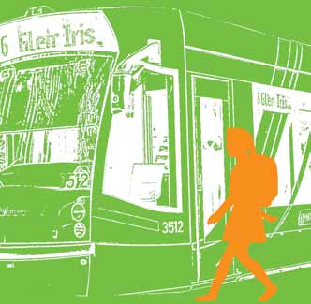

### Sample observation of travel tasks and competency sign-off

|  |  |  |  |  |  |  |  |
| --- | --- | --- | --- | --- | --- | --- | --- |
| Student name: Johnnie Brown | | | | | | | |
| From: St Georges Road, Elsternwick | | Mode/s of transport: train | | | | | | |
| Via: Sandringham station to school | | Route no# and name: Sandringham Line. Am service 8:06, pm service 3:28 | | | | | | |
| Date & Travel Task | | | | 12/7 | 18/7 | 22/7 | 30/7 | | | |
| Ready at agreed location | | | | ✓ | ✓ | ✓ | ✓ | | | |
| Dressed appropriately | | | | 🗶 | ✓ | ✓ | ✓ | | | |
| Has concession card | | | | ✓ | ✓ | ✓ | ✓ | | | |
| Has Myki card | | | | ✓ | ✓ | ✓ | ✓ | | | |
| Has mobile phone | | | | ✓ | ✓ | ✓ | ✓ | | | |
| Has credit on phone | | | | ✓ | 🗶 | ✓ | 🗶 | | | |
| Has money if needed | | | | ✓ | 🗶 | ✓ | ✓ | | | |
| Has a wallet for safe storage of cards | | | | ✓ | ✓ | ✓ | ✓ | | | |
| Has key to get into the house | | | | ✓ | 🗶 | ✓ | ✓ | | | |
| Has a way to tell time | | | | ✓ | ✓ | ✓ | ✓ | | | |
| Walks safely to first transport link | | | | ✓ |  | ✓ | ✓ | | | |
| Is fully aware when walking (no iPod) | | | | 🗶 | ✓ | ✓ |  | | | |
| Can check credit on Myki if necessary | | | | 🗶 | ✓ | ✓ | ✓ | | | |
| Can touch on/off | | | | ✓ | ✓ | ✓ | ✓ | | | |
| Proceeds to correct stop or platform | | | | ✓ | ✓ | ✓ | 🗶 | | | |
| Can identify route numbers and destination banners | | | | ✓ |  | ✓ | ✓ | | | |
| Can identify who to ask for help | | | | 🗶 | ✓ | ✓ | ✓ | | | |
| Can use intercoms on platforms | | | | 🗶 | ✓ | ✓ | ✓ | | | |
| Can use an travel Apps on their phone | | | | ✓ | ✓ | ✓ | ✓ | | | |
| Can board transport independently | | | | ✓ | ✓ | ✓ | ✓ | | | |
| Can recognise landmarks on the route | | | | ✓ | ✓ | V | ✓ | | | |
| Knows how to behave appropriately on the transport | | | | ✓ | ✓ | ✓ | ✓ | | | |
| Knows how to show their cards to ticket inspectors | | | | ✓ | ✓ | ✓ | ✓ | | | |
| Knows where to get off | | | | ✓ | ✓ | ✓ | ✓ | | | |
| Knows how to walk to school/home from transport | | | | ✓ | ✓ | ✓ | ✓ | | | |
| Crosses roads correctly | | | | ✓ | ✓ | ✓ | ✓ | | | |
| Obeys traffic laws | | | | 🗶 | ✓ | ✓ | ✓ | | | |
| Other tasks | | | | ✓ | ✓ | ✓ | ✓ | | | |
| **Assessment outcome** | **COMPETENT** | | **NOT YET COMPETENT** | | | | | | |
| If deemed not competent, why not | | | | | | | | | | |
| Actions needed to obtain competency | | | | | | | | | | |
| **1.** | | | | | | | | | | |
| **2.** | | | | | | | | | | |
| **3.** | | | | | | | | | | |
| **4.** | | | | | | | | | | |
| Due to be reassessed for competency: / / | | | | | | | | | | |
| **Actions taken**: | | | | | | | | | | |
| **Principal notified of outcome and next steps** | | | | | **Y / N** | **Date** | | | | |
| **Parents notified of outcome and next steps** | | | | | **Y / N** | **Date** | | | | |
| **Assessor’s name**: Florence Jones | | | | | | | | | | |
| **Assessor’s position**: Assistant Principal | | | | | | | | | | |
| **Signature** | | | | | **Date** | | | | | |

## Final assessment and sign-off

The student is deemed to have achieved the capacity to travel independently when he/she can demonstrate the ability to:

1. Confidently and safely complete the journey both ways unassisted and without supervision.
2. Confidently articulate and/or put into practice their problem solving skills and remain calm.
3. Successfully manage any personal concerns about travelling independently
4. Demonstrate the appropriate behavioural standards on public transport.

Schools may have additional competencies or benchmarks they require the student to meet before they deem them competent to travel independently.

As parents have the final say as to whether their child will travel independently, the school should meet with the parents again to discuss post-training monitoring. The student should be involved in the sign-off process and take the opportunity to celebrate their success.

## Post-travel education monitoring

To ensure the student’s continued safety and success, it is recommended that the student is monitored at the start and end of each journey by the school and family. The length of the monitoring period will vary between students and should be determined prior to independent travel commencing but can be extended or terminated depending on how the student is managing.

It is recommended the student immediately checks-in with an appointed staff member who asks a few simple questions to determine how the journey went and how the student is feeling. Any issues raised by the student can be managed and the necessary steps taken by the staff member. Parents are asked to undertake the same enquiry for the return journey. Parents should be asked to notify the school of any incidents or issues that may have arisen on the journey home and together the school and parents can find a solution.

# Other strategies for success

1. If possible, and with the agreement of parents, meetings between the school and parents should take place at the student’s home as this builds trust and understanding.
2. Photographs and videos of the local area showing students in action while travelling on public transport are useful modelling and instructional tools. Videos can also demonstrate to parents their child’s capabilities and progress.
3. Most parents like to be kept involved and up-to-date on the progress of their child during the independent travel education process. Regular updates from the school can reassure parents and are likely to ensure their continued support for the travel education program. Schools should discuss with parents how often and/or what milestones they wish to be updated on.
4. Students need to be able to identify the route number and destination banner of transport vehicles as models of trains, buses or trams may vary on the route.
5. Parents could be encouraged to reinforce the travel skills learned by taking a family outing using public transport. This extra practice allows the young adult the opportunity to take a leadership role in a family activity and helps reassure parents of the skills their child is developing.
6. Once full independent travel between home and school has been achieved, parents might want to assist their child to transfer the skills developed and learn other routes that allow her/him to pursue leisure and social activities.
7. The school may wish to enhance its existing relationship with officers at the nearest police station to make them aware of the travel education program.
8. The school may also establish relationships with local public transport providers e.g. bus company, nearest staffed railway station, nearest tram depot. Key staff at each of these services should be aware that students are learning to use them and may require extra assistance.
9. Where one or more students lives in the same neighbourhood they could be encouraged to become ‘travel buddies’ and travel the route together. They could undertake some of the initial practical training together with the teacher but the individualised one-to-one journey practice regimen must still be completed for each student.
10. As some students often lose their Myki cards only issue cards with limited credit. It is suggested the school maintain a bank of replacement Myki cards for students.
11. When having students identify landmarks along the route, be careful to select permanent markers such as buildings or official street signs that remain constant rather than temporary markers such as colours or billboards.
12. Complete and regularly maintain all relevant documentation in relation to a student’s travel education journey.

# Travel education sample letter templates

Attached are a series of letter templates to assist schools in communicating with parents and documenting a student’s progress. These letter templates can be adapted by schools to suit their requirements.

Letters include:

1. Invitation to participate in group travel education – this letter is addressed to parents, inviting their child to participate in group travel education. The letter outlines what the student will learn and who will be supervising them. At the bottom is a permission slip for parents to return agreeing to their child participating in group travel education.
2. Invitation to participate in advanced travel education – this letter is addressed to parents, inviting their child to participate in advanced travel education. The letter requests parents sign a permission slip either giving permission or seeking a meeting to further discuss advanced travel education.
3. Competent to travel independently – congratulatory letter and request to meet and take parents through the final steps including post-training monitoring and the independent travel contract.
4. Independent travel contract – is an agreement between the student and school on agreed behaviour, time-keeping and route management and details the possible consequences for not adhering to the travel contract. Parents also sign the contract. A copy should be retained by all parties.

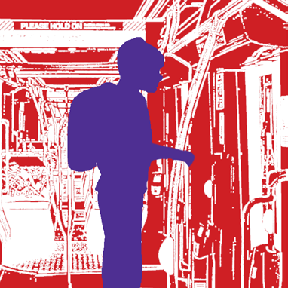

# Promoting travel education to parents

As discussed in this document, the benefits of being an independent traveller are invaluable for students and their families. However, this beneficial program is often not widely promoted by schools, meaning they are met with unnecessary resistance when independent travel is first raised with an uninformed parent.

Enrolment and open days are opportune times to make families aware of travel education and the expectation that students identified as capable will be taught to become independent travellers. Expectation setting and the inclusion of travel education within learning plans will make it easier for schools to discuss advanced travel education with a parent.

If possible, the school can develop a travel education information sheet that explains what it means to be an independent traveller and how students are taught to travel independently. Parents of students already travelling independently could be the ‘champions’ of travel education and provide quotes for the information sheets. These information sheets should be available at the school’s reception area and inserted in enrolment packs.

On the next page is a sample information sheet.

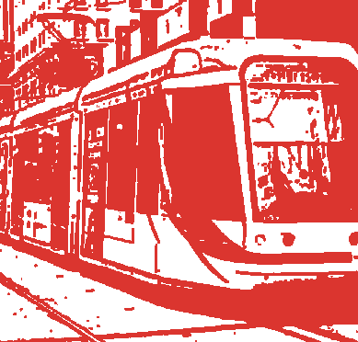

Sample travel education information sheet for parents

###### Happy Kids School

Happy Kids School offers a graduated travel education program that aims to see as many of our students as possible travelling independently to and from school.

Being able to travel independently is a wonderful life-long skill for your child to have as it will increase their job and study opportunities, improve their social connectivity and boost their self-esteem and confidence. Parents too benefit knowing their child can get themselves to and from places independently.

Travel education is offered at beginner, intermediate and advanced levels with all students having it incorporated into their learning plans. Travel education is a mixture of classroom activities and practical group experiences. Students learn at their own pace and are monitored for suitability for advanced travel education, which is where they learn the skills and behaviours required for independent travel.

With advanced travel education, students work one-on-one with a travel educator to learn their predetermined route between home and school. The safety and welfare of the student is paramount and the student and the environment are continually assessed and monitored during advanced travel education.

Only when the school is satisfied the student has acquired the behaviours and skills required will they be considered capable of travelling to and from school independently. Parents are involved in every decision regarding advanced travel education, including the decision to allow their child to travel independently.

‘I did it and I get to sleep in now that I don’t have to take the school bus.” – Student 1

*“I didn’t think my child could learn to travel by herself but she proved me wrong and I am so proud of her.”   
– Parent 1*

“One of the best things my child learned was to travel to and from school by themselves.” – Parent 2

*Note: not all students undertaking travel education will become independent travellers; some may require further training in post-school years.*

# Resources

### Background and research

Supporting Independent Travel Through Skills Training

Donna Smith, The College of Education and Human Development, University of Minnesota [http://ici.umn.edu/products/impact/183/over9.htm](http://ici.umn.edu/products/impact/183/over9.html)l

A paper that discusses benefits of travel education and an approach to a program.

Travel Training: An Exploration of The Importance Of Public Transportation For Suburban Students With Disabilities

Jessie Guidry Baginski

[http://trove.nla.gov.au/resul](http://trove.nla.gov.au/result)t?q=subject%3A%22Travel+Training.%22

A short academic paper that studies benefits of travel education. The appendix provides example forms and curriculum materials.

Easter Seals Project Action website

Washington DC, USA

[http://www.projectaction.org/Training/TravelTraining.asp](http://www.projectaction.org/Training/TravelTraining.aspx)x Advocacy for travel education and resources available for free download or purchase.

### Practical guides and teaching materials

Public Transport Victoria

[http://ptv.vic.gov.au](http://ptv.vic.gov.au/)/

A wide range of practical information and resources for public transport users in Victoria. It includes timetables, routes and app downloads.

Vicroads

[http://www.vicroads.vic.gov.au/Home/SafetyAndRules](http://www.vicroads.vic.gov.au/Home/SafetyAndRules/RoadSafetyEducation)/ [RoadSafetyEducatio](http://www.vicroads.vic.gov.au/Home/SafetyAndRules/RoadSafetyEducation)n/

Information about road rules for all users, road and pedestrian safety and teaching resources.

Road Safety Step by Step

Road Safety, Scotland

[http://www.a2bsafely.com/pdf/pocketguide.pd](http://www.a2bsafely.com/pdf/pocketguide.pdf)f

Road safety resource for parents and students. The main site contains a range of other resources for travel safety among young people.

Travel Training: Good Practice Guidance

Department for Transport, UK

[https://www.gov.uk/government/uploads/system/uploads](https://www.gov.uk/government/uploads/system/uploads/attachment_data/file/4482/guidance.pdf)/

[attachment_data/file/4482/guidance.pd](https://www.gov.uk/government/uploads/system/uploads/attachment_data/file/4482/guidance.pdf)f

A detailed guide for establishing, conducting and managing a travel education program for members of the community who face barriers to accessing public transport. There are some very useful considerations and strategies coming out of short case studies many of which are schools.

Students on the Go: A Travel Training Manual

Laurent Clerc National Deaf Education Centre Gallaudet University, Washington DC, USA

[http://www.gallaudet.edu/clerc_center/information_and](http://www.gallaudet.edu/clerc_center/information_and_resources/info_to_go/transition_to_adulthood/students_on_the_go_a_travel_training_manual.html)_ [resources/info_to_go/transition_to_adulthood/students_on](http://www.gallaudet.edu/clerc_center/information_and_resources/info_to_go/transition_to_adulthood/students_on_the_go_a_travel_training_manual.html)_ [the_go_a_travel_training_manual.htm](http://www.gallaudet.edu/clerc_center/information_and_resources/info_to_go/transition_to_adulthood/students_on_the_go_a_travel_training_manual.html)l

A detailed guide for content and strategies in a travel education program with sample forms and materials. While the focus is on deaf students much is readily transferable to other contexts.

Travel Training Manual

Centro, West Midlands Passenger Transport Executive, UK <http://www.networkwestmidlands.com/travelwise/Training.aspx>

A detailed guide for content and strategies in a travel education program with sample worksheets and forms.

A Guide to Travel Training

Ride Connection, Portland Oregon USA

[http://www.rideconnection.org/ride/LinkClick.aspx?fileticket=dw](http://www.rideconnection.org/ride/LinkClick.aspx?fileticket=dwrbjbCP7_o%3D&tabid=69)r [bjbCP7_o%3D&tabid=](http://www.rideconnection.org/ride/LinkClick.aspx?fileticket=dwrbjbCP7_o%3D&tabid=69)69

A detailed guide for content and strategies in a travel education program with suggested lesson plans.

New Horizons Partnership website

Northern Ireland [http://www.newhorizonspartnership.co.uk/tt_ov.htm](http://www.newhorizonspartnership.co.uk/tt_ov.html)l

Sample matrices for assessing student competencies in travel education.

Travel Training Key stages 3 and 4

The Royal Society for the Prevention of Accidents, UK

[www.rospa.com/roadsafety/info/travel_training.pd](http://www.rospa.com/roadsafety/info/travel_training.pdf)f

Teaching notes and resources which can be adapted by schools and teachers for local use.

Street Sounds

Vicroads, Victoria

[http://www.vicroads.vic.gov.au/Home/Moreinfoandservices](http://www.vicroads.vic.gov.au/Home/Moreinfoandservices/DigitalAndMobileApplications/)/ [DigitalAndMobileApplications](http://www.vicroads.vic.gov.au/Home/Moreinfoandservices/DigitalAndMobileApplications/)/

A road safety interactive storybook app and game suitable for children aged four to eight years.

### Useful agencies and services

Public Transport Victoria provides free travel trainer passes.

[http://ptv.vic.gov.au/assets/PDFs/Application-forms/Travel Trainer-Pass-Info-and-App-Form.pdf](http://ptv.vic.gov.au/assets/PDFs/Application-forms/Travel%20Trainer-Pass-Info-and-App-Form.pdf)

Metro trains

[http://www.metrotrains.com.au/accessibility](http://www.metrotrains.com.au/accessibility/)/

Describes services for disabled train travellers. Post-it note books are available from staffed train stations so travellers in wheelchairs can ensure the driver knows when to come and assist them.

Travellers aid

[http://www.travellersaid.org.au](http://www.travellersaid.org.au/)/ Association of Travel Instruction (USA)

[http://www.travelinstruction.org/index.htm](http://www.travelinstruction.org/index.html)l

Taxi Services Commission

[http://www.taxi.vic.gov.au/passengers/travelling-with-a](http://www.taxi.vic.gov.au/passengers/travelling-with-a-disability/talking-taxis-communication-boards)- [disability/talking-taxis-communication-boar](http://www.taxi.vic.gov.au/passengers/travelling-with-a-disability/talking-taxis-communication-boards)ds

The Taxi Services Commission supplies picture-based communication tools, Talking Taxis Communication Boards, that help people with disabilities catch taxis and are also useful on other modes of transport

1. The SSG represents a partnership in the educational planning process between the parents/guardians/carers of the student, the parent/guardian/carer’s advocate, the teacher/s, the principal or nominee (to act as chairperson) and where appropriate, the student with a disability.