

# What’s been happening…

Hello families 😊

We have some exciting news for the end of March.

On the 31st of March at After School Care we are hosting an Easter event. We will be doing face painting and an easter egg hunt, just to name a few of the activities.

Parents are welcome to come along as well.

Please let me know if you have any questions and ensure you book in as soon as possible, as spaces are limited.



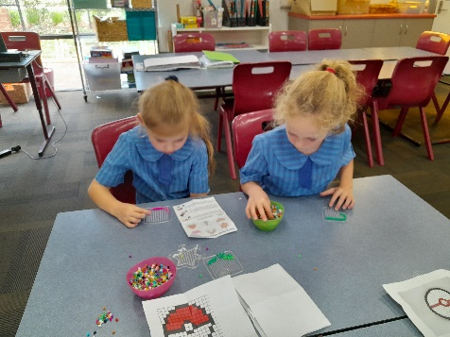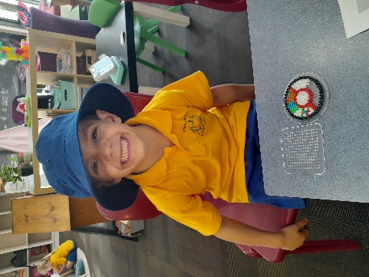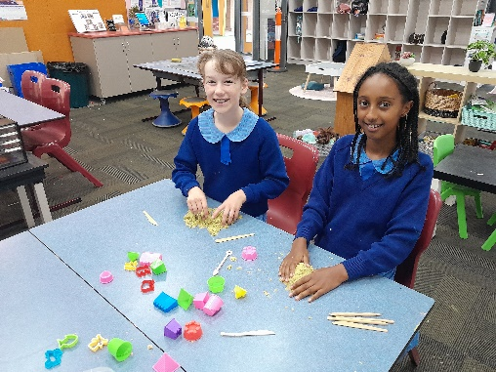

**Quality Area 5: Positive and trusting relationships with educators help children to play, learn and develop.**

This term we have been focusing on building children’s self-esteem and wellbeing. We have been using a fidget toy box in the quiet area where the children can self-regulate and have some quiet time.

We have also set up a wellbeing display on the wall which displays positive affirmations the children can read to ensure they feel positive towards themselves and others.

Early Finish Day

1pm Finish

Term 2 Commences

Early finish Day

1pm Finish

If you have any queries or require further assistance, please contact us on 0401 501 661. Our contactable hours are between 7am and 9am and 3pm and 6pm; however, if you leave us a text message or voicemail outside of these hours, we will get back to you as soon as possible.

You can also call our Customer Service & Billing team on 1300 395 735

# Contact Us

# Quality Area Reflection

We have been exploring lots of sensory play and art and craft experiences using different materials. We have done activities with kinetic sand and melty beads.

These experiences create opportunity for the children to develop their fine motor skills and is also wonderful for patience and for self-regulation.

# Art & Craft Experiences

# Important Dates

# Let’s Reflect

# OSHClub Stars

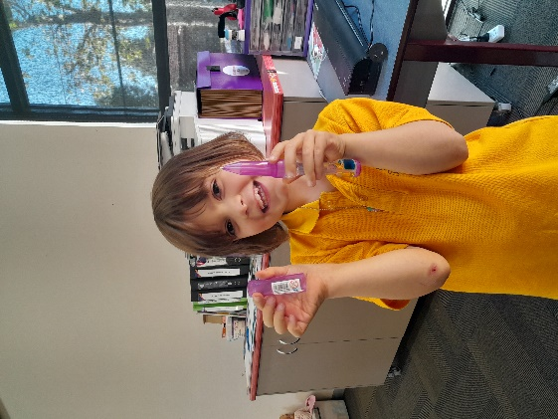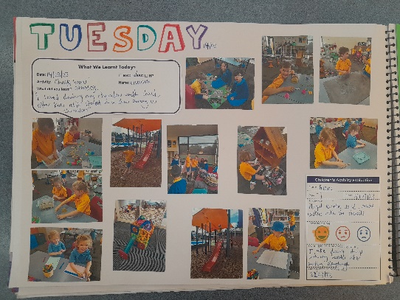

Well done to the children this term for getting 10 Dojo points and receiving a prize from the prize box 😊

Congratulations!

Come in and check our weekly reflection journal!

Inside you’ll find an overview of each day and all the fun activities the children have been enjoying.

Filled with pictures and the kid’s artwork, come in and have a look.

