Level 5 Homework Matrix
Homework tasks should ideally be completed with adult supervision. The Homework Matrix for each level will be available in the Connect newsletter once a fortnight. Tasks will be completed in student homework books and handed in to the teacher, to be signed, two weeks later on a Friday morning (even weeks). Teachers will sign homework books.

L5/6 – Reading + 8 tasks/fortnight
Reading (compulsory)  Read for: minutes every day.  Record the title of your book and the pages read in your diary. Ask an adult to sign your diary.   | Writing (saying verbs)  Rewrite the following sentences with saying verbs that match the speech. Can you also add descriptive detail?  e.g “Don’t touch that!” pleaded the scientist, with a worried look on her face.  1. "Don't let them hear us," ________ Jack.  2. "I hid the treasure map in the old oak tree," ________ the pirate  3. "I have a secret," ________ Lily  4. "Get out of my room right now!" ________ the brother.  5. "Watch out for the falling rocks!" ________ the tour guide  6. "Look at the beautiful rainbow in the sky!" ________ Sarah  7. "I can't wait for our trip to Disneyland," ________ Ben  8. "What time does the science fair start?" ________ the parent | Physical Education Challenge  Athletics Practice  Go for a run at home with a parent or guardian. Alternate between jogging and sprinting. Remember to learn forward, use your pumping arms and drive your knees when you sprint. | Gratitude  Pick 3 people you are grateful for  this month. Make sure you explain  why you picked each person.
Reading:  Choose a novel from your home to complete the following book analysis.  Title:  Author:  Front Cover  What I notice…. (colours, pictures, font, title, positioning).  Blurb  How does the author make the book sound amusing?  What are three words in the blurb that capture what the book is about?  What predictions could you make about the text’s plot, theme or genre from the blurb? | Maths  Use at least 2 different strategies to solve 24 x 56 (eg. area model, vertical algorithm). Show your working. | Art Challenge  Select a colour and draw 3 objects. Explore tone by showing light and dark variations of that colour.  Create a portrait focusing on proportion, detail and expression. Consider personality and mood | Mindfulness  Lay in a quiet room of the house or  somewhere comfortable outside  e.g. on the grass for a few minutes.  Take a moment to just stop and  listen to all the sounds around you.
Spelling  We have learnt that the Latin root word spir/spire means to breathe. Use the following prefixes and suffixes to build spir/spire words. Break them into their morphemes and record their meaning. Don’t forget to drop the silent final e when adding a vowel suffix.  e.g in + spire = inspire | Maths Skills/Fluency  Practice your 1-12 times tables by making, and completing, your own times table chart.  Challenge: Can you label your chart so the number are not in order from 1-12?  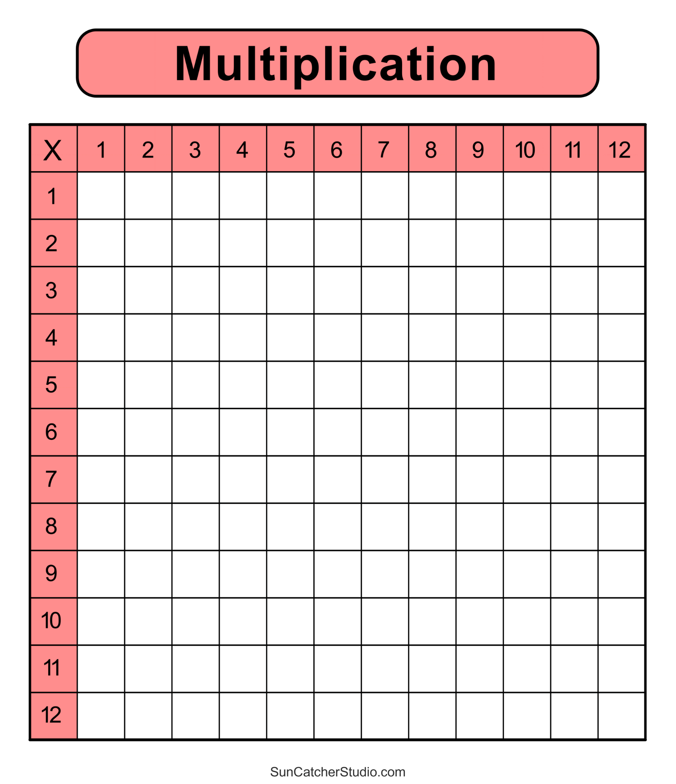 | Science Challenge  Does anyone in your family wear glasses? If so, are they short sighted or long sighted? Can you explain how their glasses work?  (Ask a teacher if no one at home wears glasses).  Can you show your parents or guardians one of our refraction experiments? | Emotional Literacy  Create a feelings collage using  magazines, coloured paper or art  supplies. Find pictures  representing different emotions to  create a collage that visually  portrays your feelings.
  Prefix + | Root | +Suffix
  Un-  In-  Per-  Ex-  A-  Tran-  Re- | spir/spire | -al  -ing  -ed  -ation/ion  -ant  -s
Maths  Choose an answer from the list below. Create at least 2 different ‘questions’ and one worded problem, that result in your chosen answer.  - If 24 is the answer, what might the question be?  - If 0.75 is the answer, what might the question be?  - If 6m is the answer, what might the question be?  Eg. If 12 is the answer, what might be the question?  3 x 4  24 ÷ 2  I had 36 lollies and I shared them between 3 friends. How many lollies did each friend get? | Online Platforms  - Read a book on Wushka  - Complete tasks on Mathletics  - Play a game on Maths frame  - Listen to a story on Storybox | Mandarin Challenge  Write 6 sentences using:  会 huì (could), 不会 bú huì (couldn’t), 但是 dànshì (but), 也 yě (also) | Empathy  Think about 3 ways in which you  can brighten someone’s day this  week or ways in which you can  cheer someone up if you notice  they’re sad.

