St Roch’s Glen Iris

Upcoming Activities
- Back to School
- Welcome and setting in activity.
- All about me craft
- Belonging display

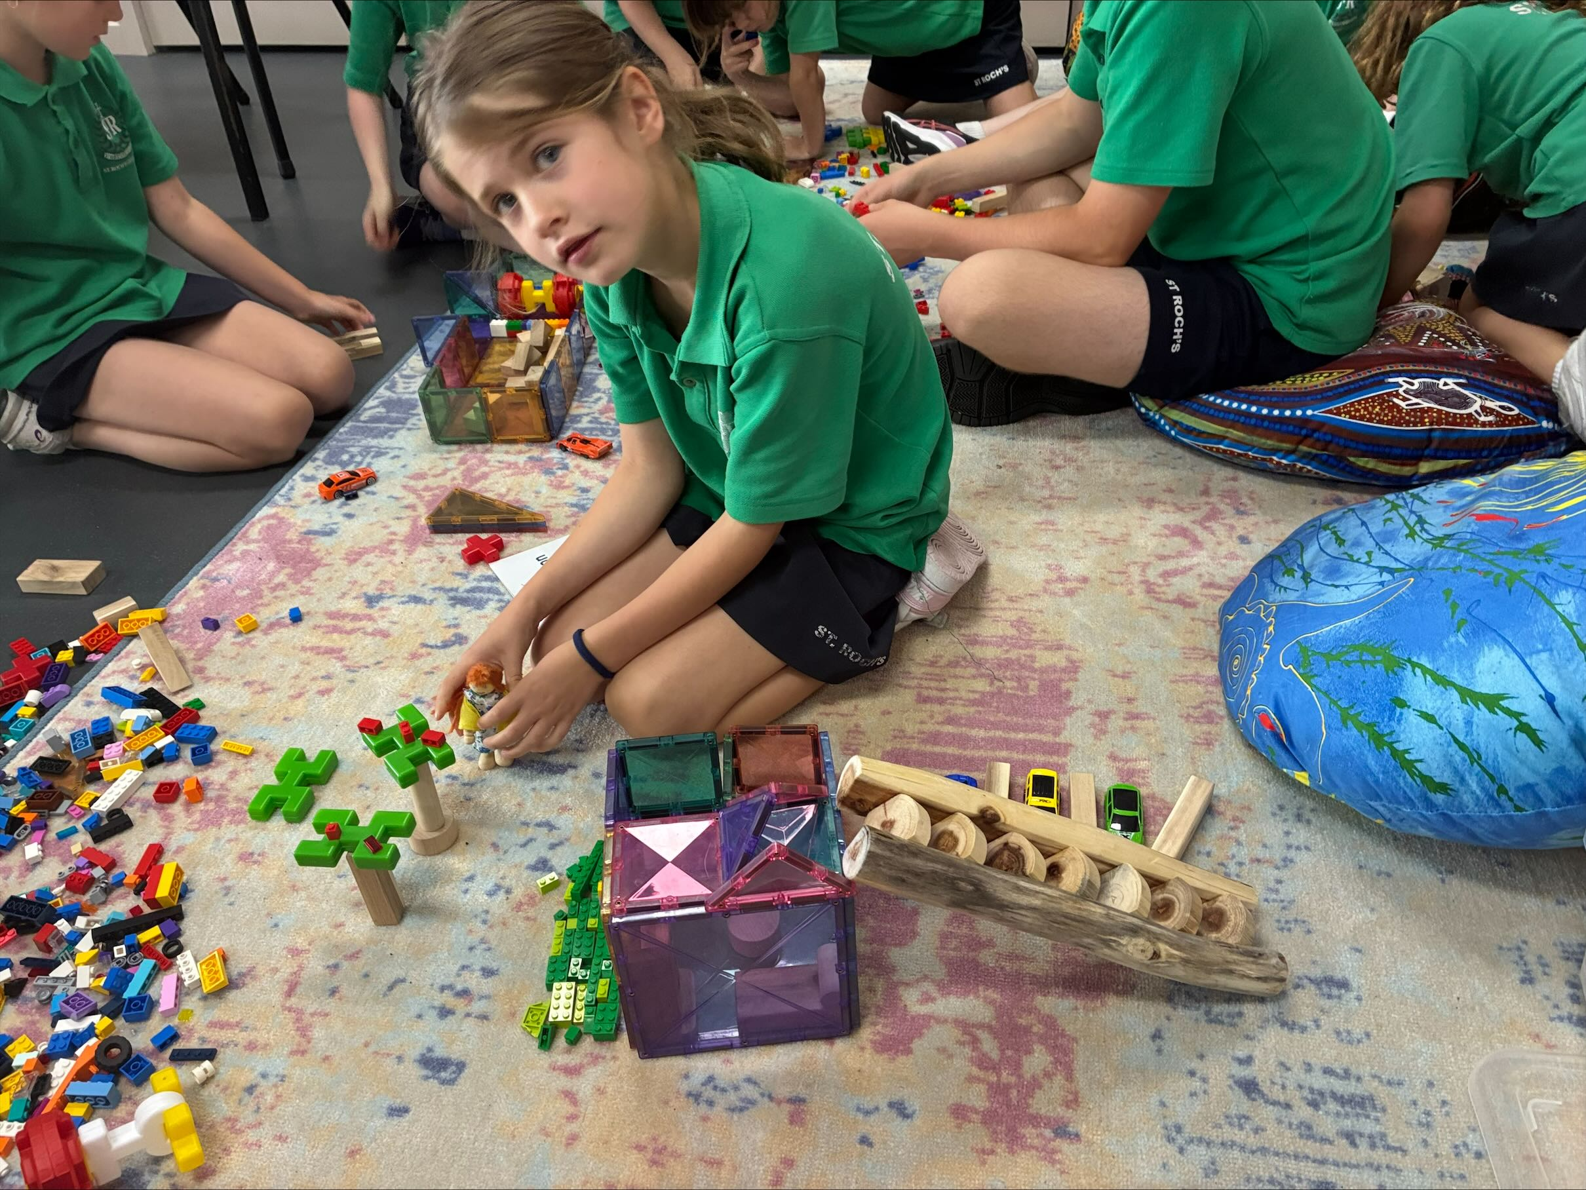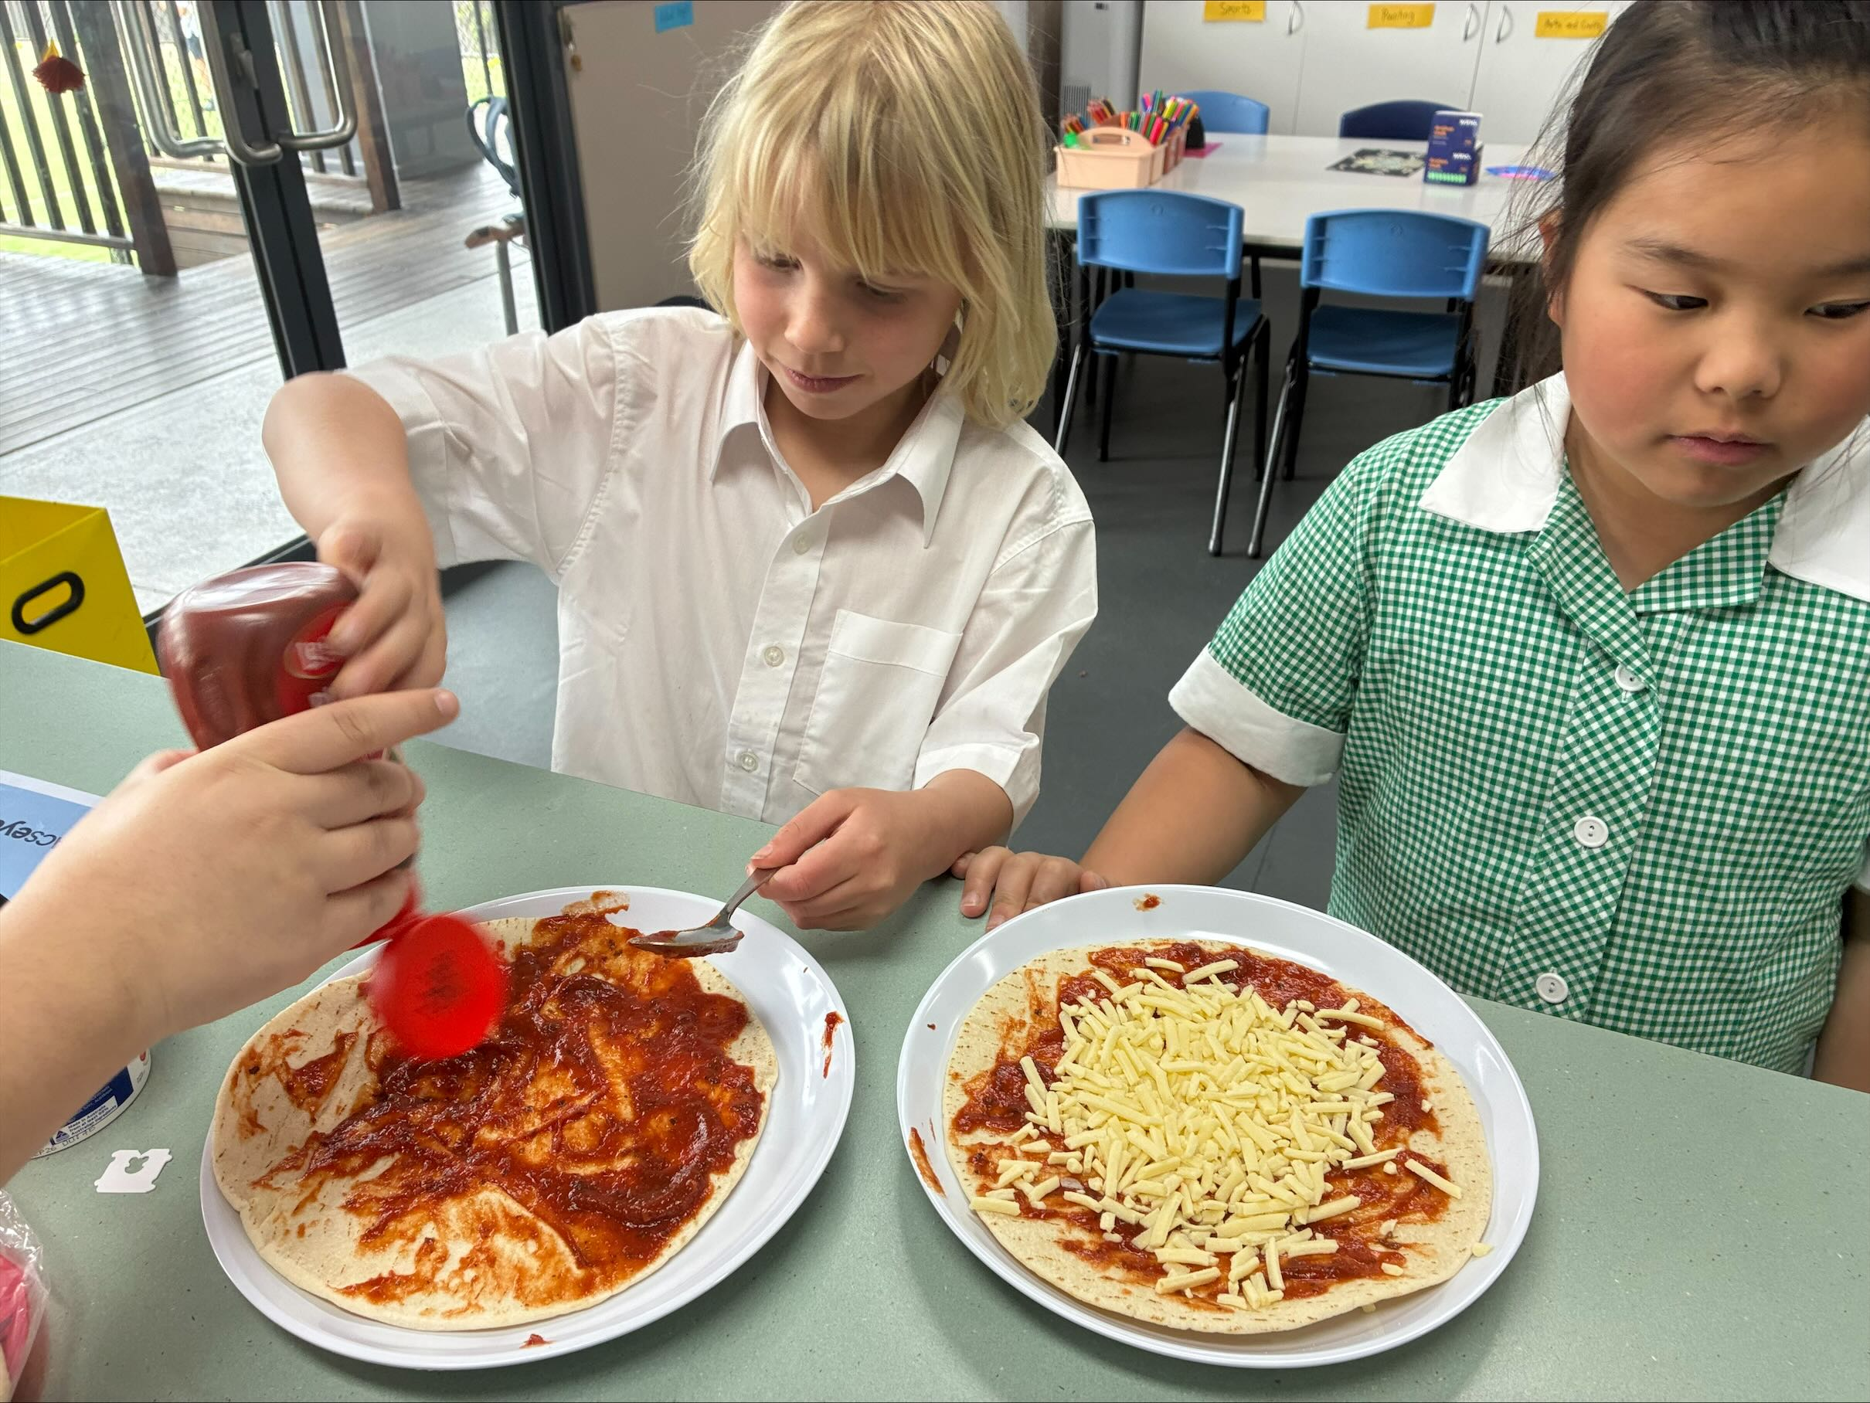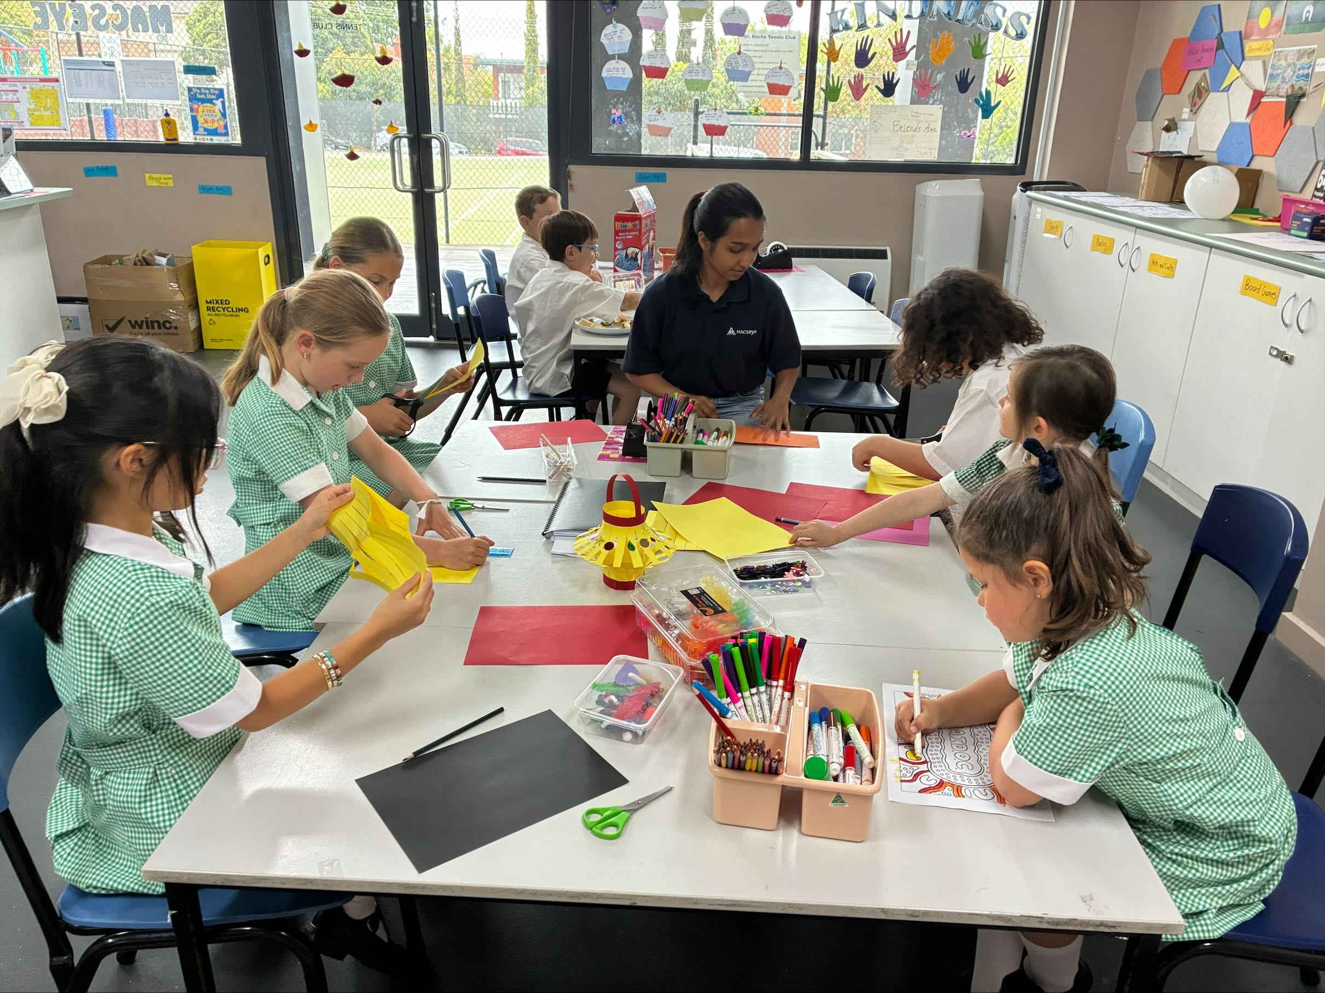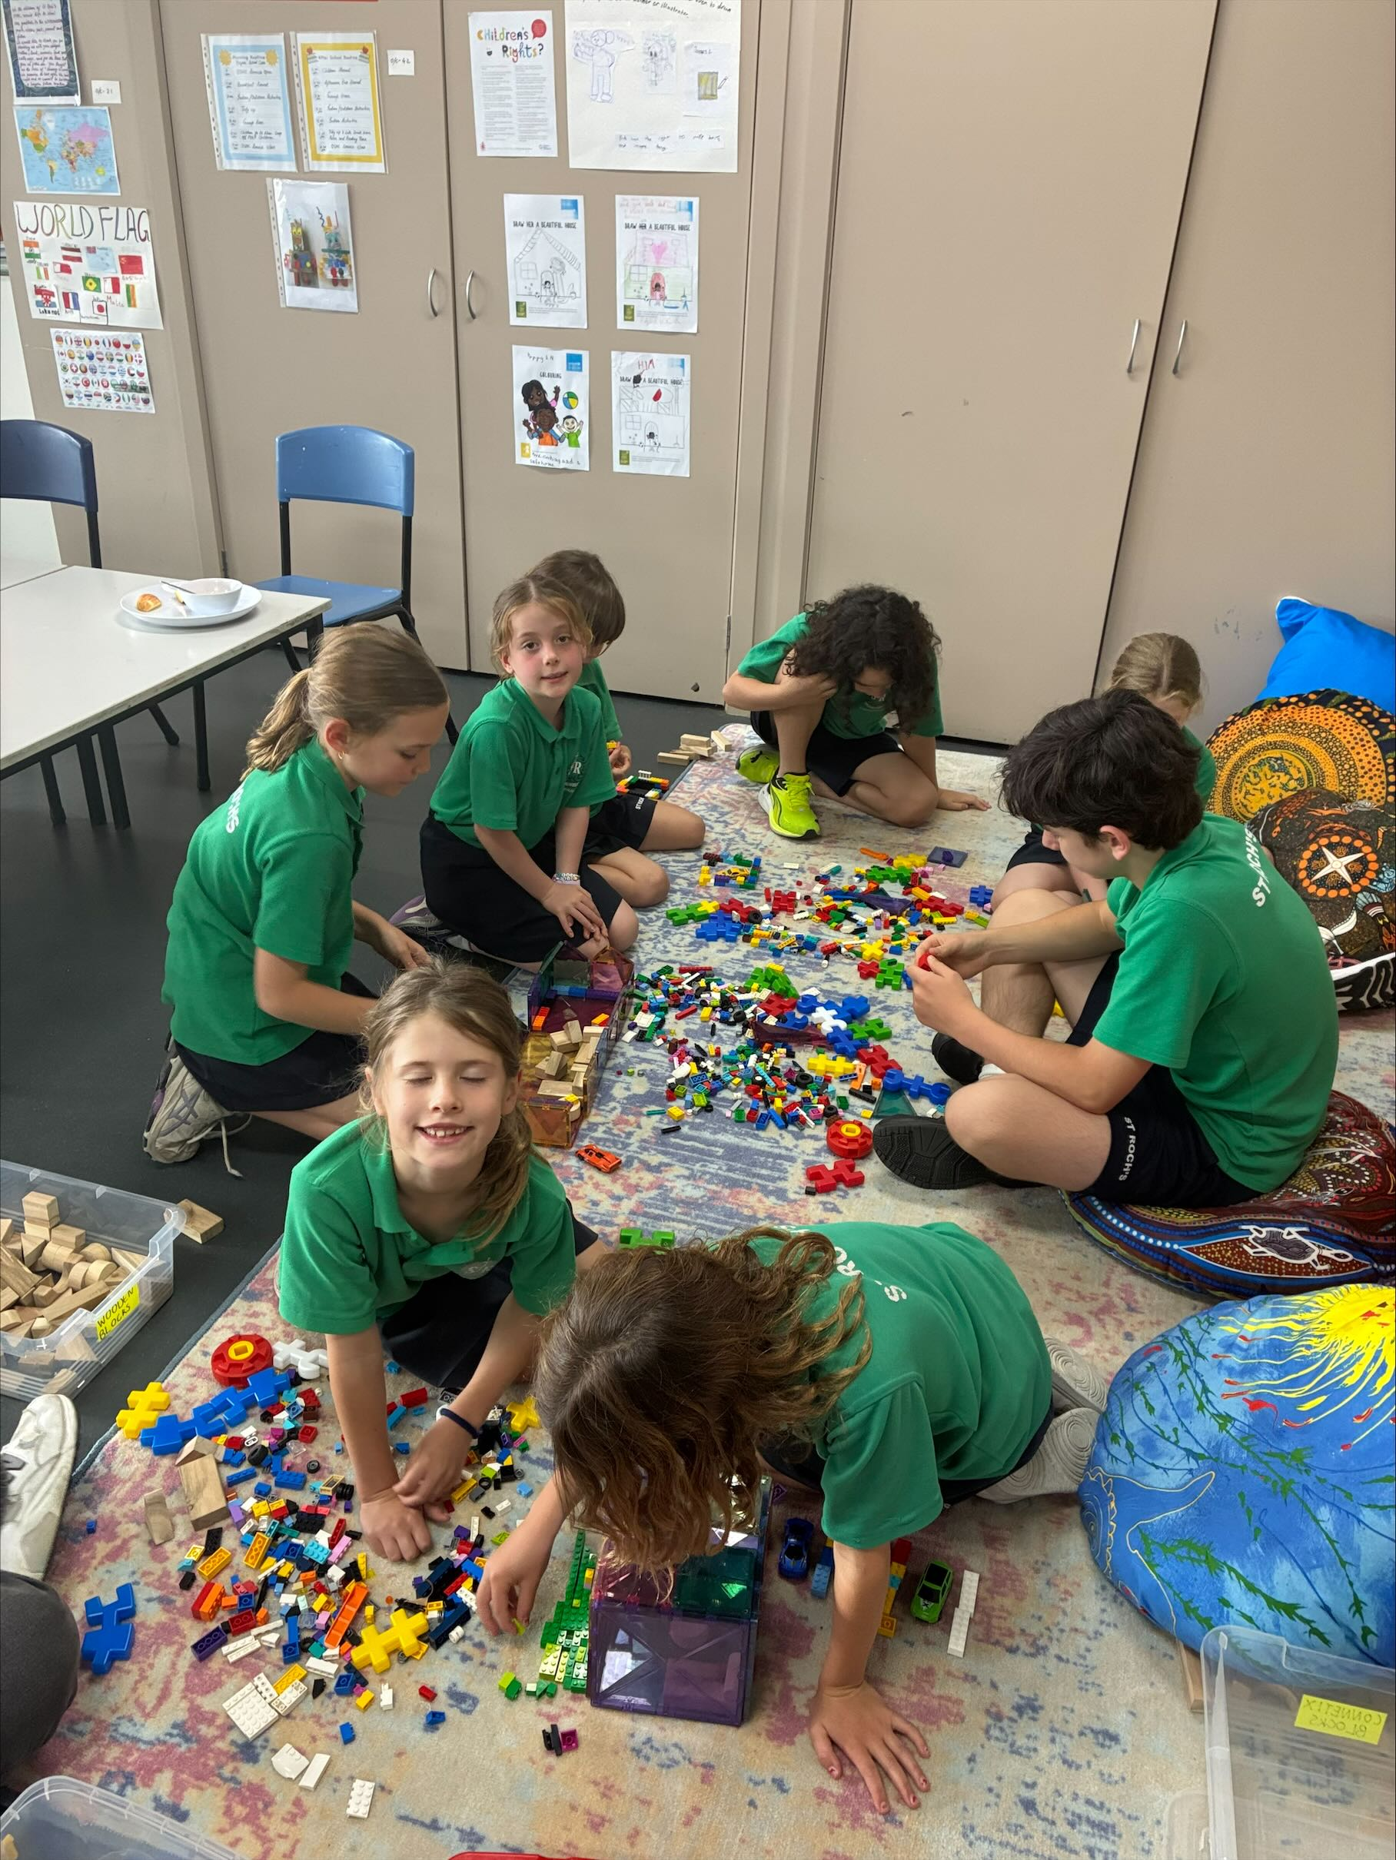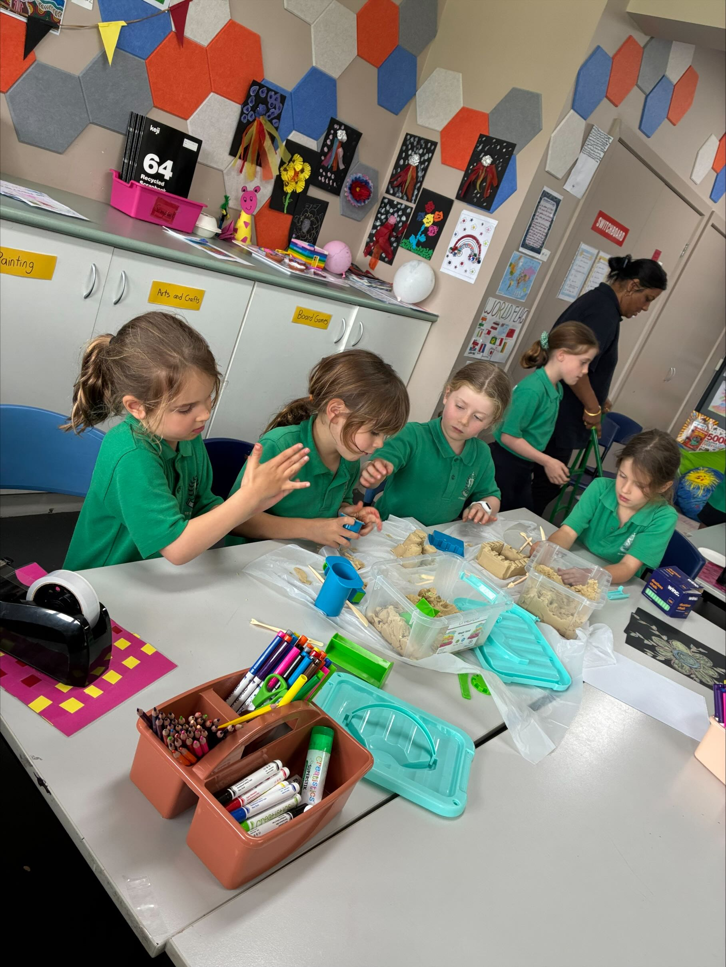
- 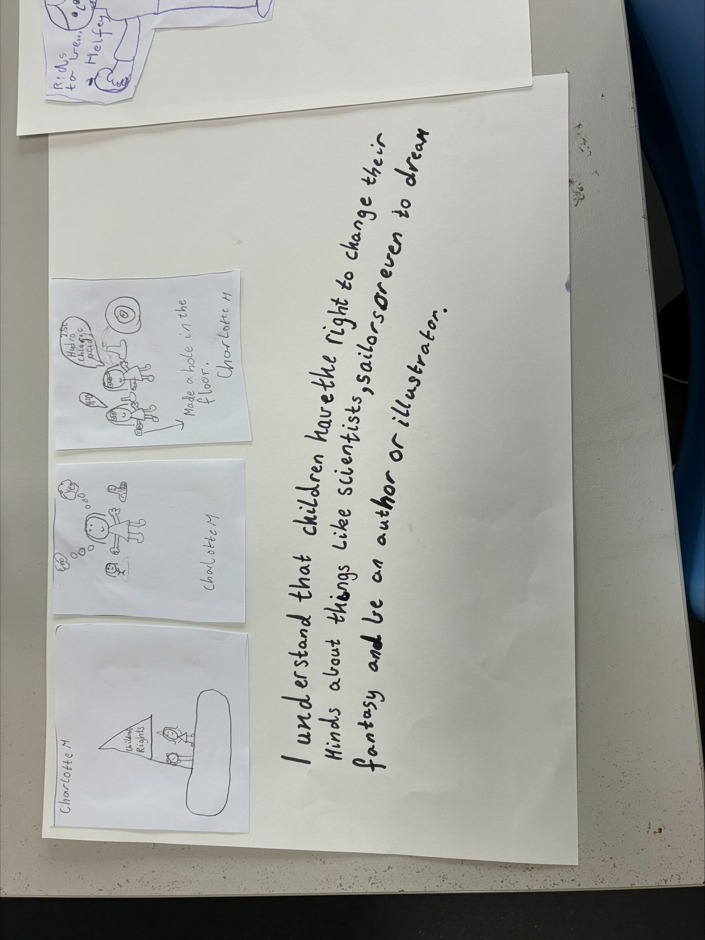Pizza making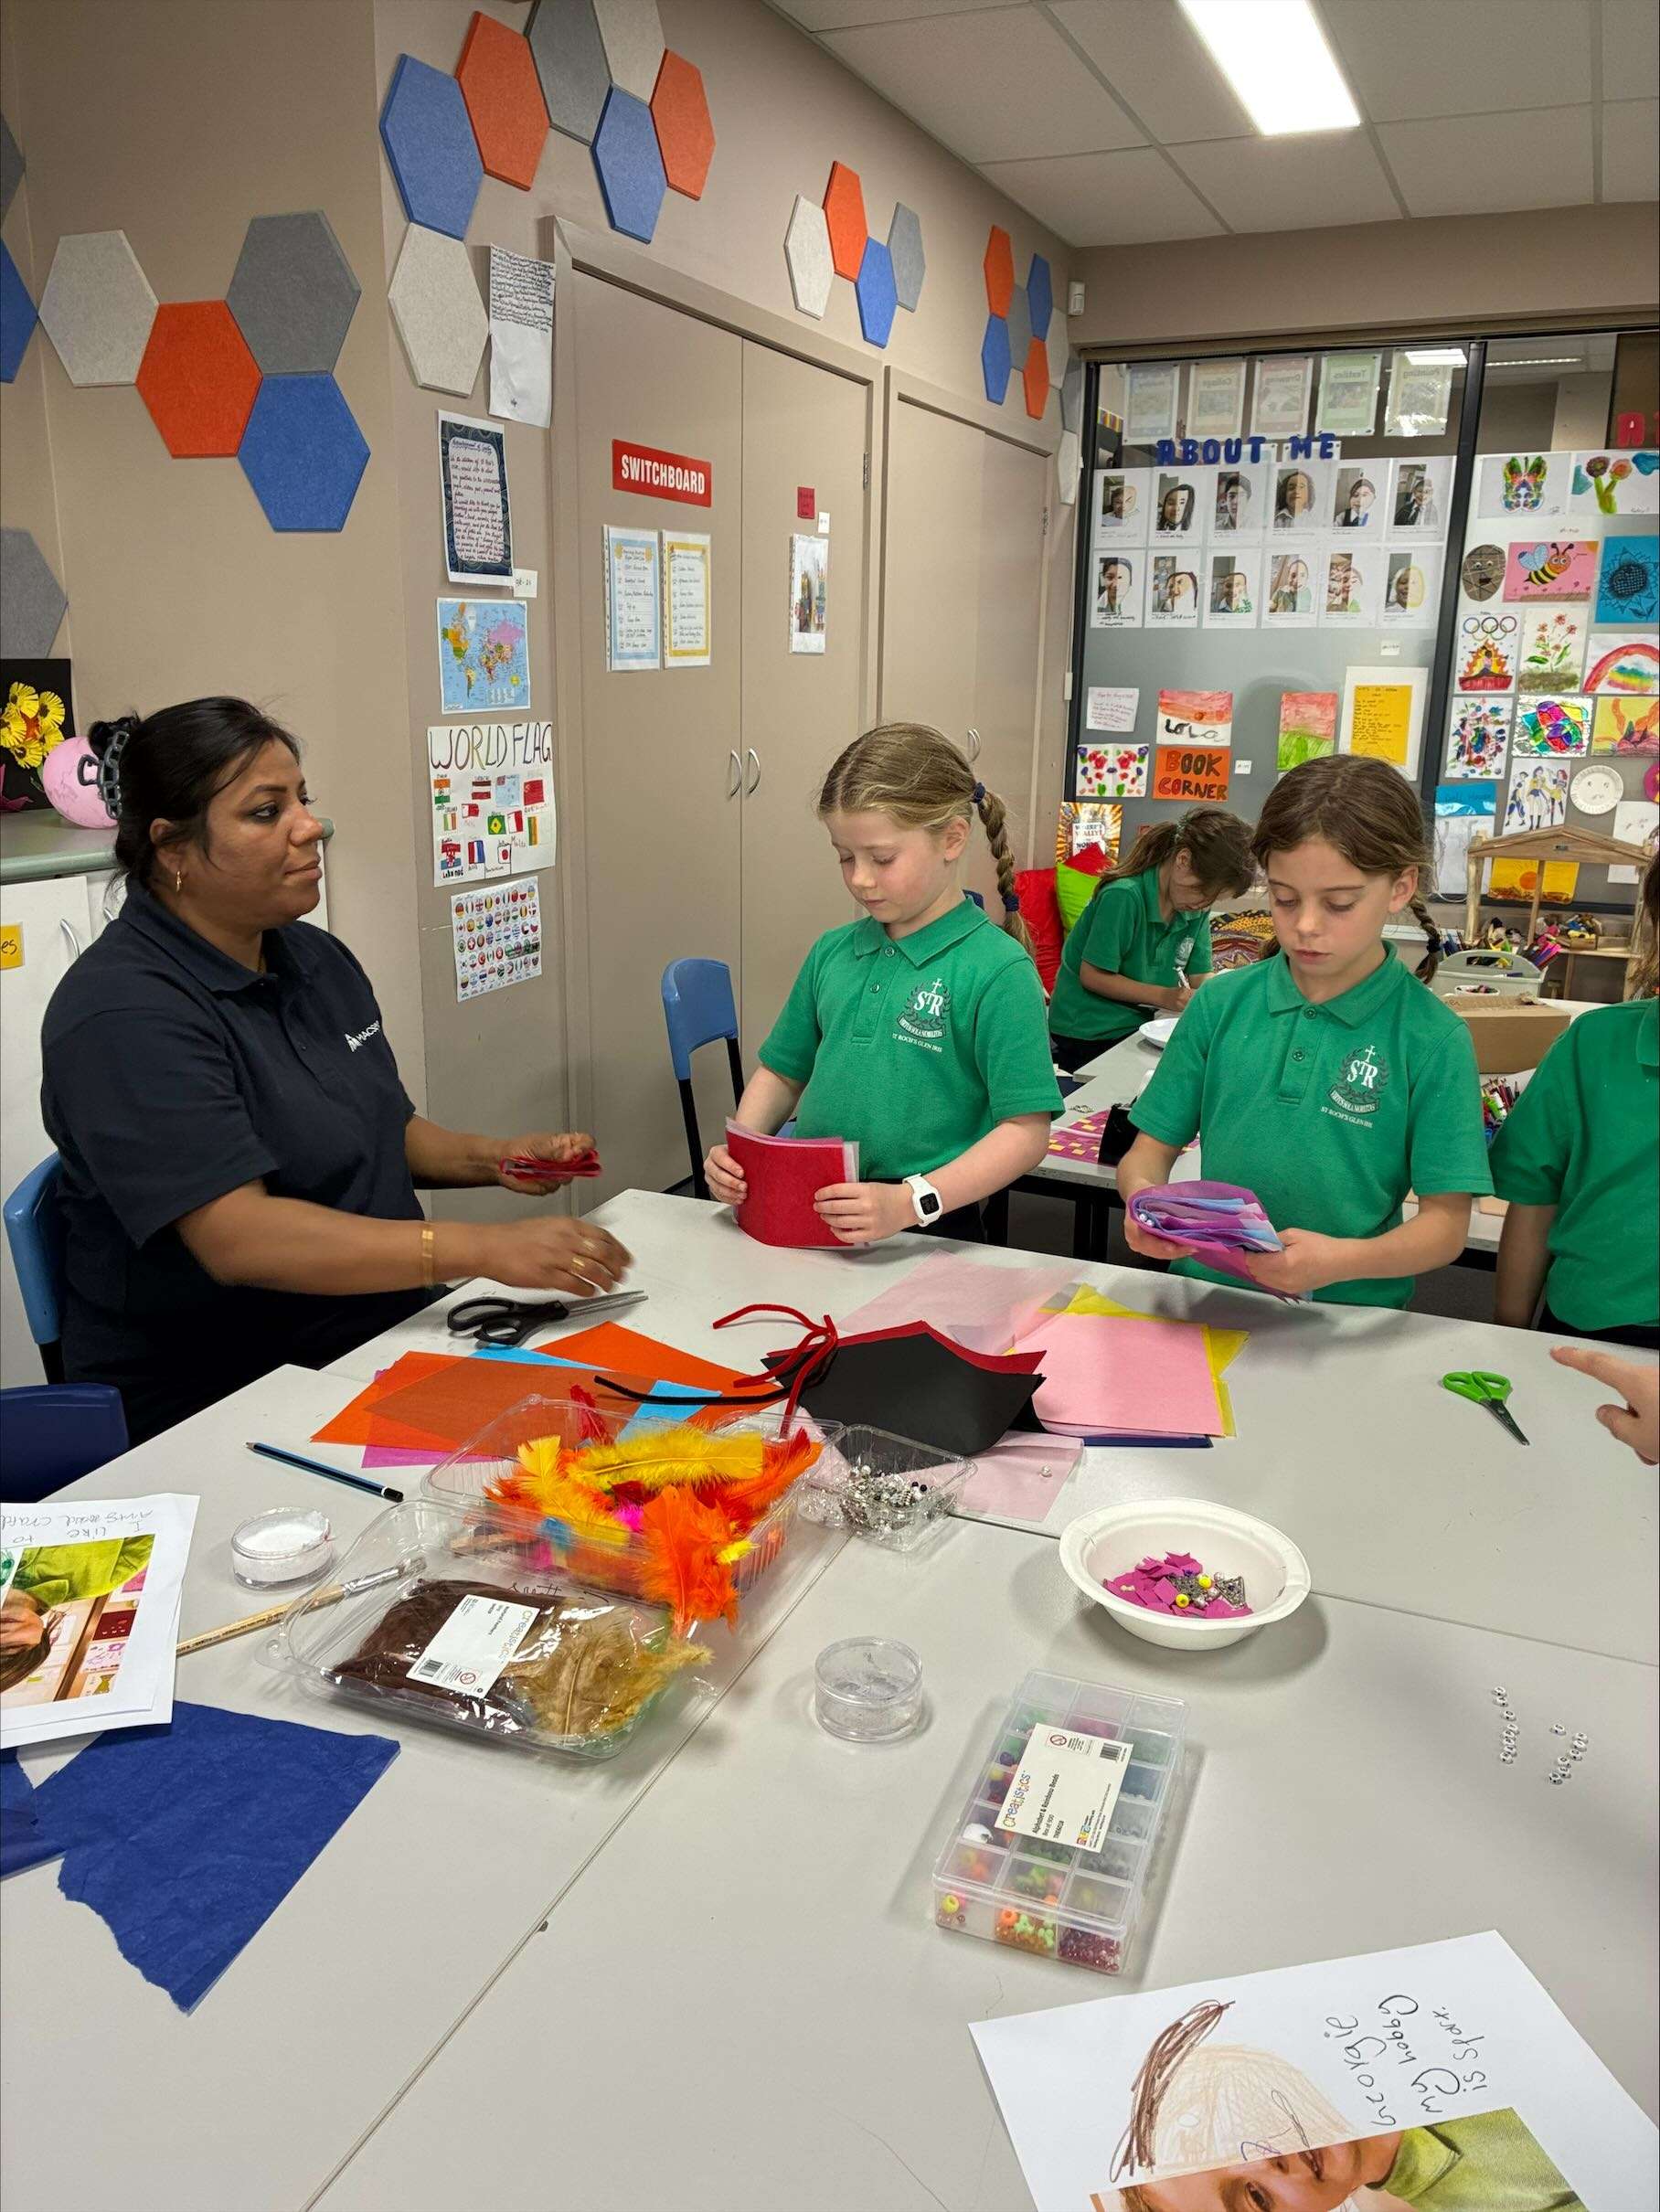
- Outdoor play
- Aluminium foil art

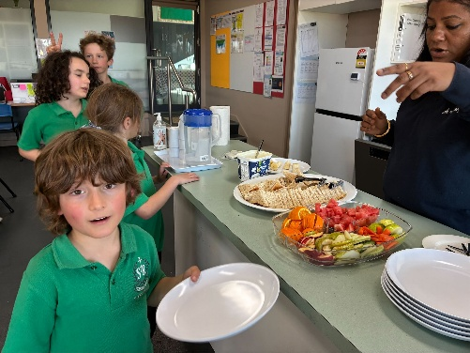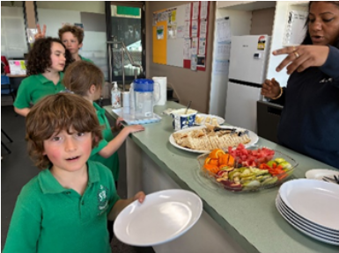

Term 4, December 2025

A message from the team
Dear Families,
As we come to the end of the year, we celebrate the wonderful learning and fun the children have enjoyed. This week they took part in range of activities including Christmas crafts, blue snowflakes salt painting, Karaoke songs and dance, Noodles balance play, Board games, Group games and Outdoor play. These experiences supported their social skills, confidence and physical development.

We are proud of children’s growth and joy they bring to our learning environment. Thanks to all for the ongoing support and partnership.

Wishing all our families a Joyful Christmas and a safe, relaxing holiday break and Happy New Year. We look forward to more learning and laughter in the new year!
Noted: Families are reminded that 16th December will be the last day of OSHC, and the session on that day will begin at 1pm.
Our aftercare program will resume on 30th January next year.

Jyoti Gupta (Coordinator Service Leader)

Check out the fun!
Make a booking!
Experience the fun of MACSEYE’S OSHC program at St Roch’s Glen Iris School today!
Call our friendly team: 0493180483 or 1300 501 029
Visit us: St Roch’s OSHC room, 7am – 9am, 3:30pm – 6:30pm
Email: enrolments macseye.vic.edu.au
Website: www.macseye.vic.edu.au

