# ***KSC/ SGSMP Scholarship Information***

*The successful applicant of this scholarship will receive discounted instrument tuition ($123 off) and free hire on an instrument listed below for a period of 12 months.*

*Instruments offered for the scholarship;*

|  |  |  |  |
| --- | --- | --- | --- |
| *Flute* | *Clarinet* | *Saxophone* | *Trumpet* |
| *Trombone* | *Euphonium* | *Tuba* |  |

*The process for application;*

* *To be eligible student must be in Year 7 or Year 8 for 2022*
* *No prior music experience is necessary*
* *Students must agree to attendance of Band and Lessons as outlined in SGSMP Handbook*
* *Students return an application form to Ms Handley.*
* *If application successful, students will be notified of an allocated time to sit an interview with Ms Handley and Mr Wilson or Ms Dauphin*
* *Interview – student will be asked a series of questions about their interests and passion for music.*

*Please find the application on the next page, you/ your child will be notified for an audition/ interview. The school would like to recognise the Korumburra Lions Club for their kind donation and continued support to our school community and Music Program.*

For more information contact:

Ms. Rosie Handley

Performing Arts Coordinator

[rosie.handley@education.vic.gov.au](mailto:rosie.handley@education.vic.gov.au)

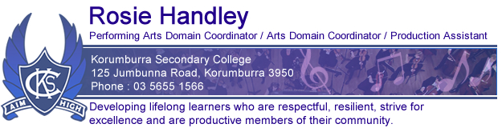

# ***KSC/ SGSMP Scholarship Application***

*The successful applicant of this scholarship will receive half price instrument tuition ($123) and free hire on an instrument listed for a period of 12 months. Please fill out all questions on the application below.*

*Name: Form:*

1. *Why do you think you would be a good fit for the SGSMP Music Program?*

1. *Why is music important in education?*

1. *Can you outline an example of time you have had to commit to something for more than 12 months?*