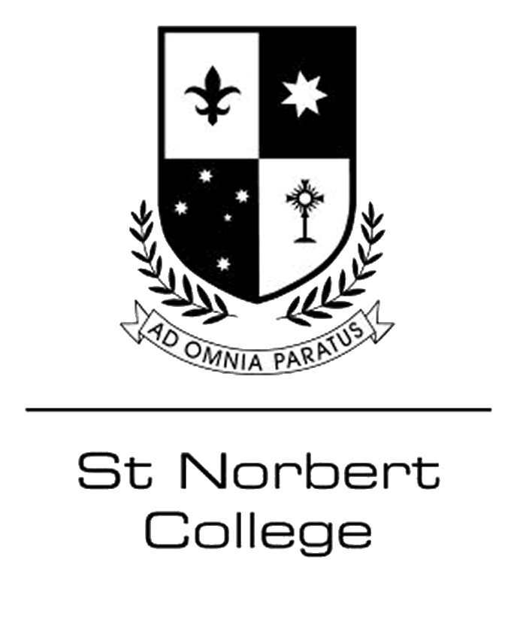
EXAMINATION TIMETABLE – Semester One (2023)
ATAR Pathway students – Attend the College for examinations only
Vocational / General Pathway students – Attend regular scheduled classes.
Year 10 students – Attend the College for examinations only

(All ATAR examinations will be in the Business Centre unless otherwise indicated)
Day / Date | 8:50am | 12:50pm
Monday 22/5 (Cappenburg) | 12 EALD (1)  12 English (28)  12 Literature (21) | 11 English (45)  11 Literature (12)
Tuesday 23/5 | 11 Mathematics Specialist (2)  11 Psychology (21)  12 Psychology (17) | 11 Physics (6)  12 Physics (8)
Wednesday 24/5 | 11 Accounting & Finance (10)  11 Chemistry (18)  12 Economics (12) | 11 Health Education (18)  12 Health Studies (15)
Thursday 25/5 | 11 Religion & Life (26)  12 Religion & Life (23)
Friday 26/5 | 11 Human Biology (34)  12 Human Biology (13) | 12 Modern History (14)
Day / Date | 8:50am | 12:50pm
Monday 29/5 | 12 Mathematics Applications (30)  12 Mathematics Methods (12) | 11 Mathematics Applications (25)  11 Mathematics Methods (21)
Tuesday 30/5 | 11 Economics (24)  12 Accounting & Finance (12) | 11 Computer Science (6)  12 Visual Arts (4)  12 Chemistry (8)
Wednesday 31/5 | 11 Geography (17)  12 Geography (11) | 12 Mathematics Specialist (6)  12 Dance (5) – Practical
Thursday 1/6 | 12 Japanese (5)  11 Japanese (8) | 12 Dance (5)  12 Computer Science (2)
Friday 2/6 | St Norbert Day

(Year 10 examinations will be in the Cappenburg, Business Centre and P7)
Day / Date | 8:50am – 10:50am | 1:30pm – 3:20pm
Monday 5/6 | WA Day (Public Holiday)
Tuesday 6/6 | 10 English | 10 Science
Wednesday 7/6 | 10 Humanities | 10 Japanese
Thursday 8/6 | 10 Religious Education | 10 Sports Science
Friday 9/6 | 10 Mathematics

