STK SCHOOL FOOTBLL ACADEMY EXPRESSION OF INTEREST
The STK School Football Academy is an elite junior development program that gives Secondary School students a taste of an elite AFL environment including skill development, high performance/nutrition education, facility access, match day experience & athlete development education.

The Program format is as follows:
- 6 x Development Training Sessions with Elite Level 2 St Kilda FC Coaches
- 1 High Performance experience at RSEA Park where you will train in an AFL club environment (details to follow)
- An enrolment and participation pack including:
1 x GA Ticket to a Men’s Home Game, Scarf/Beanie/Hat, sticker pack, RH Sports voucher etc.

Program Outcomes:
- Improved fundamental skill development & overall game knowledge
- Increased awareness on elite professional standards and what it takes to be an ‘AFL’ player
- Connected to an AFL Club (STKFC Inner Sanctum Experience)

Patterson River Secondary College would like to offer this program to students in Year 7-9. It will run in Term 4 2024 from 3:15 to 4:45pm on a Thursday afternoon for 6 weeks.

The total cost of the program will range between $250.00 to $350.00, depending on the number of students that take up this offer. The more students, the cheaper the cost. We expect that the program will be at the lower end of the above price range. A $50 deposit is required by 11.59PM 14th June 2024 to secure your position. A payment plan for the remaining balance will be set up in Term 2 (details to follow). The full balance is to be paid by Sunday 11th October 2024

This is an expression of interest in the STK School Football Academy so that we can add your child to the event and begin planning the delivery of the program. Please complete this form below if your child is interested by the 10th May 2024 so your child can be included.

Please scan the QR Code below to become involved in the Program by 21 May 2024

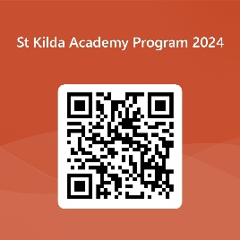

Or click this Link:

St Kilda Expression of interest form

