Summer School @ WAAPA
The WA Academy of Performing Arts Summer School offers intense, creative training for students in years 7 to 12.
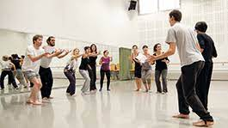
2024 Summer School courses
- Acting for Camera
- Acting Up
- Dance Squad
- Improvise for a Day!
- Jazz Summer School
- Music Theatre Kickstarter
- Tell Your Story - (For CALD Students)
Check details HERE.

Level Up Career Coaching and Resume Clinic - Rockingham
People aged 12 – 24 can get free one on one support to develop their career plan, improve their interview skills and prepare a job application.
Check details HERE.

Rotary Youth Exchange Applications for 2025 Close March
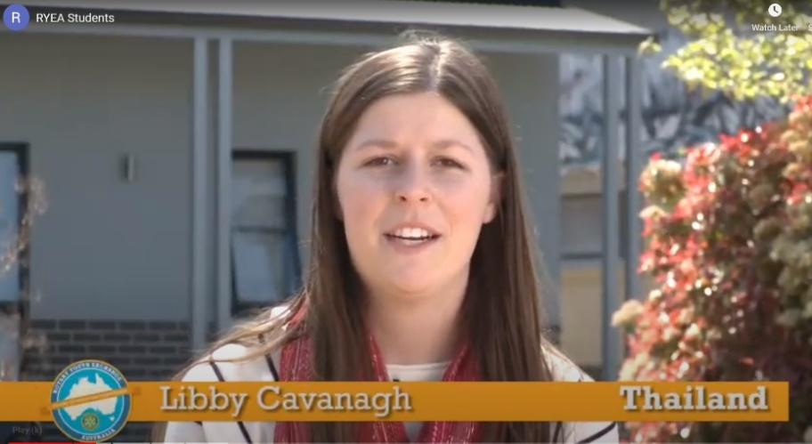
Senior school students have the opportunity to go overseas to study as part of the Rotary Youth Exchange.
The Exchange Student program is a life changing experience.

Year 10 students interested in the Rotary Youth Exchange program should check out the website HERE or the Facebook page HERE.

University Opportunities

Curtin Connect year 12 assistance
Curtin Connect will be open and available throughout the December holiday period to provide year 12 students with course advice or assistance with their TISC application. They will be open Monday - Friday from 8.30am - 4.30pm (Tuesday from 9.30am) but will be closed on regular public holidays.

Change to early offers for select Health courses

Whilst previously many Health Sciences courses were not included in Curtin's Early Offers Program, we are now implementing a reviewed offer process to enable us to send a limited number of early offers for the following competitive courses:
- Bachelor of Science (Nursing)
- Bachelor of Science (Occupational Therapy) (Honours)
- Bachelor of Science (Speech Pathology) (Honours)
- Bachelor of Science (Physiotherapy) (Honours)

School Leaver applicants will be considered for Early Offers through the TISC system and offers will be based on their predicted ATAR.

For information about Important TISC Dates for 2023 go HERE.

Early Offers for Uni 2024
- If you received an early offer and you are not clear what to do, contact the university that made you the offer that you want to accept.
- If you don’t want to accept the offer for the start of 2024, but don’t want to lost the offer, you should contact the university and ask to “defer”.

Did you get more than one offer?
- If you received an offer that you no longer wish to accept, please let the university know so that they can offer the place they had allocated to you, to someone else.

ATAR Calculator – estimate your ATAR score
- You can get a rough idea of your ATAR score by going HERE and estimating what you think you will get for your top subjects.
- This is just a guide using raw scores. Raw scores are scaled according to subjects and schools to ensure fairness.

Estimate your Uni Fees
You can estimate your uni fees for 2024 through the UWA Fee Calculator.
- The calculations are for 2023 but there won’t be much change and you can get a fair idea of your costs.

- You can do your calculations by course or down to the individual unit level. Most units go for one semester and cost $1892.

- The cost of your degree will grow most based on the number of years you spend at uni, rather than the cost of each unit.

Future Student Scholarships for 2023
If you are going to university in 2023, PLEASE check out scholarships. Some are for academic superstars, but not all of them.
Curtin Future Student Scholarships | UWA Future Student Scholarships
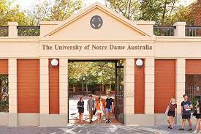  Notre Dame Future Student Scholarships | ECU Future Student Scholarships
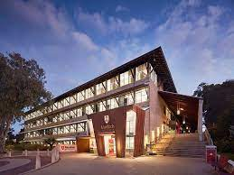  Murdoch University Future Student Scholarships | Good Universities Guide Scholarships

Curtin Merit Scholarships
If your child achieves an ATAR of 96+ in year 12, they will automatically receive the Curtin Excellence Scholarship. They don’t need to apply – they just need to list an eligible Curtin degree as their first preference through TISC.

Curtin Equity Scholarships
Your child can receive study support with the STAR Scholarship
The Curtin STAR Scholarship makes university possible if your child is facing financial hardship and could not otherwise consider tertiary study.

Curtin Plea to Parents
If you are unsure about whether your child is eligible for a scholarship or require more information, contact the Scholarships Office at scholarships@curtin.edu.au or 1300 222 888. You can also explore our Frequently Asked Questions to find out more.

3 December Notre Dame 2024 Scholarships Close
Most of Notre Dame’s 2024 scholarships close on 3 December There are many. Check them out HERE. All scholarship enquiries can be directed to scholarships@nd.edu.au 08 9433 0545 for WA

15 December Women of STEM scholarship applications open
Scholarships for women aged 18 - 20, studying a STEM related degree.
The Women of STEM Scholarship is a national program and provides women with financial grants of $5,000 per year for the life of their degree, up to a maximum of 5 years. This year we have awarded scholarships to three exceptional female students.
Find details HERE.

Year 12 Opportunities

15 January Westpac Young Technologist Scholarship deadline
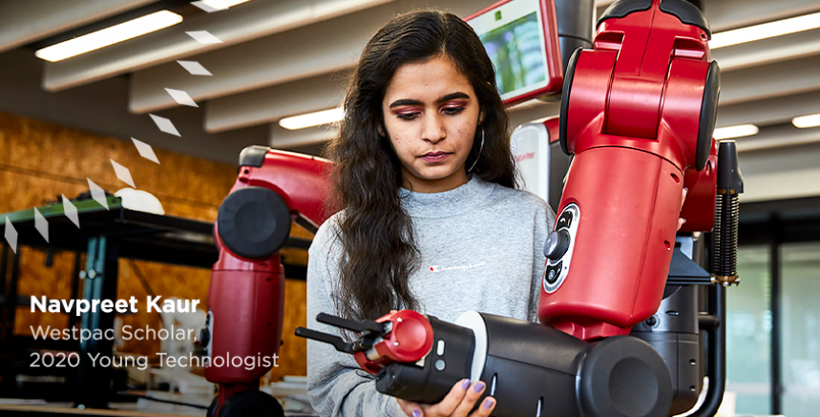
Westpac Young Technologists Scholarships are designed for high school graduates who are passionate about technology and eager to explore its potential for good.
- $20,000 for undergraduate studies.
- Leadership development
- Connection with other W100 Scholars
You can register your interest in receiving information HERE.

Middle School

Equity Scholarship for Middle School Students
Name of Scholarship | Who is it for? | Benefit
Bob Hawke Regional Academic Scholarship | Gifted and talented RRR students going into year 7 | Payment of boarding costs at City Beach Regional College
Olive A Lewis scholarship for students in need of financial support | Gifted and talented students in year 7,8,9 or 10 in need of financial support. | $250 - $1.500 per year

Year 10 Opportunities

Choosing your subjects for Years 11 and 12: Free Career Counselling at Unis
If you want to go to uni when you finish school, you can start to get to know the environment by going to see a career counsellor on campus.
- You can ask about different courses.
- Find what is new in the fields you like.
- Find out about different subjects (units) that you can take.
- Find what subjects you MUST study in your WACE as pre-requisite courses.

Most students go with a friend or family member. Just search for “career advice” at the uni of your choice.

Year 11 Results Important for Uni Entrance
You need to start getting great results right from the start of Year 11.
If you apply for an early offer at a university, they will use your Year 11 results to decide if they will offer you a place.

Year 9 & 10 Opportunities

23 – 25 January Discover cool STEM stuff @ Curtin
DISCOVER is a three-day program for years 9 and 10 delivered by a team of friendly STEM-passionate people who gives students the chance to meet Curtin innovators (including current students) and get an insight into their cool research.
Time: 9.30am to 3.30pm daily
Cost: $160
Get details HERE.

First Robotics Competition
FIRST Robotics Competition is a summer robot-building program for students interested in a mechatronics future:

- Mechatronics = working with mechanical and electronic engineering. It’s a mix of new electronic and computer sciences. For more details go to Wikipedia HERE.

Students build a working robot under the supervision of Curtin students and staff which competes against teams across WA. Tim Keely runs it and he is super enthusiastic about helping students to love robotics.

To get involved or for further enquiries, email Tim Keely at T.Keely@curtin.edu.au.

Scholarships to Private Schools for 2025
Details of scholarships for academically gifted students who want to go to private schools are listed below or go HERE for details.

Defence Opportunities

31 October ADF Scholarship Deadline
Children and grandchildren of veterans have an opportunity to access scholarships that can support their tertiary education journey at universities, TAFEs, and various training providers.
Don't miss out on this chance to be recognized for the contribution made by your family member.

Scholarship Details:
- All scholarships, including bursaries and sponsored scholarships, are specifically for tertiary education.
- Scholarship values range from $4,000 to $6,000 per year, with the potential to receive funding for up to three years.

Application Period: Applications opened on August 18 and will close on October 31. Act now to secure your chance for financial assistance!

How to Apply:
- Visit AVCAT Scholarships to access the application portal and apply.
- For guidance on preparing a strong application, be sure to review our detailed Application Guide
Applications opened 18 August and close 31 October.

RRR Opportunities

14 November South West Information Evening
If you want to study at ECU South West, attend our Information Session to find out more.
ECU South West is Western Australia's largest university campus outside the metropolitan area. The campus features a wide range of contemporary facilities to enhance student and staff experiences. These include state-of-the-art teaching facilities and commercial outlets providing key services; most services on-campus are also open to the wider community.
Time: 6 – 7.30PM
Register HERE.

Bob Hawke Regional Academic Scholarships for Boarding costs
Students from regional and remote Western Australia, applying for enrolment at Bob Hawke College through the Gifted and Talented Academic program, are eligible to apply for a scholarship to meet the cost of boarding at the Department of Education’s City Beach Residential College.
Find details HERE.

Name of Scholarship | Who is it for? | Benefit
Bob Hawke Regional Academic Scholarship | Gifted and talented RRR students going into year 7 | Payment of boarding costs at City Beach Regional College

Harry Perkins Memorial Scholarhsip
The Harry Perkins Memorial Scholarship has been developed by Curtin University to support students who are required to relocate from a regional or remote area to commence an undergraduate degree at Curtin University, who are from a low socio-economic background and are experiencing financial hardship.
Find details HERE.

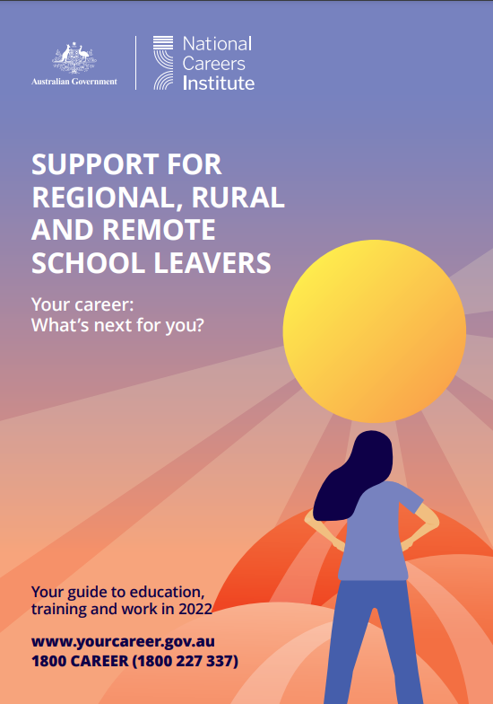
Support for regional, rural and remote young people
This booklet delivers information that is relevant to school leavers.

The Rural Inspire site
Where to find important information
Find the Support for Regional, Rural and Remote School Leavers HERE.

Earning Opportunities for School Leavers and Families
Part of the shortage of workers in rural and remote areas can be addressed by providing childcare to little kids, freeing their parents up to go into the paid workforce.
The Family Day Care program is run from people’s homes. You must be 18 to apply for this sort of work. You get help from a family day care service to prepare to register your business.
Find out more about how to get into this sort of work HERE.

Aboriginal and Torres Strait Islander

1 November Applications open for Madalah Scholarships 2025
Applications for secondary school scholarships at West Australian independent schools in 2025 open on 1 November.
- Be of Aboriginal or Torres Strait Islander descent and be able to provide proof of descent
- Be eligible for ABSTUDY and/or demonstrate some form of disadvantage, e.g; financial, geographic etc and provide proof.
- Apply to one or more of our partner schools and provide proof of offer or enrolment where you have it
- Provide most recent academic results.
- Provide one letter from a referee.
- Applicants must have a good school attendance and behaviour record.
- Applicants must have a home location in Western Australia
For details go HERE.

14 – 19 January 2024 National Indigenous Business Summer School – Broome
The University of Notre Dame Australia's School of Law and Business invites you to apply for the 2024 National Indigenous Business Summer School program (NIBSSWA).
If you’re an Aboriginal or Torres Strait Islander student going into Year 11 or 12 in 2024, and you’re ready to challenge yourself and explore new opportunities, NIBSSWA is for you!
Time 14-19 January 2024
Questions: Email nibsswa24@nd.edu.au

Training for Indigenous Students at Midland 2024
These courses are designed with and for Aboriginal and Torres Strait Islander students.

- Cert II Rail Infrastructure
- Cert II Light Vehicle Mechanic
- Cert III Business Administration (Perth Campus)
- Cert II Salon Assistant and Retail Cosmetics

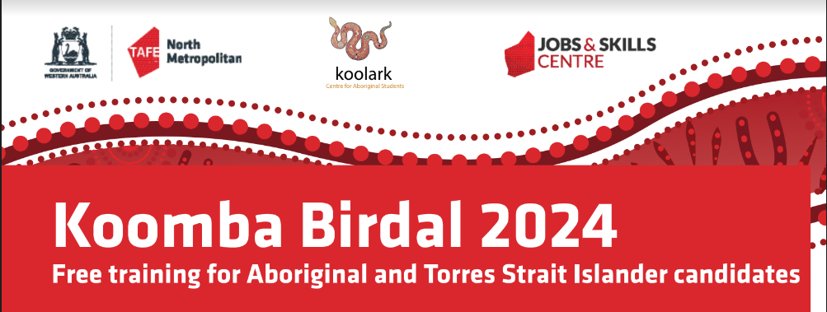
For more information contact AJ.lowe@nmtafe.wa.edu.au

Aboriginal Advisory Board for Education in WA
Ten Aboriginal people have been appointed to an Advisory Body that will advise the State government on how to create a culturally responsive education system.

There have been boards like this in the past that have been disbanded by different governments.

You can find details of the Advisory Board HERE.

Students with Disability

School of Special Education Needs: Medical and Mental Health
If you know a young person who is unable to fully participate in school due to medical or mental health issues, the School of Special Educational Needs: Medical and Mental Health,may be able to help. It offers specialized educational assistance to students attending primary and high schools who face challenges which may hinder their full participation in their current school programs. Check out the help that is available HERE.

CoderDojo@Curtin Autism Academy
The CoderDojo@Curtin is a fun, free volunteer-driven, computer programming (coding) club for young people. There is:
- a stream for students over 12 years old and
- a stream for children interested in Curtin’s Autism Academy (AASQA).
Check out details HERE.

North Metro TAFE Accessibility and Learning Support
Accessibility and Learning Support Coordinators work across all North Metro TAFE campuses to provide support for students with diagnosed disability, medical condition or mental health condition, whether temporary or permanent. This service is free, confidential, and optional.

Find details HERE.

Student Wellbeing Hub – Autism Resources
These resources are designed for students of all ages. There are resources for primary school students through to school leavers.

There is a whole section called Get ready to learn

There are other resources linked to the page.
