Service Name: Barwon Heads | Week Beginning: 12th to 16th December 2022 (Term 4. WEEK 11)
Community Involvement/ Service planned for the week:
- Following the schools’ Mental Health & well-being topic which is HOPE. Hope has to do with positive expectations about the future. It involves optimistic thinking and focusing on good things to come
- Doing the compost and completing the task of putting the chickens in their chicken coop.
- Celebration of DAYS: 1-31 DIC No Gender. No Gender December marks a time to make a stand against the gendered marketing of toys to children.
Projects to be undertaken or planned:
- Making our OSH newsletter with children
- Christmas tree with recycled materials. What else could we add to the Christmas tree? Presents? What type of presents? Wishes?? What would you would like to happen for next year? .
Team Goals for this Week:
- Support children to make the OSH newsletter and create a Christmas tree
Theme or Main Focus for this Week’s Planner: Christmas and new year around the world
Learning Outcomes:
- 1.1 Children sense and respond to a feeling of belonging
- 2.1 Children understand different ways of contributing through play and meaningful projects
- 3.2 Children seek out positive experiences
- 4.2 Children investigate, imagine and explore ideas
- 5.3 Children use a range of texts for instructions for leisure activities such as sport and craft.
School Holiday Program
We have an amazing School Holiday program coming up. Like all our holiday programs, we have an awesome time with the children, full of fun packed experiences that I am sure they will always remember. Please complete your booking forms as soon as possible and if you have any questions, come and speak to one of the staff at our program who will be happy to help.
Big Childcare Philosophy
Big Childcare is a leader in the out of school hour’s industry. Our team is professional, experienced, nurturing and committed to providing a supportive and transparent environment for families where their feedback and support is highly valued. We provide exceptional quality out of school hours care for school aged children which meets the health, safety and wellbeing needs of the children and families in the community. We believe in making our programs engaging, diverse, physically active and fun, where children’s learning can be scaffolded, so they can reach their full potential. Through these experiences’ children will develop a range of life long skills including building on their social and emotional capacity. Children are valued and respected as individual are central to our programs. The programs we offer are developed in conjunction with educators, schools the community, children and families. They are critically reflected upon and evaluated to ensure we are providing positive experiences that are age appropriate and extend every child.
We encourage all children and parents to provide us with feedback on the running of our service
All children are given the freedom to choose and change the activities they participate in

 | Monday | Tuesday | Wednesday | Thursday | Friday
Before Care  Creative Experiences | Creative Experiences  Christmas cards  France- Who is Papa Noël ?  Papa Noel is what we know as Santa Claus. On December 6th in France, people celebrate Santa Claus day by giving presents to their loved ones. Make a card for your friends, family, teacher…  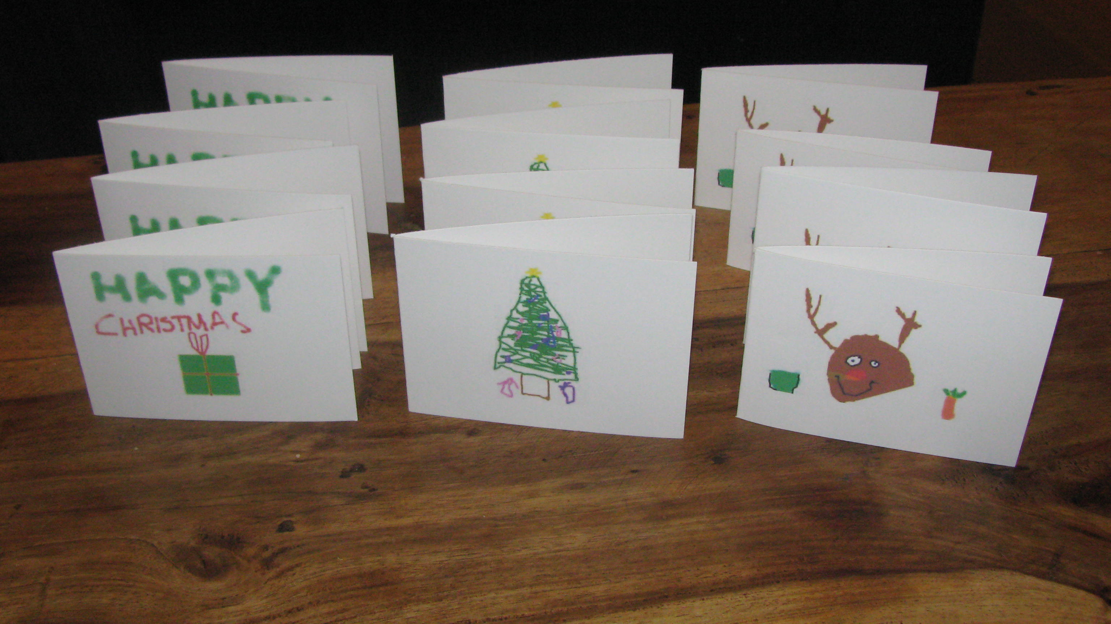  L/O: 3.2, 5.3  NQS: 1.2.1, 3.2.2, 5.1.1  Current Interest  17.11.22 Charlotte | Creative Experiences  Australia- Summer hammer beads decoration  Children will use beads to create different decorations to put on the Christmas tree.  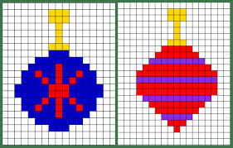  L/O: 1.1, 3.2, 4.2  NQS: 1.2.1, 5.1.1  Current interest of  21.11.22 Oscar, Eli, Emma 23.11.22 Max and Alfie. | Creative Experiences  England- DIY Christmas cracket  In England, Crackers are placed on the table at Christmas lunch. Two people pull each side and it makes a cracking sound. There is usually a paper hat and toy inside.  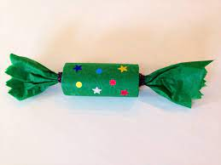  L/O: 1.1, 3.2, 4.2, 5.3  NQS: 1.2.1, 3.2.2, 5.1.1  Current Interest 23.11.22  Audrey, Emma and Charlotte | Creative Experiences  Adding more decoration to our Chrisamas tree  What would you like to add to our Christmas tree? Use paper and texter to create a decoration for our Christmas tree.  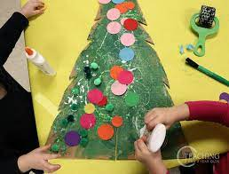  L/O: 2.1, 3.2  NQS: 1.2.1, 3.2.2, 5.1.1  Current interest of  24.11.22 Thom | Creative Experiences  Christmas ornaments  Children will create their own christmas ornaments.  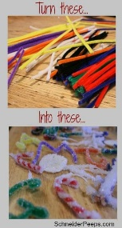  L/O: 1.3, 2.4, 3.2  NQS: 1.2.1, 5.1.1  Current interest of  30.11.22 Billie B. Ella, Goldi and Lola.

Before Care  Physical Experiences | Physical Experiences  Santa Claus Elf’S presents  Similar to Giant treasure and Night in the museum, children will attempt to get a present from the Elf but if he sees you, you have to go back to the start point.  L/O: 3.2, 5.1 NQF: 2.1.3, 5.2.1  Current interest: 29.11.22 Extension of Night a the museum- Rossie and Max C. | Physical Experiences  Christmas riddles  Children will read the Christmas around the world. Then we will ask them question and they will need to loofk for the answer around the room.  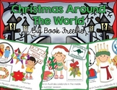  L/O: 3.2 NQS: 1.2.1  Current Interest of: 28.11.22 Rossie and Max C | Physical Experiences  Elimination Tag  Run and be the first to get the ball, then eliminate the rest of the players who will pretend to be fishes by throwing the ball to them. Agree on three rules with your educators and peers.  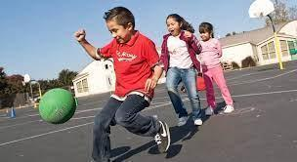  L/O: 3.2  NQS: 2.1.3  Current interest of  25.11.22 Raff and Sonny | Physical Experiences  Christmas riddles  Children will read the Christmas around the world. Then we will ask them question and they will need to loofk for the answer around the room.  L/O: 3.2 NQS: 1.2.1  Current Interest of: 28.11.22 Rossie and Max C | Physical Experiences  Basketball knockout  The players line up in a single file with the first shooter in the shooting line and others behind him. The goal is to eliminate the other players by making shots and by the last standing.  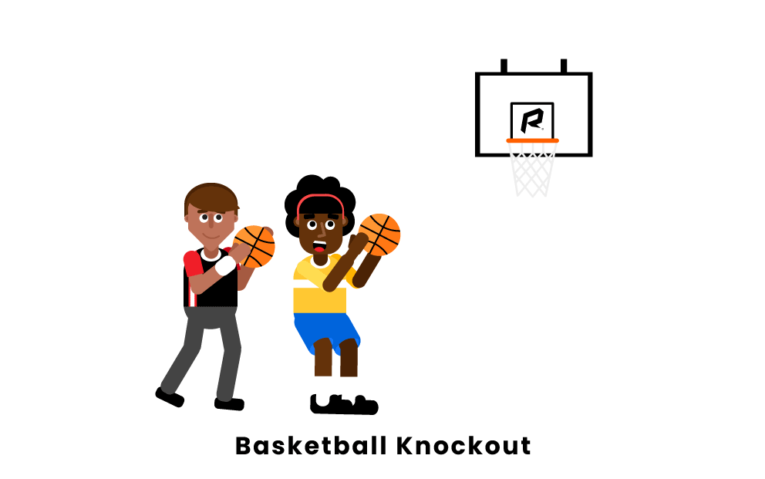  L/O: 3.2  NQS: 1.2.1  Current interest of  24.11.22 Lola
Before Care Intentional Teaching or Discussion | Topic:  INTRODUCE THE TOPIC Christmas and new year around the world  Santa Claus has many names around the world. Could you name one of his names?  Tell me about a question that you would like to be asked.  Delivered by: Azucena  (*13.09.22 Will’s idea) | Topic: Topic:  INTRODUCE THE TOPIC Christmas and new year around the world  Can you say Merry Christmas in a differente language?  Tell me about a question that you would like to be asked.  Delivered by: Azucena  (*13.09.22 Will’s idea) | Topic: Topic:  INTRODUCE THE TOPIC Christmas and new year around the world  What is your favourite dish or food to eat in christmas or summer? Is this healthy?  Tell me about a question that you would like to be asked.  Delivered by: Azucena  (*13.09.22 Will’s idea) | Topic:  INTRODUCE THE TOPIC TALES  In the story Hanzel and Gretel, what character is enthusiastic? Or what fairytale character have you known that is enthusiastic?  Tell me about a question that you would like to be asked.  Delivered by: Azucena  (*13.09.22 Will’s idea) | Topic: Space  INTRODUCE THE TOPIC TALES  What can you learn from a fairytale?  Tell me about a question that you would like to be asked. .  Delivered by: Azucena  (*13.09.22 Will’s idea)
 | Monday | Tuesday | Wednesday | Thursday | Friday
After Care  Creative Experiences | Creative Experiences  France- Advent wreath  Many French people count down the weeks until Christmas with an advent wreath. Children will make the advent wreath and write down their wishes for this Summer.  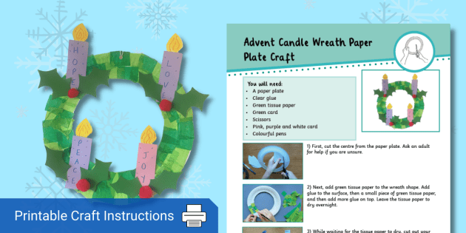  L/O: 1.2, 2.3, 4.2  NQS: 1.2.1, 3.2.2, 5.1.1  Current Interest of 28.11.22 Emma | Creative Experiences  Christmas butting around the world  Children will colour a Christmas butting to display in the room. Through it, they will learn how to say Merry Christmas in different languages and how other people celebrate it.  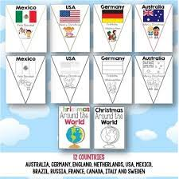  L/O: 1.2, 2.3, 4.2, 5.3  NQS: 1.2.1, 3.2.2, 5.1.1  Current Interest of 28.11.22 Emma | Creative Experience  DIY Kerstkransjes  Kerstkransjes are a traditional Dutch Christmas cookie. Kerstkransje means ‘Little Christmas Wreath’ because these cookies resemble Christmas wreaths  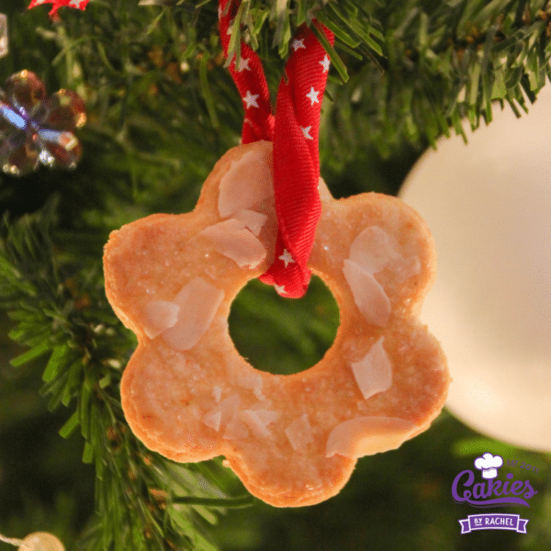  L/O: 1.2, 2.3, 4.2, 5.3  NQS: 1.2.1, 5.1.1  Current interest of  30.11.22 Goldie | Under the sea craft  Italy- La Bafana’s christmas boot  In Italian folklore, the Befana is an old woman who delivers gifts to children throughout Italy on Epiphany Eve (the night of January 5) in a similar way to Santa Claus. Children will make a christmas boot with his image to decorate our christmas tree.  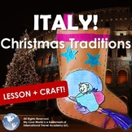  https://youtu.be/0C8stMVqzCg  L/O: 1.2, 2.3, 4.2, 5.3  NQS: 1.2.1, 3.2.2, 5.1.1  Current interest of 1.12.22 Madisson. | Creative Experiences  Christmas butting around the world  Children will colour a Christmas butting to display in the room. Through it, they will learn how to say Merry Christmas in different languages and how other people celebrate it.  L/O: 1.2, 2.3, 4.2, 5.3  NQS: 1.2.1, 3.2.2, 5.1.1  Current Interest of 28.11.22 Emma
After Care  Physical Experiences | Physical Experiences  India- Kite Festival  Kite Festival is a popular festival in India and it takes place during Makar Sankranti in the month of January. This festival celebrates the arrival of spring and the success of the harvest. Children will take turns flying a kite outside. We will agree on rules.  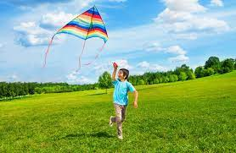  L/O: 3.1 and 5.3  NQS: 2.1.3  Current interest of 28.11.22 Oscar | Physical Experiences  Santa Claus Elf’S presents  Similar to Giant treasure and Night in the museum, children will attempt to get a present from the Elf but if he sees you, you have to go back to the start point.  L/O: 3.2, 5.1 NQF: 2.1.3, 5.2.1  Current interest: 29.11.22 Extension of Night a the museum- Rossie and Max C. | Physical Experiences  Christmas riddles  Children will read the Christmas around the world. Then we will ask them question and they will need to loofk for the answer around the room.  L/O: 3.2 NQS: 1.2.1  Current Interest of: 28.11.22 Rossie and Max C | Physical Experiences  Skiping the rope while listening Christmas songs  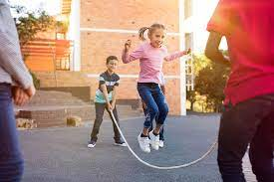  L/O: 3.2 NQS: 2.1.3  Current Interest of: 1.12.22 Maddison and Jimmy. | Physical Experiences  Elimination Tag  Run and be the first to get the ball, then eliminate the rest of the players who will pretend to be fishes by throwing the ball to them. Agree on three rules with your educators and peers.  L/O: 3.2  NQS: 2.1.3  Current interest of  25.11.22 Raff and Sonny
After Care Intentional Teaching or Discussion | Topic:  INTRODUCE THE TOPIC Christmas around the world  Santa Claus has many names around the world. Could you name one of his names?  Tell me about a question that you would like to be asked.  Delivered by: Azucena  (*13.09.22 Will’s idea) | Topic: Topic:  INTRODUCE THE TOPIC Christmas and new year around the world  Can you say Merry Christmas in a differente language?  Tell me about a question that you would like to be asked.  Delivered by: Azucena  (*13.09.22 Will’s idea) | Topic:  INTRODUCE THE TOPIC TALES  INTRODUCE THE TOPIC Christmas and new year around the world  What is your favourite dish or food to eat in christmas or summer? Is this healthy?  Tell me about a question that you would like to be asked.  Delivered by: Azucena  (*13.09.22 Will’s idea) | Topic:  INTRODUCE THE TOPIC TALES  In the story Hanzel and Gretel, what character is enthusiastic? Or what fairytale character have you known that is enthusiastic?  Tell me about a question that you would like to be asked.  Delivered by: Azucena  (*13.09.22 Will’s idea) | Topic:  INTRODUCE THE TOPIC TALES  What can you learn from a fairytale?  Tell me about a question that you would like to be asked. .  Delivered by: Azucena  (*13.09.22 Will’s idea)

