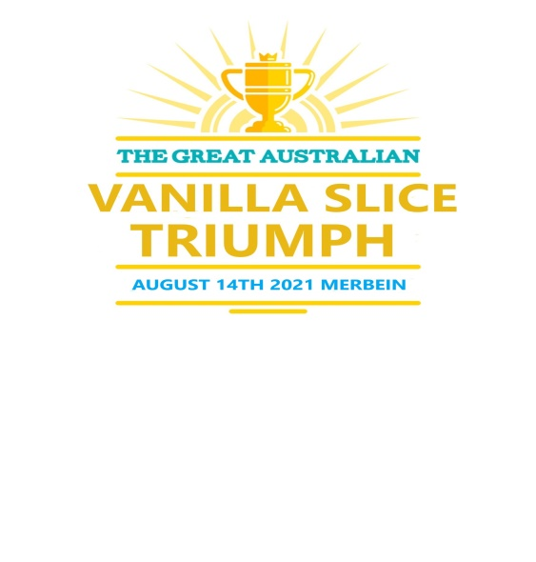

**AMATEUR ENTRY DETAILS**

**Entrant’s Name ---------------------------------------------------------------------------------------**

**Address ---------------------------------------------------------------------------------------------------**

**--------------------------------------------------------- Postcode ----------State --------------------**

**Email ---------------------------------------------- Phone ---------------------------------------------**

**ENTRY CRITERIA**

**TERMS AND CONDITIONS**

* **One entry per Person for all sections.**
* **Six Vanilla Slices must be presented with a square or rectangle shape.**
* **When tasted, the slice should reveal custard with a creamy smooth texture and a balance of vanilla taste with a crisp, crunchy pastry topped with a smooth and shiny glaze/fondant.**
* **Entry must be made from scratch, NO professional baking products can be used in the production of the Vanilla Slice, please supply recipe with your entry.**

**NOTE: The entrants can use the supplied recipe or use your own custard recipe, as long as the guidelines have been followed.**

**Applications/entries can be also done online from our website**

**www.thegreataustralianvanillaslicetriumphmerbein.com**

**Enquiries: email** [greatvanillaslicemerbein@gmail.com](mailto:greatvanillaslicemerbein@gmail.com)

**P: Mickey Nelson 0428 353 956**

**JUDGES FEEDBACK**

**For feedback after the event contact:**

**Anne Nash – Judging Coordinator P: 0439 042 160**

** **



**MAJOR SPONSOR**

**ENTRY CATEGORY**

What categories will you be entering?

□**SCHOOLS** 10-18 years - **$5.00**

□**OPEN** 18-50 years - **$5.00**

□ **OVER 50’S -** 50 + years **-$5.00**

**Entry Form and payments by 4th August 2021**

**Payments to:**

**BSB 633-000**

**Account: 169208618**

**# Ref: your name**

**ENTRY DELIVERY**

**Entries must be delivered via rear lane entry door at Club Merbein 108 Commercial Street Merbein (lane**

**between Railway Ave. and O’Bryan St.)**

**Entries will only be received between**

**9am-12 on * Friday 13th August 2021 Late entries will not be accepted.**

**# See Prize list on reverse**