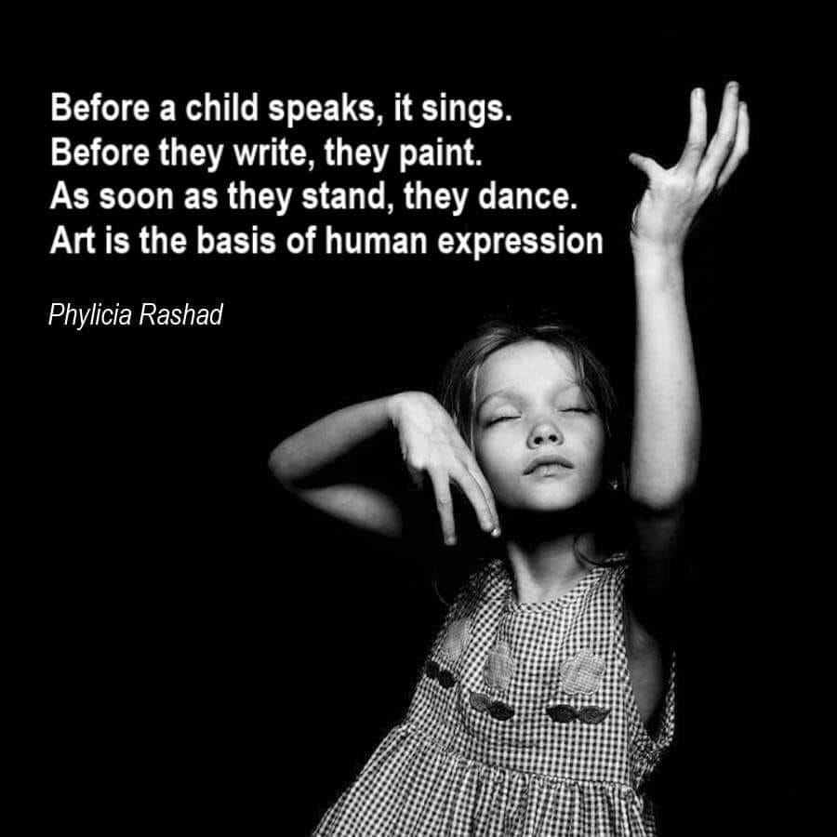  Art Psychotherapy (or more simply Art Therapy, Expressive or Creative Arts Therapy) is a person-centred style of therapy and can bring the unknown into the known through the exploration of various art materials and art-making techniques. It does not require talking like traditional therapies – a lot can be said in the non-verbal experiencing. Some of my favourite activities are:  Playing with paints, pencils and oil pastels; Collage, Scrapbooking and Art Journaling; Creating 3D objects from Mixed Media and Found Objects; Mask and Costume Making; Clay, Plasticine and Sand Play; Photography (I have been a photographer for over 15 years.) Creative Writing, Poems and Story-telling; Mandala and Zentangle Making with pen and paper, food, found objects and even human bodies!  ART THERAPY ALSO INCLUDES DANCE!  Also experienced with Authentic, Improvisational Movement and Dance with the use of Props - I am an established Tribal Style Belly Dance Instructor (so this is dear to my heart!); Voice Work; Music Making and Dramatisation. | Art Therapy is for EVERYONE!  It is for kids and teens, adults and elderly – regardless of age, gender identity, cultural background, neurodiversity, ability or physical fitness.  No one has to be the “perfect artist” – because we are ALL creative beings in some form. You just have to be able to put pen to paper or wiggle a toe!  Just some of the Benefits of (and a bit of science behind) Art Therapy:  New ways of learning and finding new ways to express yourself.  A way to build self-esteem, self-awareness and self-esteem. Changing the “No, I can’t.” to “Yeah, I can!”  Processing and moving through Trauma and Mental Health Issues; can assist with Pain Management.  Can be tailored to the individual.  Creates new neural pathways – especially helpful in the Aging Brain.  The ultimate act of Mindfulness and Self-care – all the senses can be engaged in the moment of the activity, bringing you back to your centre.  Meditative State and Flow – when time passes, you are not over-thinking because you are just having FUN!  FOLLOW ME ON INSTAGRAM!  arttherapeuticsbymissfisher  L  l  L  . | aRT therapeutics by miss fisher  - With Lauren Fisher Ph: 0433149953  - artdancetherapybymissfisher@gmail.com

