Seek and Find while you walk to school – Urban Accents
Remember, it’s gotta be outside. No ‘living-room flying ducks’ allowed

70’s style It could be a car or a house. Always colourful, the 1970’s saw a flood of dubious style infiltrating everything from clothing to cars and architecture. It can look worn out and a little jaded today but with a bit of love and care the glam 70’s can shine again. Just ask your folks, or your folks folks. | 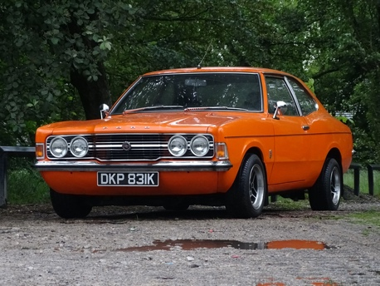 |  |  | A street seat What is it with all the chairs on the footpath? Will someone please design the perfect chair so that we can stop throwing them away. I’ve stumbled across designer delights and antiques that would have lasted decades and supported countless bums only to be tossed aside for something …new. | 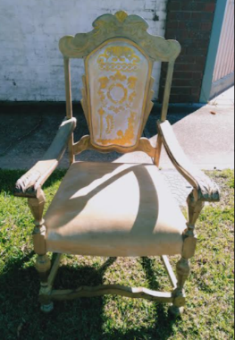
Green Bin Sculpture Sometimes even the most humble things can emanate a sense of pathos or joie de vivre. Don’t believe me? Check out… https://www.instagram.com/greenbinikebana/?hl=en  They’re all local and you may even find your own art documented. | 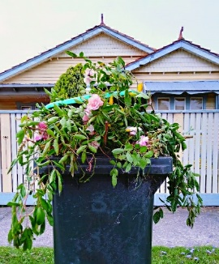
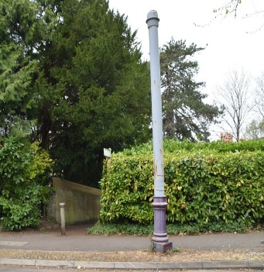  Stinkpoles Have you noticed them? Do. They are important. Smellbourne, as it used to be known is a relatively flat city with mostly gentle slopes leading to Port Phillip Bay. Of course, the hazards of sending sewage into the bay would’ve been known by the time the Werribee sewage pumping station was built. But when you don’t have much downhill gravity to assist in moving things along the danger from a build-up of gases must be alleviated somehow. So, ornate or industrial, please allow me to draw your attention to the humble stinkpole. See… https://www.instagram.com/stinkpoles_of_melbourne/?hl=en |  |  |  | Three in a row Ducks, trees…it doesn’t matter what, but there does have to be 3 of them, and they must be in a row. Ban the bin and instead keep your eye open for the unexpected…it’s more fun that way. | 
Bluestone intersection (X or Y)  Moreland/Merri-Bec is known as the Bluestone Council and the origin of the laneways was to provide access for the ‘night soil collection’ in days pre-sewage. How often do you deviate from the footpath in order to explore the laneway network? |  |  |  | Historic marker You might not have noticed them but if you look up you may see a historic street sign commemorating some aspect of local colonial history, a fairly forgotten Lord Mayor or a site of some note. | 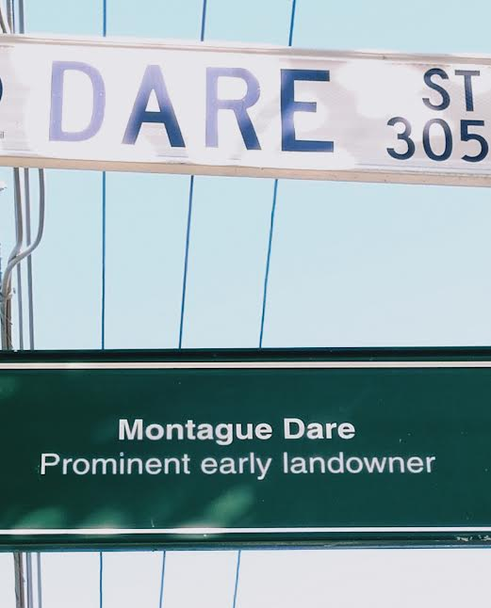  A good name for a movie star …or a nemesis.
Skateboarding Recognition of skateboarding as an Olympic sport has allowed it to move away from its gritty origins to public respectability. Some would say it’s ‘Lost its soul,’ while others would say ‘Forget that. Let’s skate.’ It’s been a bumpy journey from the humble driveway wooden ramp to the swoopy architectural cement bowl delight. |  |  | 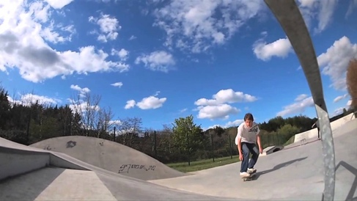 | Cactus  I’m not talking about the ubiquitous yucca, I’m talking about real cactus, spikes and all. Think spaghetti westerns…good, bad and ugly. |  | 
Community Garden Parsley, sage, rosemary and thyme…and rhubarb and cabbage and artichokes and leeks and chickens and so forth. As inner-city urbanisation gets more and more dense community gardens offer the chance to join like-minded folk who want to experience the simple joy of getting their hands dirty and growing their own fresh fruit and vegetables. |  |  | 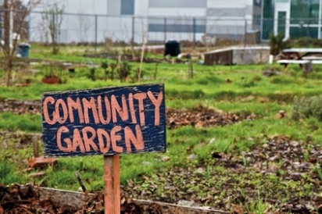 | Footpath Library Box  Isn’t it great how some people truly embrace the community spirit so far as to set up a small urban library on their front fence. Take a book, leave a book, share a book. Wonderful! |  | 