**WEST COBURG St ANDREWS CRICKET CLUB**

  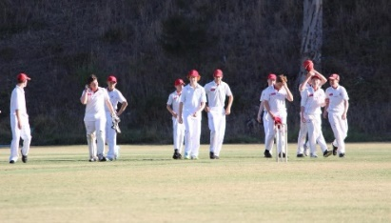

**BOYS AND GIRLS TEAMS**

**U10, U12 & U14**

**ALL ABILITIES FAMILY FRIENDLY INCLUSIVE CLUB**

**NO PREVIOUS CRICKET EXPERIENCE NEEDED**

We are looking for boys and girls to have fun, meet new friends playing cricket on Friday evenings or Saturday mornings. Girls only teams are also available and play Monday or Wednesday evenings.

All equipment is provided. No previous experience needed.

We look forward to seeing you and your family at shore Reserve for some fun, family friendly activities.

**CONTACT TRISTAN PAGLIANITI-ROBERTS ON 0407 256 614 OR**  **sign up via the link for** **junior cricket:** [https://www.playhq.com/cricket-australia/register/e18ed9](https://l.facebook.com/l.php?u=https%3A%2F%2Fwww.playhq.com%2Fcricket-australia%2Fregister%2Fe18ed9%3Ffbclid%3DIwAR2qDoaUTZzGnys18wUyKChJ5V7C4h0uL4uI5-Q22Sg5SDU_GBlkq5C6JvU&h=AT267x1oy5Tg3UylrTsQnzLAC6uC7skSekOZZq7GRCY3aH7efq-bxUj08QIPLkQXmChsrTDjZojvyk2M-bZv2L6LppE_zLWX43Ypp6-sEG561veRa51BNib6283WLIFILg&__tn__=-UK-R&c%5b0%5d=AT0ci-KQwDBllp4MlWcbBxn3-MkctzlG8kKoYuHdPlE9ZjyYYGnFna92D104qe1Hkucmmt0llhSO3ui0zwISujUEcigEi_jSx9ok37CL136l7nhjf888sKAT-WEz-4jyyMDOS4pneYVOmUabxaBdfhPlvCwgxW-QGaOL9BtYbeKoah8qyCj0SaALZODBjChkpVFuOHYNfzfysow5YQ)