
LEVEL NEWSLETTER - Grade 6
2026  Term One  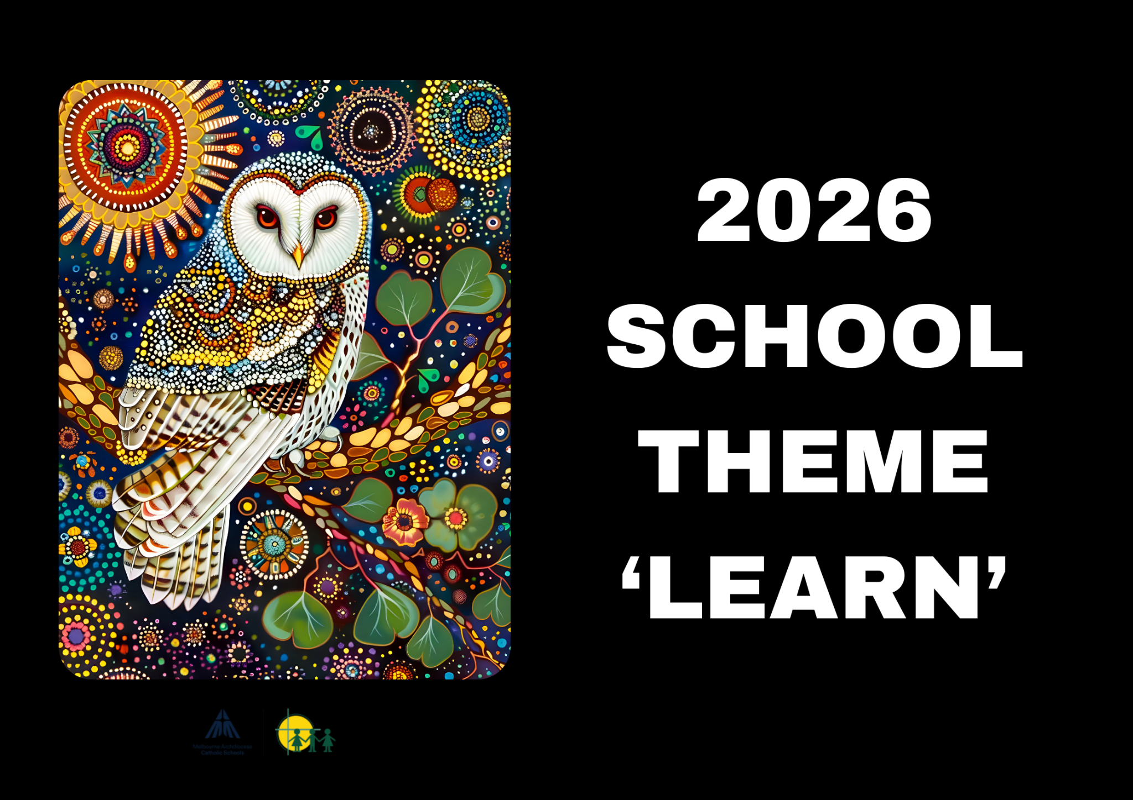 |  |   BIRTHDAYS  We wish the following students a happy birthday and hope they have a great day!  January - 1st Oscar, 5th Acacia, 20th Scarlett  February -  March - 6th Ella, 18th Dayshan  April - 1st Daniel Z, 1st Suzie, 16th Evie, 23rd Aslan, 30th Ruby
Staff Contact |  | Please remember to only email staff between the hours of 8am & 4pm (Mon-Fri)  Becc Lark (6L) - rlark@hfmw.catholic.edu.au  Juliette Hancke (6HB) - jfoenander@hfmw.catholic.edu.au
Specialist Classes | MONDAY
Specialist Classes | TUESDAY | 6L & 6HB STEM
Specialist Classes | WEDNESDAY | 6HB Please remember: wear sports uniform  6L Auslan  6HB PE
Specialist Classes | THURSDAY | 6L Please remember: wear sports uniform  6L PE, Performing Arts, Visual Art  6HB Performing Arts, Visual Art and Auslan
Specialist Classes | FRIDAY | Please remember: wear sports uniform  Year 6 Sport
RELIGION  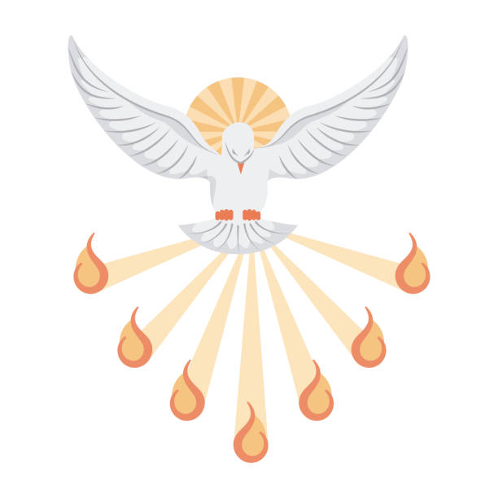 | TOPIC: Lent & Easter  During the second-half of term one the students will learn about Lent and Easter. Students will explore the concept that Easter is a time to celebrate hope in the risen Lord.  TOPIC: Confirmation  In term two many of our year 6 students will receive the sacrament of Confirmation. This is a very special and memorable moment in their Catholic journey as they are accepting the Holy Spirit into their lives to support their service to Jesus Christ.  During the second half of term one all students will be learning about the sacrament of Confirmation, its importance in the Catholic church and will complete a research project where they are required to put together a presentation on a chosen saint. For those students making their Confirmation this saint will be their chosen Confirmation name.
SPELLING    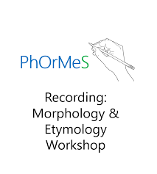 | We will be spelling using the PhOrMeS Word Reading and Spelling (as per last year). It is an evidence-informed, Foundation-Year 6 decoding and spelling curriculum, which can be taught at the whole classroom or intervention level. PhOrMeS stands for Phonology (sound), Orthography (spelling system), Morphology (internal structure of words), etymology (origin of words) and Semantics (meaning of words).  In Year 6, we are starting at:  Lesson 6 - Greek morpheme hydr, meaning ‘water’. For example, hydrologists (a person who studies the flow of water), is hydr (water) + /o/ (connecting vowel) + log (the study of) + ist (person) + /s/ (plural).  Lesson 7 - Latin base words spire, meaning ‘breathe’. For example, inspire, is in (in) + spire (breathe) = to breathe life into something.  Lesson 8 - Greek morpheme therm, meaning ‘heat’. For example, thermal, is therm (heat) + al (adjective).  Lesson 9 - Latin base words capt/ceit/ceive/cept/cip, meaning ‘take/catch/hold’. For example, capture is capt (catch/hold) + ure (noun) = a catch, but usually, to catch.  Lesson 10 - Greek morpheme astro/aster, meaning ‘star’. For example, astrology is astr (star) + /o/ (connecting vowel) + logy (the study of) = the study of stars.
LITERACY  (Reading/Writing)   | TOPICS: British Colonies, Consent & Autonomy, Immigration & International interactions.  Throughout these units the students will be using their literacy skills to analyse, debate and write responses to topics relating to the lesson’s subject matter. Students will be required to utilise their decoding skills, (such as their knowledge of morphemes and breaking words into syllables), as well as their literal and inferential comprehension to find answers to questions within texts.  Students will engage in regular revision of grammatical concepts, such as compound and complex sentences, coordinating and subordinating conjunctions, appositives, as well as correct structure of paragraphs using the SPO (Single Paragraph Outline).  Throughout these units students will be exposed to tier two vocabulary relating to the topic of that lesson. These words will support the student’s understanding of concepts and deepen their knowledge, whilst also encouraging them to explore richer and more varied vocabulary in their own writing.
MATHEMATICS  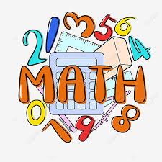 | This term, the areas of Maths we will learn about are:  - Data Representation  - Prime, Composite, Square and Triangular numbers  - The four operations (+, -, x, ÷)  - Area  - Time  Lessons will begin with a daily review of previously taught concepts before moving onto applying new content. Students will practice fast recall of numbers using all four operations. They will also be supported through extension opportunities.
KNOWLEDGE RICH UNIT   | British Colonies  We begin the term exploring British Colonies and Consent & Autonomy, then continue the Consent unit alongside Immigration & International interactions.  British Colonies The Big Idea: The colonisation of Australia changed the land and its people in many ways. By exploring the reasons for colonisation, the experiences of different groups, and key events like the gold rush and the Eureka Stockade, we can understand how colonial life shaped modern Australia’s identity, democracy, and society.  Consent & Autonomy: Students will:  - Describe strategies for seeking, giving, or denying consent and rehearse how to communicate their intentions effectively and respectfully across multiple settings (online and offline).  - Explain and apply strategies to demonstrate respect, empathy, and inclusion to positively influence relationships.  - Explain how communication skills, protective behaviours, and help-seeking strategies can help keep themselves and others safe online and offline.  - Analyse how various strategies influence the health, safety, relationships, and wellbeing of individuals and communities (aligned with VC2HP6P10 content description).  Immigration & International interactions:  The Big Idea: Australia is connected to the world through its geography, history, and people. By learning about different countries, migration, and the stories of individuals, we can understand how these connections have shaped Australia’s population, culture, and identity.
BEHAVIOUR CURRICULUM   | Routines  Lining up and sitting down after break times  Calm entrance/exit routine

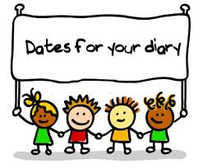 | Term One Important Dates (refer to our Google Calendar as well)  FEBRUARY  Wed 4 Prep Rest Day  Fri 6 Parent Welcome Event  Sun 8 Prep/New Family Welcome Mass (10am)  Mon 9 Children’s Mental Health Week (Wear an outfit that makes you feel confident and comfortable)  Tues 10 Safer Internet Day  P&F Meeting (6:30pm)  Meet the Teacher (Prep-Year 6)  Wed 11 Prep Rest Day  Meet the Teacher (Prep-Year 6)  Thur 12 District Swimming  Fri 13 Whole School Mass (9:15am)  FIRE Carrier Induction (10am)  Tues 17 Shrove Tuesday  Wed 18 Ash Wednesday (12pm Mass)  Prep Rest Day  Fri 20 Interschool Sport (1)  Mini Vinnies Soccer Event  Play Group commences (9:30am)  World Day of Social Justice  Wed 25 SAC Meeting (5:30pm)  Wed 25 Prep Rest Day  Fri 27 Interschool Sport (2)  MARCH  Wed 4 Prep Rest Day  Division Swimming  P&F Meeting (6:30pm)  Thur 5 Twilight Sports Day  Fri 6 School Closure Day (Vision for Engagement)  Sun 8 International Women’s Day (Give To Gain)  Mon 9 Labour Day Public Holiday (School Closed)  Wed 11 NAPLAN commences  Year 4 Reconciliation/Eucharist Info Night  Fri 13 Year 3-6 Athletic Trials  Sun 15 Catholic Education Week (Christ Beside Me-Walking in the Footsteps of St Patrick)  Tues 17 St Patrick’s Day  Wed 18 Open Day (all day) Everyone Welcome  Fri 20 Community Colour Run (Major Fundraiser)  Mass of St Patrick (St Patrick’s Cathedral)  Sat 21 Harmony Day  World Down Syndrome Day  Tues 24 Sacrament of Reconciliation (5pm)  Fri 27 Halogen Young Leaders Day  Summer Sport Gala Day (TBC)  Tues 31 EMR Swimming  APRIL  Thur 2 End of Term 1 (1pm finish)  Holy Thursday  Fri 3 Good Friday  Sun 5 Easter Sunday

