DROMANA COLLEGE
PRICE LIST VALID UNTIL 30TH JUNE 2019
*All prices GST inclusive and are subject to change without prior notice
Pullover |  | Sports Uniform
80 - 85 - 90 - 95 | $75.00
100 + | $80.50
Rain Jacket  All sizes  Spray Jacket with polar fleece lining  All sizes  Polo Shirt Short Sleeve – White, Everyday – with logo Sizes 10c-16c  Sizes S – 5XL | $30.95  $86.95  $26.50  $28.50 | Sport Polo – Navy – with logo  Sizes 10c-16c  Sizes S-5XL  Sports Shorts - with logo  All sizes  Rugby Jumper  All sizes | $27.00  $29.00  $31.00  $84.00
Polo Shirt Long Sleeve-White, Everyday – With logo  Sizes 10c – 16c  Sizes S – 5XL | $28.50  $30.50 | Sport socks 3 Pack  Accessories  School Bags (optional)  Airopak L | $15.95  $69.95
Shorts Tab/ Belt Loop- with logo  All sizes  Trousers – with logo  All sizes  Shirt Long & Short Sleeve - with logo All sizes | $46.95  $46.50  $31.00 | Tie(Optional)  Briefs – Navy  Bike Shorts – Navy from  Scarf- Navy  Beanie– Navy  Gloves - Navy  Baseball Cap –Navy  Slouch Hat – Navy | $20.00  $10.50  $15.50  $ 9.50  $ 9.50  $ 9.50  $10.50  $11.45
Summer Dress  All sizes  Summer Skirt  All sizes  Winter Skirt  All sizes  Slacks with Logo  All sizes | $67.50  $45.00  $67.50  $62.00 | Compression tights – Black and navy  Socks 3 Pack (black, white or navy)  All sizes  Knee Hi – Black, Navy or White  Tights - (Navy or Black)  Opaque (70 Denier) from | $115.00  $13.95  $ 5.50  $12.95
Opaque Shirt - Short Sleeve with Logo  Opaque Shirt - Long Sleeve with Logo | $33.00  $36.95 | Winter Cotton Tights  Tailor Alterations  Skirt Hem  Summer Dress Hem  Trouser Hems | $18.95  $23.00  $23.00  $17.50
 |  | Iron on Name Labels (50) | $23.00
DROMANA
College

Pricelist 2018/2019
On-Campus Uniform Shop

Dromana College Trading Hours
110 Harrisons Road Tuesday 8.30am – 12.00pm
(Enter via Old Whitehill Road) Thursday 12.00pm – 3.30pm
Dromana VIC3936
Campus Shop Phone: 5984 7143

On-Line Shop- https://www.noone.com.au/shop/at/dro/

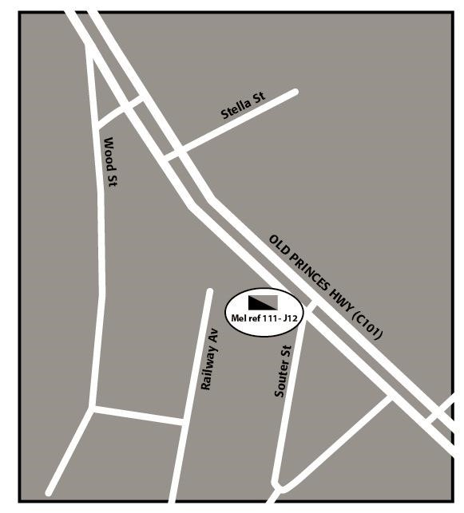
Dromana College Uniform is also available at Beaconsfield highest quality and performance standards are met in the
We work closely with Australian manufacturers to ensure the
manufacture of all our schoolwear garments.

CREDIT CARDS & EFTPOS

Visa & Mastercard accepted & in store eftpos facilities available.

TRADING HOURS : Monday – Friday 9am – 5.00pm Saturday 9am – 1.00pm
Shop 4 – Beaconsfield Hub
52-62 Old Princes Highway Beaconsfield 3807
Ph : 03 9769 9093 Fax : 03 9769 5345 beaconsfield@noone.com.au
* All prices GST inclusive and are subject to change without prior notice

