







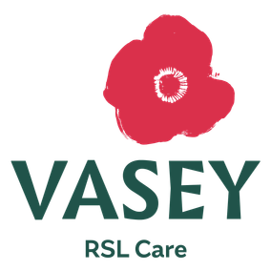

810 BONEO ROAD, BONEO
31
JULY
The Mornington Peninsula has the highest number of rough
sleepers in Victoria
20
26
SOUTHERN PENINSULA

SLEEPOUT
@

THE RANCH ADVENTURE PARK

Raising vital funds and awareness
SLEEP OUT . SPEAK UP . MAKE A DIFFERENCE

FIND OUT MORE

MAJOR SPONSORS

BRONZE SPONSORS

GOLD SPONSORS

