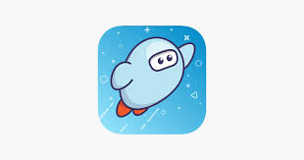

Getting started with Sora
With Sora, you can get free ebooks and audiobooks from your school.

Step 1 ______________________________________________________
Install the Sora app from the Apple App Store or Google Play Store, or go to soraapp.com.

Step 2______________________________________________________
In Sora, click on I have a setup code, then sign in.
Note: If you need your sign-in information (like an ID, username, or password), talk to a teacher.
The “setup” code is cenetau
Sign into your School – Select your school - ACEN

Step 3______________________________________________________
Browse the  tab and borrow a book. Your book will open so you can start reading right away.

Step 4______________________________________________________
Close the book and go to see all your books (including assignments). From there, you can:
- Select Open book or Open audiobook to read or listen to the book.
- Select Options to renew or return the book, see your notes and highlights, and more.
© 2020 OverDrive, Inc. All Rights Reserved.

