For 9life, Mr Yong our wonderful teacher got our media class a trip to the CITY!!! We were going to ACMI, a museum in the city. The plan was to have some free time then ACMI then more free time. How exciting. But we also had to work to do. Less exciting.

**THE ACMI EXPERIENCE**

A BLOG BY ALEISHA AND HSA HAY

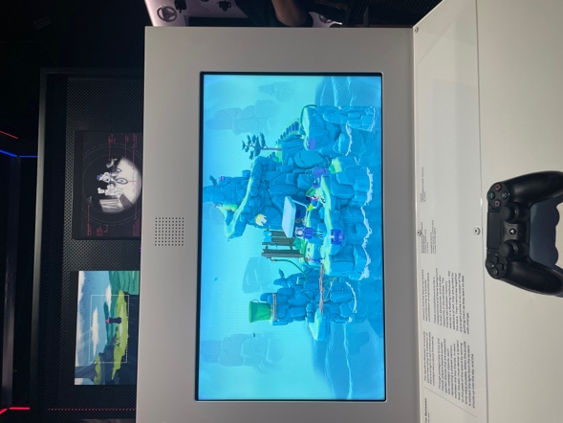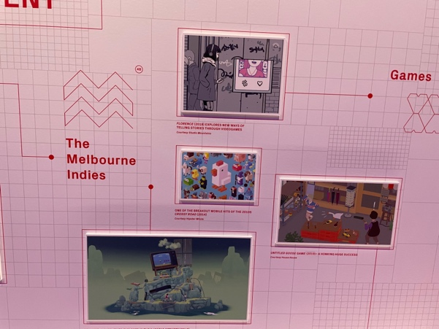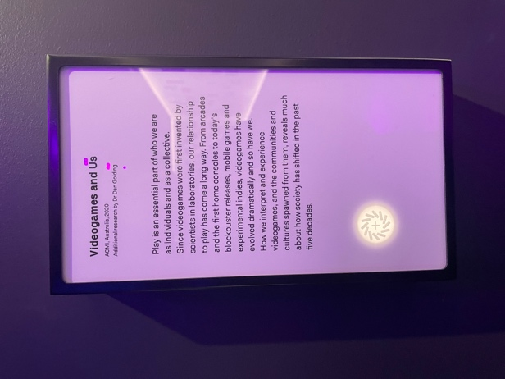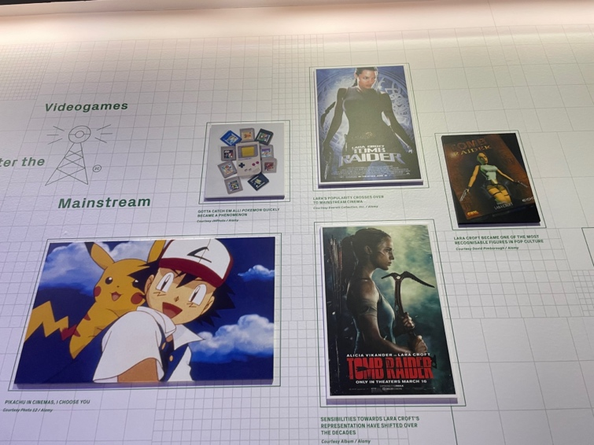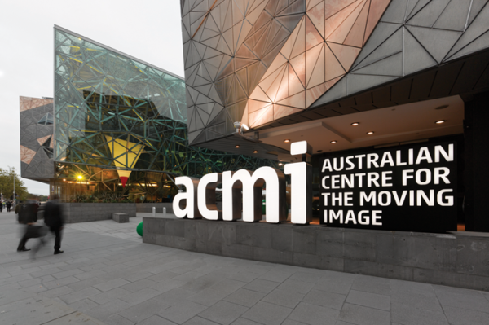

**VIDEOGAMES AND US**

In ACMI there was a lot of things to see, one of it was gaming. The gaming section was called Videogames and us, which made me feel included and loved. There was a board which had different videogames displayed with little information on them. I found this board very pleasing to look at and made my eyes very happy. There was an interactive playing area where little game stations were set up. There was a variety of games to choose from, I played this game, but I had no idea what was going on, the characters were just going back and forth. It was pretty though.

**BACKGROUND ON ACMI**

In case you haven’t heard of ACMI before here’s what you need to know: founded in 2002, ACMI – the Australian Centre of the Moving Image – is Melbourne’s very own institution celebrating film, television, and gaming. It is often known to have interactive exhibits and events such as screenings and all things related to the screen. The self-described “museum of screen culture” is located at Federation Square, Flinders Street, Melbourne.

**ARRIVAL OF TV**

Throughout ACMI there were many eye-catching exhibits but one of my personal favourites was the “Arrival of TV” exhibit. Located reasonably close to the entrance, the “Arrival of TV” exhibit consisted of a handful of different TV types from all different time eras. Starting from the early 1900s up to the 2000s, each TV model had a living room set up inside of it consistent to the time period with the TV itself inside with the shows of the time. The exhibit contained a large amount of detail and was quite aesthetically pleasing just to look at. In front of the TV’s was a screen where you could interact and find out the information about each different model. The exhibit was amazingly detailed and informative while still being entertaining. It was greatly pleasurable to see the mini living rooms set up and a demonstration with each mini *working* TV playing clips of the iconic shows that graced Aussie screens at that time. The exhibit was a story of the evolution of TV in our lives and screens and was just one of the many amazing exhibits we saw that day.

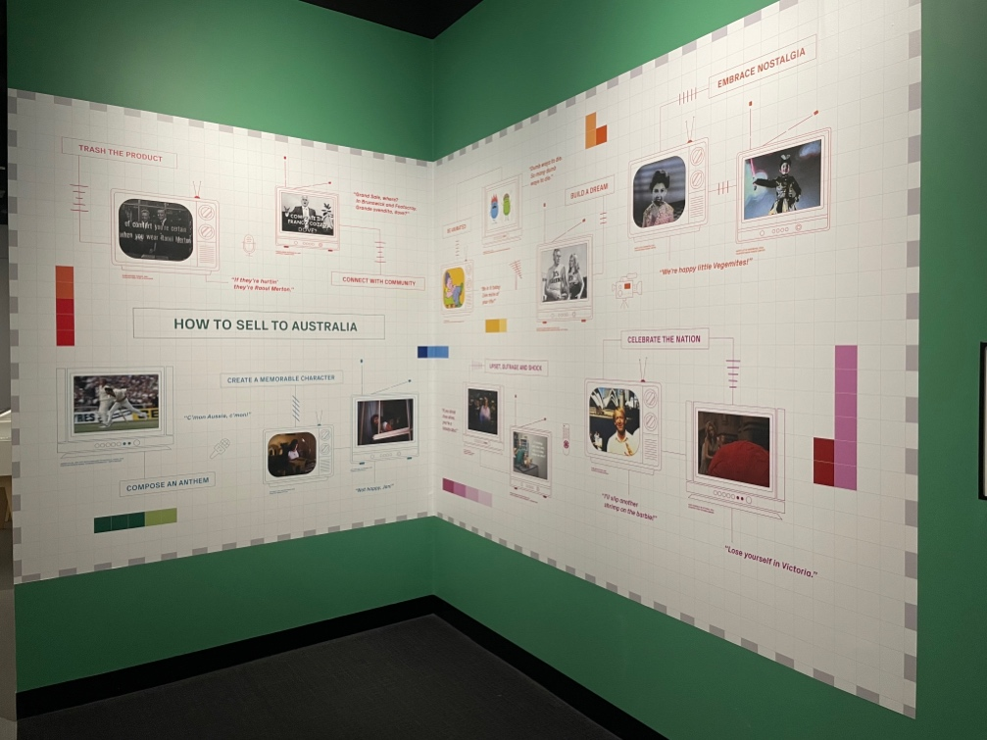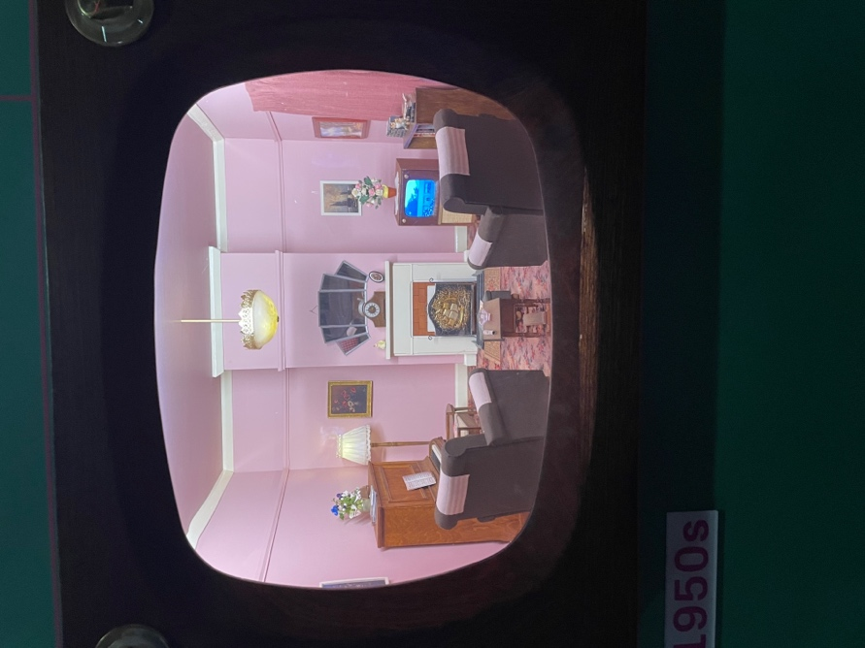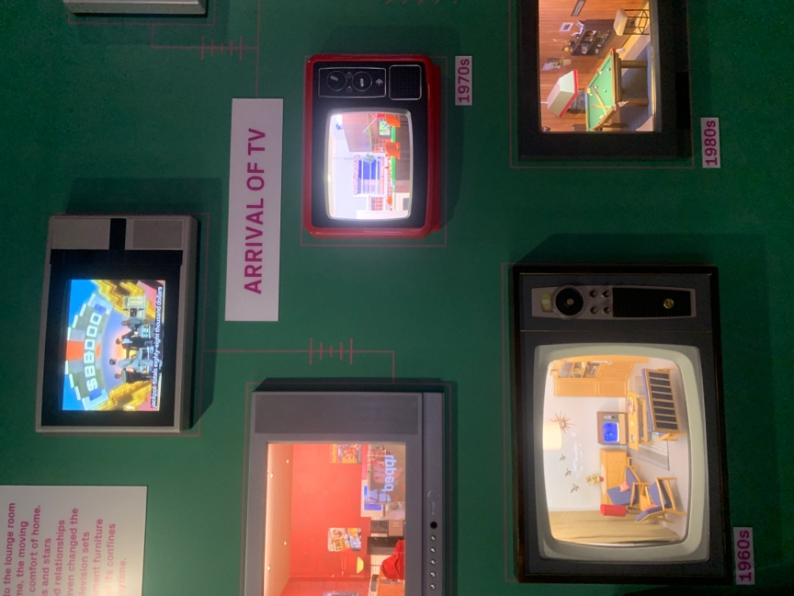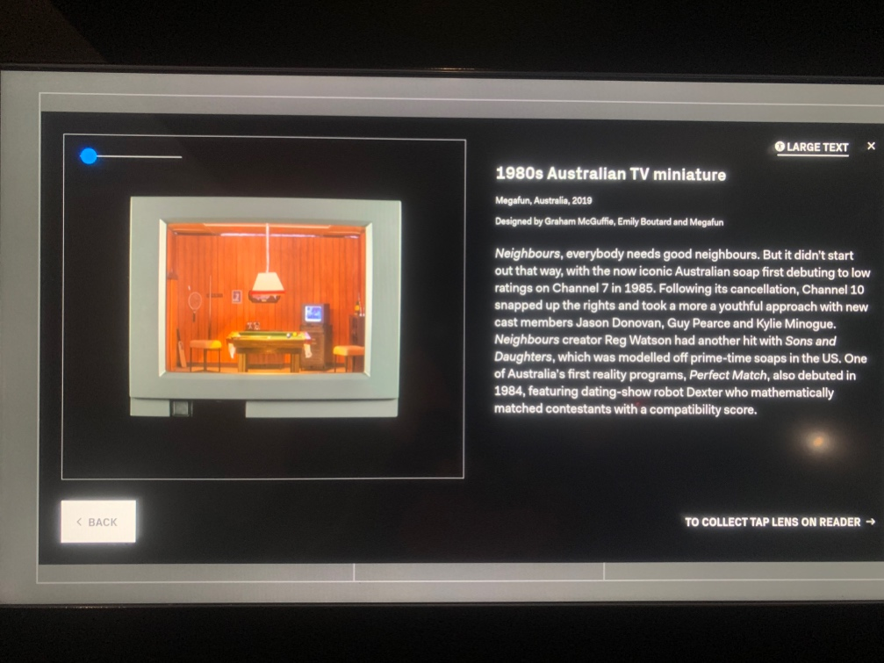

**PRODUCTION DESIGN**

The best part of ACMI for me was the production design section. Many production plannings were spread out on the walls and in glass boxes. There were rough sketches on the wall hung up along with the final product, sketch books with drawings were displayed in glass boxes. Something about those rough sketches of the production just did it for me. It was pretty but made me a little insecure cause I could never. The drawings were just to appealing, it wasn’t too detailed, kind of abstract. Everything was just so entertaining to look at and admire. Along with the sketches there were these props that were used in glass boxes. It was ok but not as cool as the sketches.

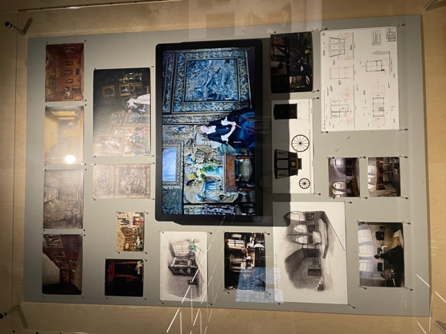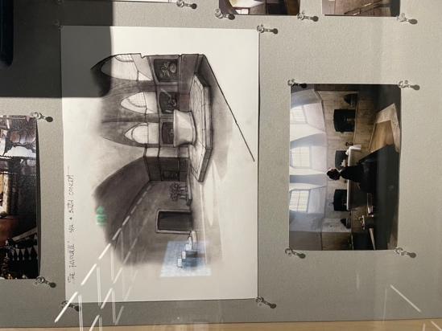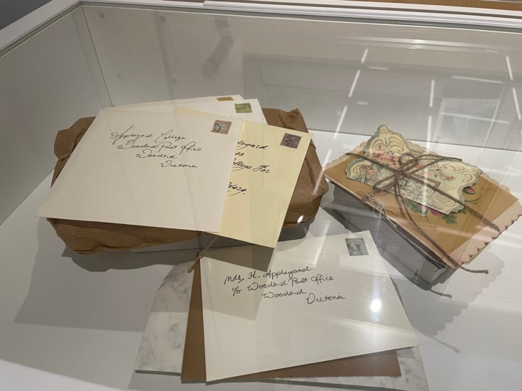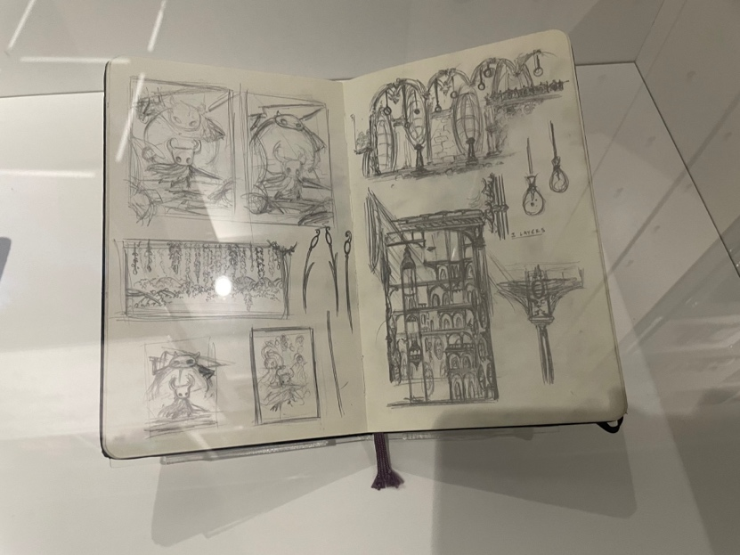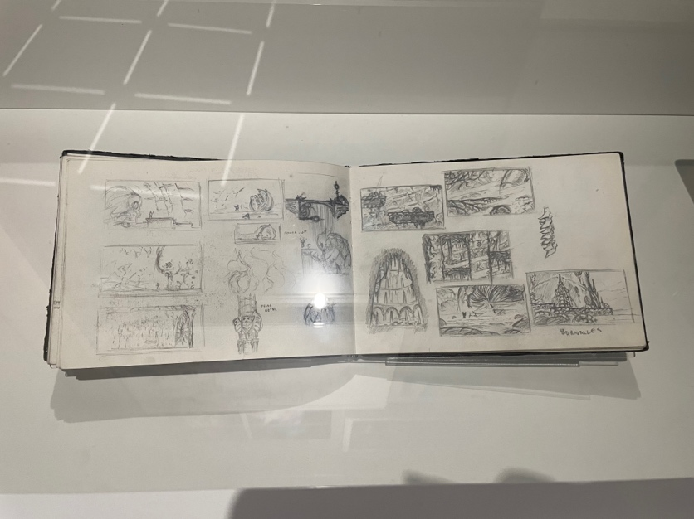

**STORYBOARDING**

As a part of the pre-production design, as you’ll learn storyboarding is a very important part of creating anything of the screen. For me, the storyboarding exhibit was extremely interesting. Having taken year 9 media, my experiences with storyboarding were mostly negative – it was time consuming, hard and seemed mostly unnecessary, but this exhibit did give another perspective. Part of the exhibit was the storyboarding in the making of Witch Beam’s *Unpacking,* the half block placing, half house decorating video game. It showed many of the designs that led up to the ones *Unpacking* fans know and love in the game. Another interesting part of storyboarding was the many storyboard images for popular animated films and TV series like *Shrek I* and *Penguins of Madagascar.* It was really funny to see the initial designs of characters like Lord Farquaad and Shrek and highly interesting to see how detailed the artists of these boards are.

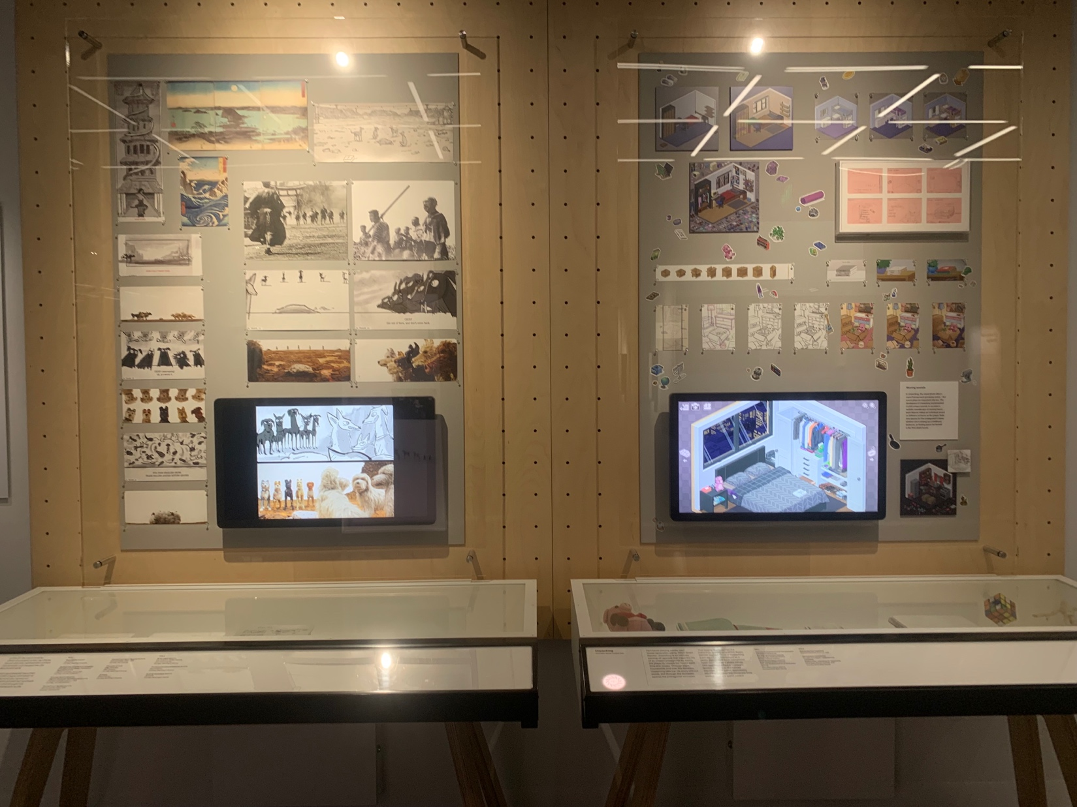

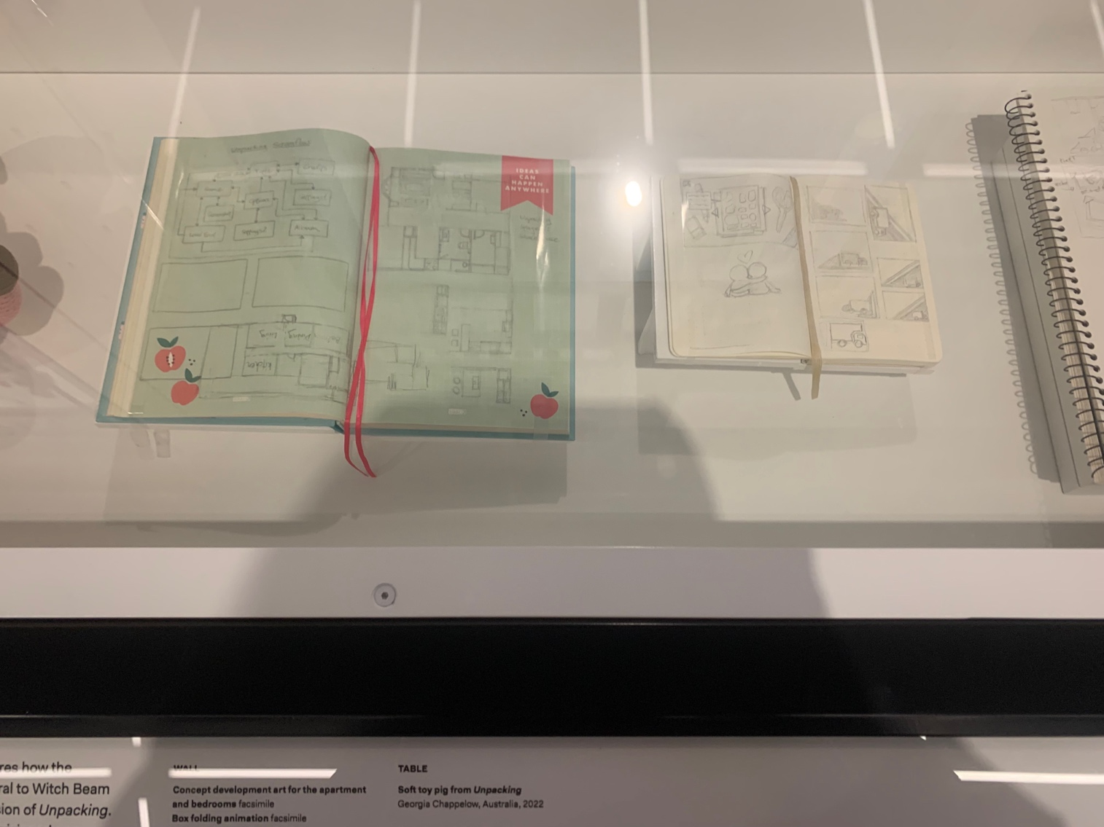

**MOVING AUSTRALIA**

One thing Has Hay and I can both agree on is our love for the Moving Australia exhibit. While throughout the day we both found our favourites exhibits, we had a lot of fun here. The exhibit was one of the bigger ones, it included various screens with interview from Australian producer and actors, such as people like Eric Bana, Gillian Armstrong, Bob Connolly and many more. There was also a screen playing iconic Australian music videos, an insight into Australian movies such as *Puberty Blues* and *The Dry*. There were boards of information set up telling the story of Indigenous broad casting and plenty of engaging and interactive exhibits. Has Hay and I both loved the music part, there were great Australian songs and artists playing, such as Kylie Minogue and Icehouse. And just to clarify, all the exhibits with sound had headphones you could put on to actually hear. There was a really cool car in the middle of the exhibit and many other interesting sights around it.

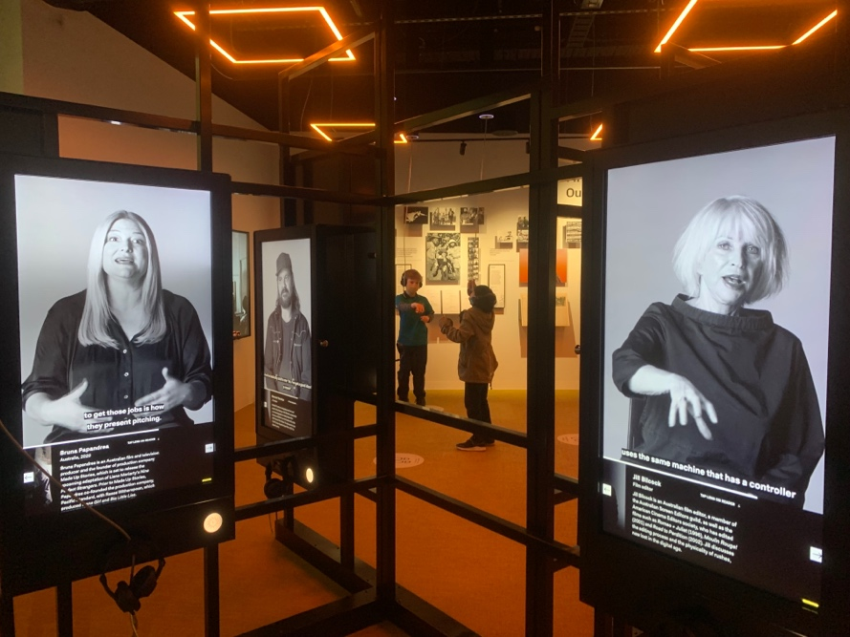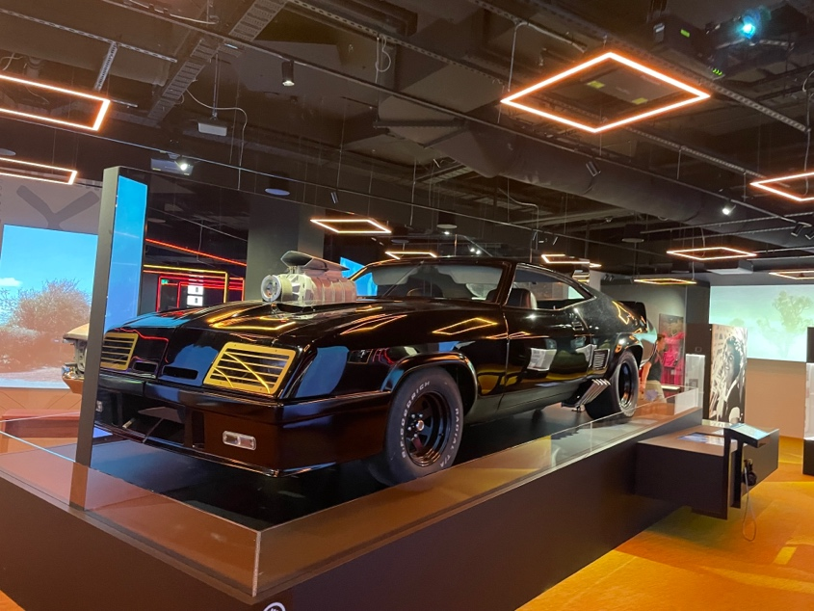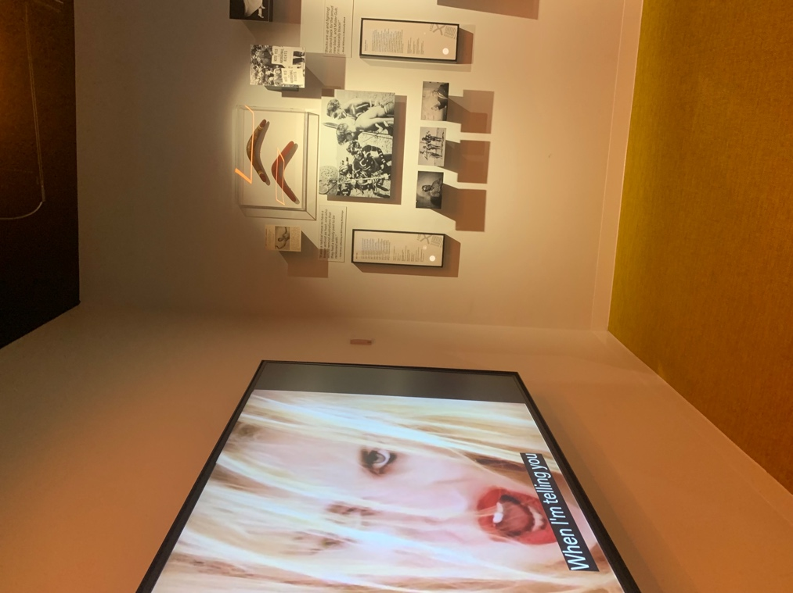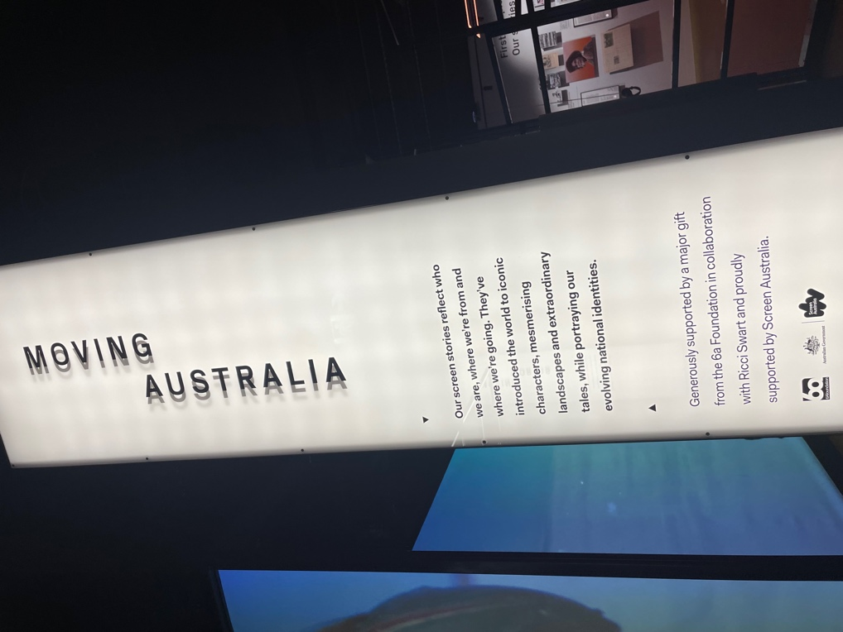

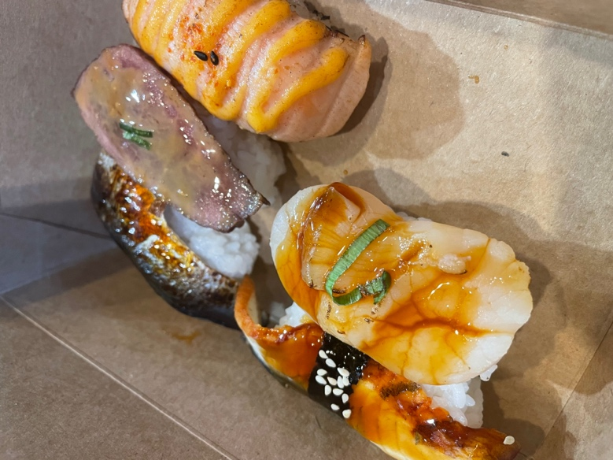

**SUSHI REVIEW**

After we had arrived in the city, smart Aleisha and I decided to go get some food cause we thought that we might not have time in the end, and we were right. So, we wandered around and barely anything was open, I walked by this focaccia, and it looked so delicious, but I don’t know why I didn’t get it now I regret it. Anyways we got sushi from this store in the food court called Tako Nori. We tried 5 new variations of sushi. Well, I tried all 5 Aleisha only had 2. The first we tried was a sardine one. The sardine had a strong fishy taste which I didn’t really like cause I’m not a big fan of foods that taste fishy. The next that I tried by myself was the wagyu. The meat was hard to chew and was rare, but it had a sort of beefy taste which I liked and was easy to swallow. Next, we shared the spicy salmon, and it was our favourite. The salmon was smoky and soft to chew, the hint of spice added to the experience. I then tried scallop which was accompanied with a sweet sauce on top and it tasted fresh because of its rawness. The last that we tried was unagi which is eel, I actually kind of like it I can’t really figure it out. It was chewy and had a sweet sauce and the skin was spongey. Overall, I quite enjoyed it, but I think it was too early for me to realise what I was doing.

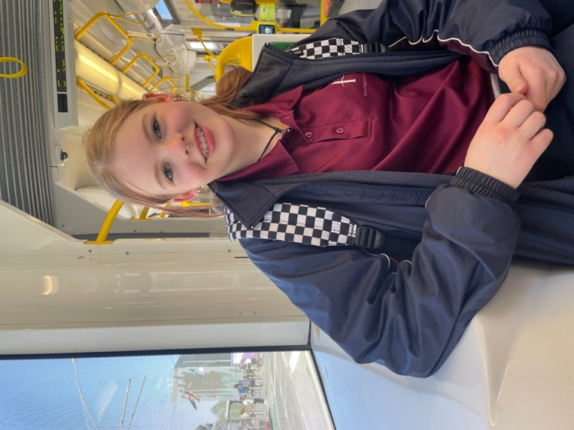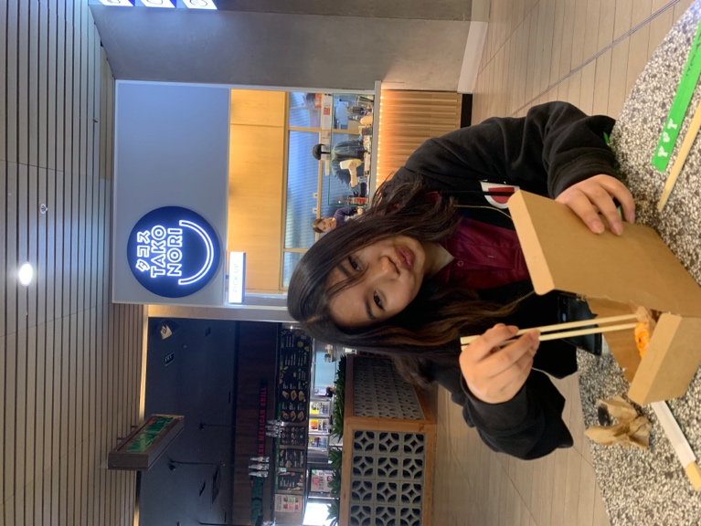

**CITY AND ACMI TRIP OVERVIEW**

Thanks to Melbourne’s public transport system, getting to the city, and ultimately ACMI, is quite easy. The media/journalism 9Life class caught the train and the journey in was pretty effortless. For once in one of these excursions the train wasn’t overly packed, and Hsa Hay and I got to sit down for majority of the ride. Once we got to the city we had time to spare before heading to ACMI so we headed to Melbourne Central. We got there around 10 and there was barely anyone there. While this might sound good it turns out they were the smart ones as it seems everything opens later there. Aside from that, we got some food and some Starbucks (after joining an incredibly long line) and explored the city a bit before heading to ACMI. ACMI was a pleasant experience, it wasn’t overly crowded which made the exhibits easy to access. The only down side was the ridiculously expensive gift shop, trust us, unless you have lots of money to spare, this isn’t the souvenir shop for you.

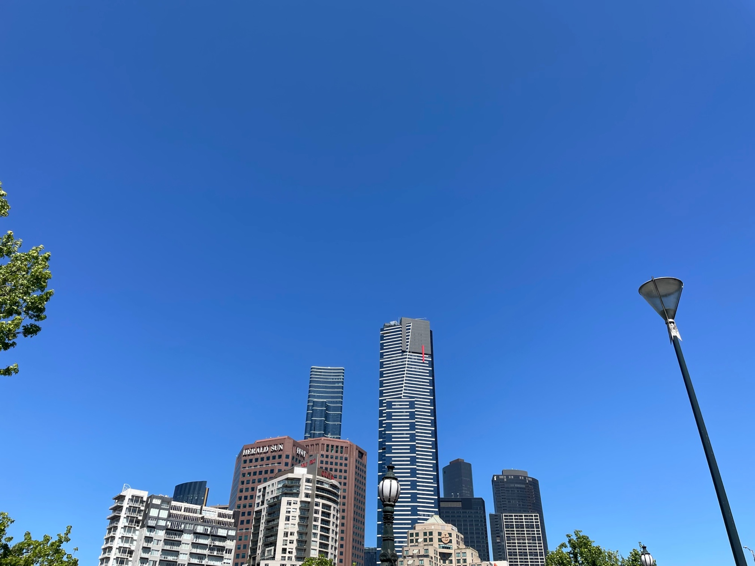

In conclusion we had a pretty chill day. There wasn’t really any rushing around which made being in the city with school stress-free. The food was good, it wasn’t revolutionary as Hsa Hay says, but it was still enjoyable. ACMI was an exciting experience, but there was a lot of things going on throughout the museum which at times made the experience overwhelming and confusing to navigate. There was just a lot to explore and not a lot of time to explore it. Overall, though, we did have a good experience. We saw a lot of interesting things and learnt a lot while also managing to have fun exploring the city together when we weren’t at ACMI.

