Option 1
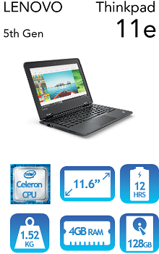
11.6" Netbook designed with robustness in mind for education use.
Lenovo 11e Netbook 5th Gen - 11.6"
$656.00 Inc GST
Purchasing will be done directly through an online website / portal set up by LWT for our school:
www.orderportal.com.au/OrderForm/OrderForm?orderformid=208&EID=317
Option 2 - ipad
128 GB
Wifi (not cellular)
You can purchase this item by going to the below web address or simply purchase from a local store e.g. JB HiFi. Ensure that you ask for the education price.
https://www.apple.com/au-hed/shop
Extra Information
Netbooks
Netbooks that are purchased are sent to the school, imaged and then handed to students.
ipads
ipads ordered online are sent to the child’s home address. At the start of the year children bring their ipads to school and they are put on the school’s wifi. Children will be given a list of free apps to upload on their device through their apple store. Any apps purchased by the school will be put on the devices at school.
Of course ipads can also be purchased from local stores.
All ipads should have a cover. There are numerous options available online and in stores.

