

**01/11/2024**

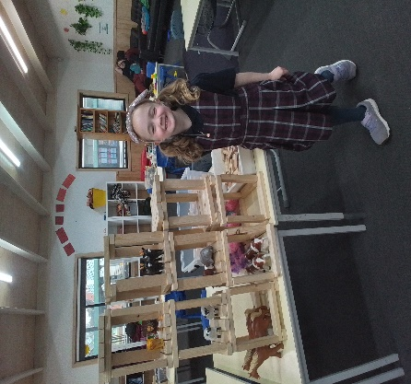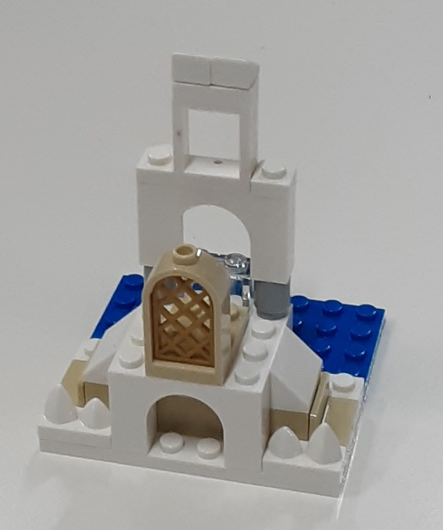[](https://pp.campaustralia.com.au/)

Families the Big Art Competition, for all children to participate showing the amazing talent we have at Oatlands Primary School. We also have Remembrance Day with craft and activities to complete and take part, so we remember.

We also have World Hello Day on the 21st November, Children create a poster in many languages in our OSHC group.

Crossing People join us in the afternoon to say thank you for teaching us good road sense and safety guidelines .

* Remembrance Day Poppies
* Acrostic Poem
* Big Art Creations

**Activities coming up**

Join in the fun of Outside School Hours Care activities and experiences with Your OSHC and Rocketeers.

**Make a booking**

Book now

**Oatlands Primary School OSHC**