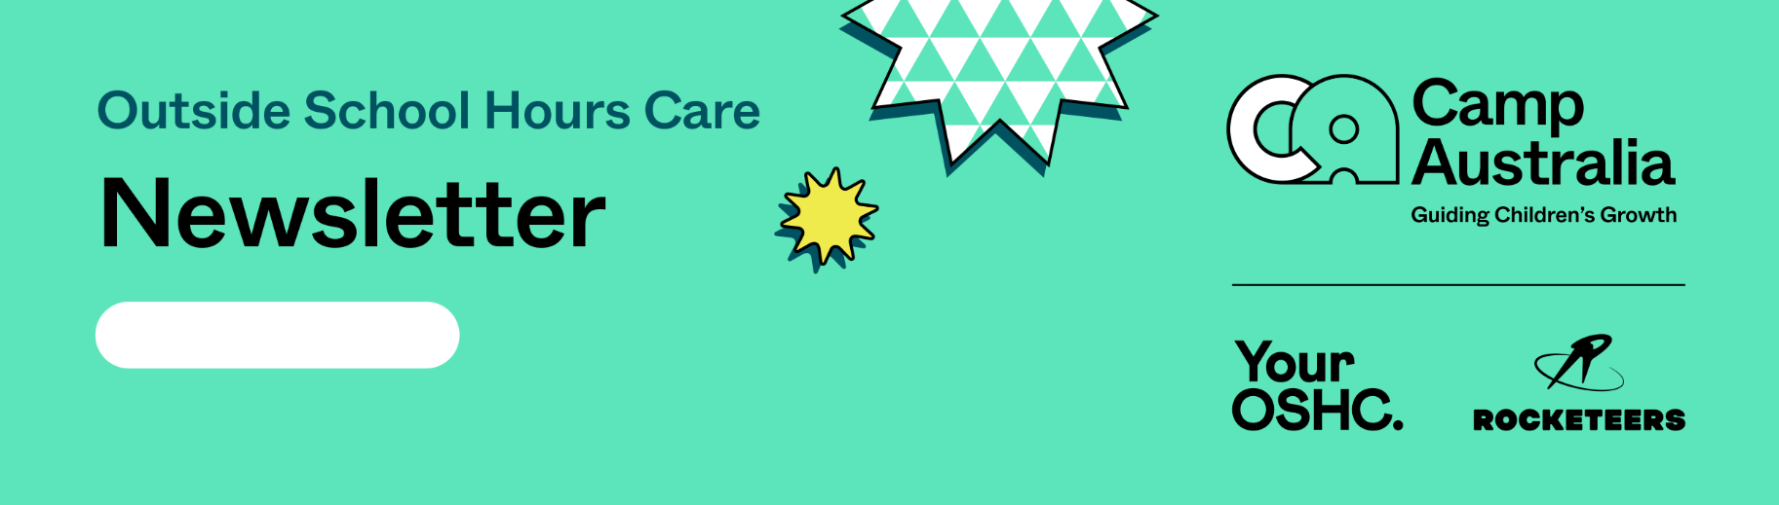

**8/5/2023**

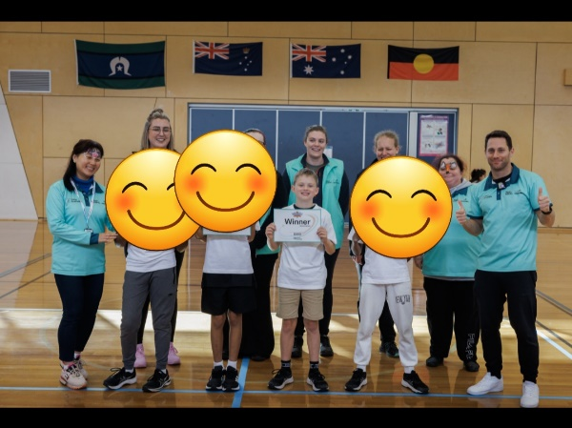](https://pp.campaustralia.com.au/)[](https://apps.apple.com/app/apple-store/id1529575453?pt=120333103&ct=edmbookings&mt=8)[](https://play.google.com/store/apps/details?id=au.com.campaustralia.parent)

**A message from your Coordinator**

Hello to all Rollins Primary school families. I would like to introduce myself as the new coordinator at our camp Australia service. My names Tessa but I prefer Tess. I am excited to get to know the children and you all.

I would like to just acknowledge and congratulate Noah who attends our before and after school care program who came first in our centre’s hand ball coemption and went on and competed in our Regional Championships on Sunday morning at Carinlea Park PS and did an amazing job at coming in at 2nd place after some epic and intense battles with children from other schools around the VIC West. His mother and brother were incredibly proud of him and he was an exemplary competitor on the day, very humble in his manner and a great sportsperson to the other children.

I am very proud of Noah and his achievements.

As I am new to the service I will be still asking the parents i

**Rollins Primary School**

Join in the fun of Outside School Hours Care activities and experiences with Your OSHC and Rocketeers.

**Make a booking**

Book now

* Big arts week in June.
* Mindfulness colourings.
* About me portfolios.

**Activities coming up**