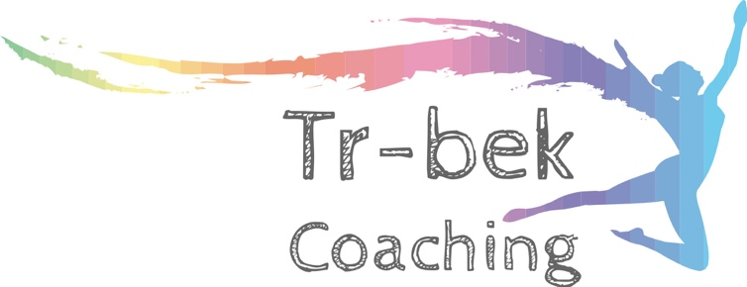

**Do you enjoy Swimming, cycling, running or all 3?**



Troy Watts   
Sports Coach  
Tr-bek Coaching  
0448 823 588

***Have you ever thought about giving triathlon a go?***

***Tr-bek Coaching in conjunction with Triathlon Victoria are putting together a FREE 6-week training program that includes a mini triathlon race and a BBQ.***

The Mini Triathlon will take place on Sunday the 24th of March and is partnered with the Shepparton Tri Club’s Summer Series Racing Program.

Race consists of a 300m swim, 9km ride, 1.8km run

Trainings will be on a Thursday night from 4.30 – 5.30pm, Shepparton Tri Club, Victoria Park Lake, Tom Collins Drive.

If you are interested in the program please email [trbek.coaching@gmail.com](mailto:trbek.coaching@gmail.com) by Wednesday 21st February

TRI2gether is a school-based program that gives secondary school students aged 13 to 17 years the opportunity to get active by participating in swim, bike, run and triathlon. The 6-week program aims to create an accessible, fun and socially inclusive environment in the spirit of *'finish line, not finish time'.* The end goal of students is competing in a mini ‘fun’ triathlon as an individual or in a team (2 or 3 students).