Registering for the Premier’s Reading challenge.
- Once you have navigated to the sign in page you have the choice to sign up at the very bottom or to use a previous sign up with an email address and password.
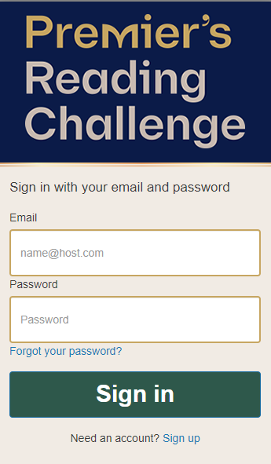
- The sign up screen will ask you to enter the student’s email,( their school email) their first and last name, and a password.
- I have asked students to create a password in the following way: to use their first name with a capital letter followed by@gsg24. So; in my case my password would be Elinor@gsg24.
- They will then receive a code via their email to verify the account they are setting up.
- Once they have entered the code from the email there is a quick series of steps to follow registration. Students can come to the library and we will help them through this process.
