
Honey Joys

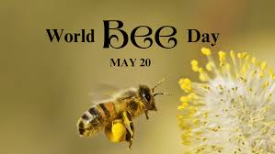

By: Tiffany McCauley

Equipment | Ingredients:
  - Cupcake papers
  - Pot
  - Wooden spoon
  - Metal spoon
  - Muffin tin
  - Measuring cups and spoons
  - 2 tbsp. coconut oil
  - ¼ cup brown rice syrup
  - 1 tbsp. honey
  - 3 cups corn flakes (clean, organic, no sugar added)

What to do
1. Heat oven to 150 degrees C.

2. Line a muffin tin with cupcake papers.

3. In a pot, over medium heat, melt the brown rice syrup, honey and coconut oil. Stir constantly while melting.

4. When completely melted, gently stir in the corn flakes and continue to stir until all the flakes are well coated with the honey mixture.

5. Working quickly, scoop the corn flakes into the cupcake papers.

6. Bake for 10 minutes.

7. Allow to cool completely and serve.

