October 2023 Vacation Care
Phone: 8277 4486 Mobile: 0428 257 789
Email: robyn.shanahan17@schools.sa.edu.au
Week 1
Monday 2/10/2023 | Tuesday 3/10/2023 | Wednesday 4/10/2023 | Thursday 5/10/2023 | Friday 6/10/2023
 | Centre-Based  CRAZY HAIR  & NAIL DAY  + Make your own lip gloss and bath crystals | Centre-Based  *Come dressed up as your favourite super hero  *Play super hero games  *Prizes for best dressed | Incursion  Painting around with Chandra  +  Minecraft activities  and games | Centre-Based  Marion  Mastermind
 | MENU: Rainbow cupcakes | MENU: Hedgehog slice | MENU: Creeper pizza | MENU: Spring rolls
Week 2
Monday 9/10/2023 | Tuesday 10/10/2023 | Wednesday 11/10/2023 | Thursday 12/10/2023 | Friday 13/10/2023
Centre-Based | Centre-Based | Excursion | Incursion | Centre-Based
MARION OSHC  HAS TALENT  ⭐Sing ⭐Jokes  ⭐Dance ⭐Magic | Science Experiments  *Erupting volcano  *Elephant toothpaste  *Flying teabags | Hazelwood Park Playground +  BBQ lunch  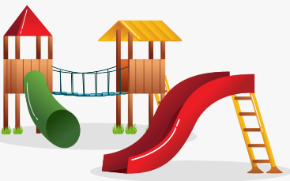  Depart 9.30 am, Return 2.00 pm | Reptiles and Marsupials  11.00 am – 12.00 pm  + Baking sausage rolls | Bring your bike/scooter and protective gear  +  Make a Japanese fan
MENU: Golden oat slice | MENU: Monster eye donuts | MENU: Jelly | MENU: Sausage rolls | MENU: Mini hotdogs

