
Learning Enrichment Activities
Term 1, 2019

Middle
30th January, 2019
Dear Parent/s,

Each term teachers plan, activities that enrich the learning experience for students. These activities incur a cost. Apart from extra-curricular activities such as Camps and Swimming it is expected that these will be the only curriculum costs for families this term.
Your child will be participating in:

- Production in Term 3-20th September

Please find below the Term One payment slip for enrichment activities for your child’s class.

As we are now using the Parent Portal on Sentral, permission is to be given via the portal from the Home Page. You will see:

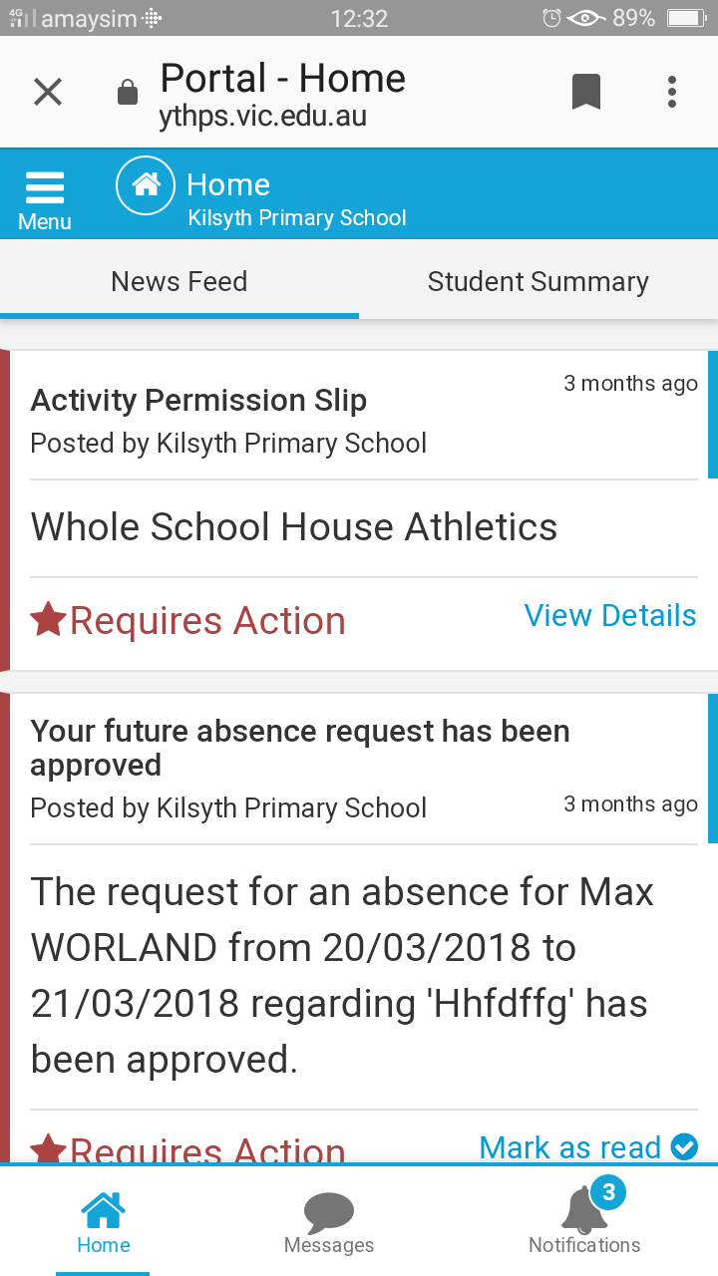
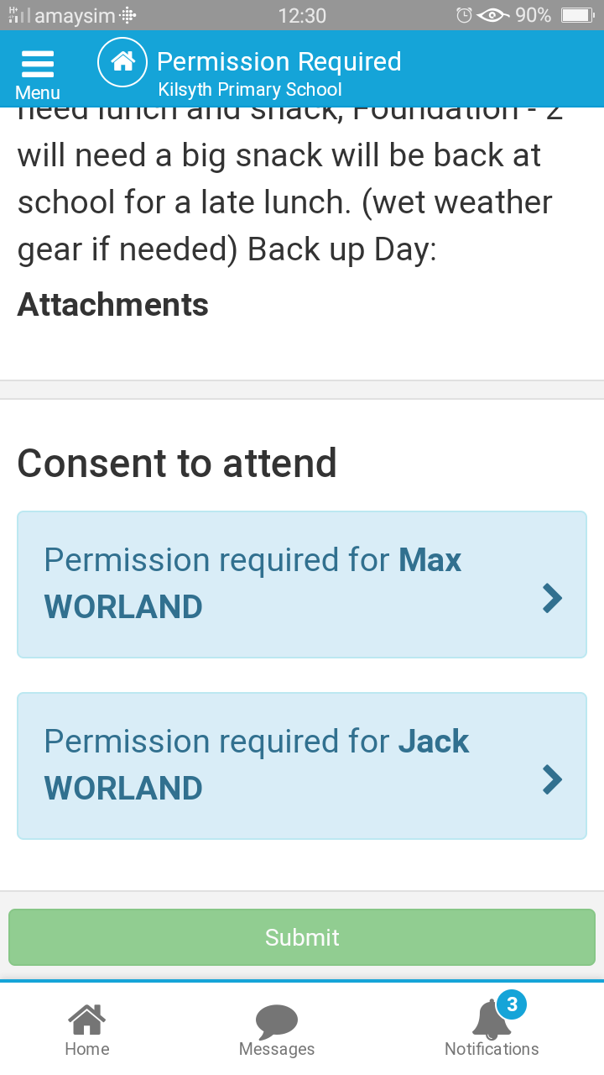

Click on

Thank you for your cooperation.
Daniel Gooding
……………………………………………………………………………………………………………………………
Middle Learning Enrichment Activities, Term One

Students Name: ____________________ Class: ____________________

Families eligible for the State Government payment through the Camps, Sports & Excursion Fund may choose to allocate a portion of their funds toward payment for these activities.

PERMISSION VIA SENTRAL AND PAYMENT FOR THESE ACTIVITIES ARE DUE BY FRIDAY 8th February 2019.
Unfortunately students will not be able to participate in these activities if payment is not made.

Cash  Cheque  Eftpos  Direct Deposit  Receipt Number:__________
Direct Deposit Details
Kilsyth Primary School
BSB: 313 140 Account #: 23183981
Ref: (Child Surname, First name) MidT1 Levy

Production (1st of 2 instalments) $10.00

TOTAL $10.00

