MOZART

Name: Wolfgang Amadeus Mozart

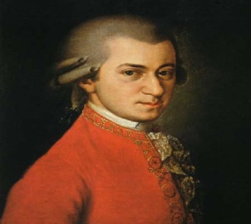
This Photo by Unknown Author is licensed under CC BY

Born: 27 January 1756
Died: 5 December 1791 (35 years old)
Country: Austria

Interesting facts:

He was one of the greatest composers of classical music ever.

He wrote over 600 pieces of music.

He was composing music when he was only 5 years old.

He was playing music for kings and queens and princesses and royalty all over Europe from age of 6.

He could listen to music just once and then go and write it without any mistakes.

One of his famous music is symphony number 40 and I listened to it and it is fast and slow. I liked it.

By Paul R

