Grease Souvenir T-shirts- $25
Sizes available:
Childs 6, 8, 10, 12, 14
Ladies 8, 10, 12, 14, 16, 18, 20
Mens S, M, L, XL, 2XL, 3XL, 4XL, 5XL
If you would like to purchase a souvenir T-shirt, please complete the order and payment details below and return to the General Office by Friday, 16th June (Report Writing Day).
(No second runs possible so if you miss this cut off date that is it)

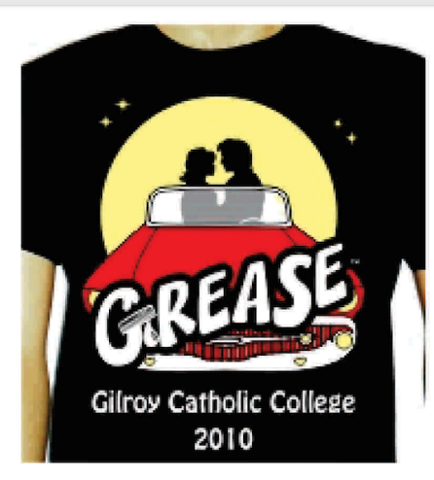
……………………………………………………………………………………………………………………………………………………………
NAME & FORM  (please print) | QUANTITY | SIZE | TOTAL

Melbourne Girls’ College
Yarra Boulevard, Richmond VIC 3121 Telephone: 9428 8955
STUDENT’S NAME: …………………………………………………………………………………………………….
PAYMENT FOR:
AMOUNT:
$

CARD DETAIL: Name…………………………………………… CCV:………. |  |  |  |  |  |  |  |  |  |  |  |  |  | Expiry Date: ……………..

