
TERM 2 CURRICULUM DAY BOOKING FORM
ZONE BOWLING
FRIDAY 20th JUNE 2025
7am – 6pm Bus Departing 9am
Friday 20th June – Cost $104 per child

Join us for a day of bowling and laser tag, where kids can team up, show off their skills, and enjoy friendly competition in a safe, supervised environment. From scoring strikes on the bowling lanes to dodging lasers in a thrilling arena, this adventure is perfect for all energy levels. It’s the ultimate mix of fun, teamwork, and unforgettable memories!

No Food provided today. Please provide Breakfast, Lunch and morning and afternoon snacks.

BOOKING PERIOD INFORMATION
Families with a Permanent Friday BSC/ASC booking | Community Families
Monday 2nd June 2025 | Friday 6th June 2025

Numbers are limited due to staffing capacity please book early to ensure your place.

Children must be enrolled with OSHC before making a Curriculum Day booking.

TERM 2 CURRICULUM DAY NOTICE

Child’s Name | Friday 20th June 2025  $104 per child | Total Cost

Contact Phone Numbers on the Day

Name: ______________________________________ Phone: ___________________

Name: ______________________________________ Phone: ___________________

Signature of Parent: _________________________________ Date: __________________
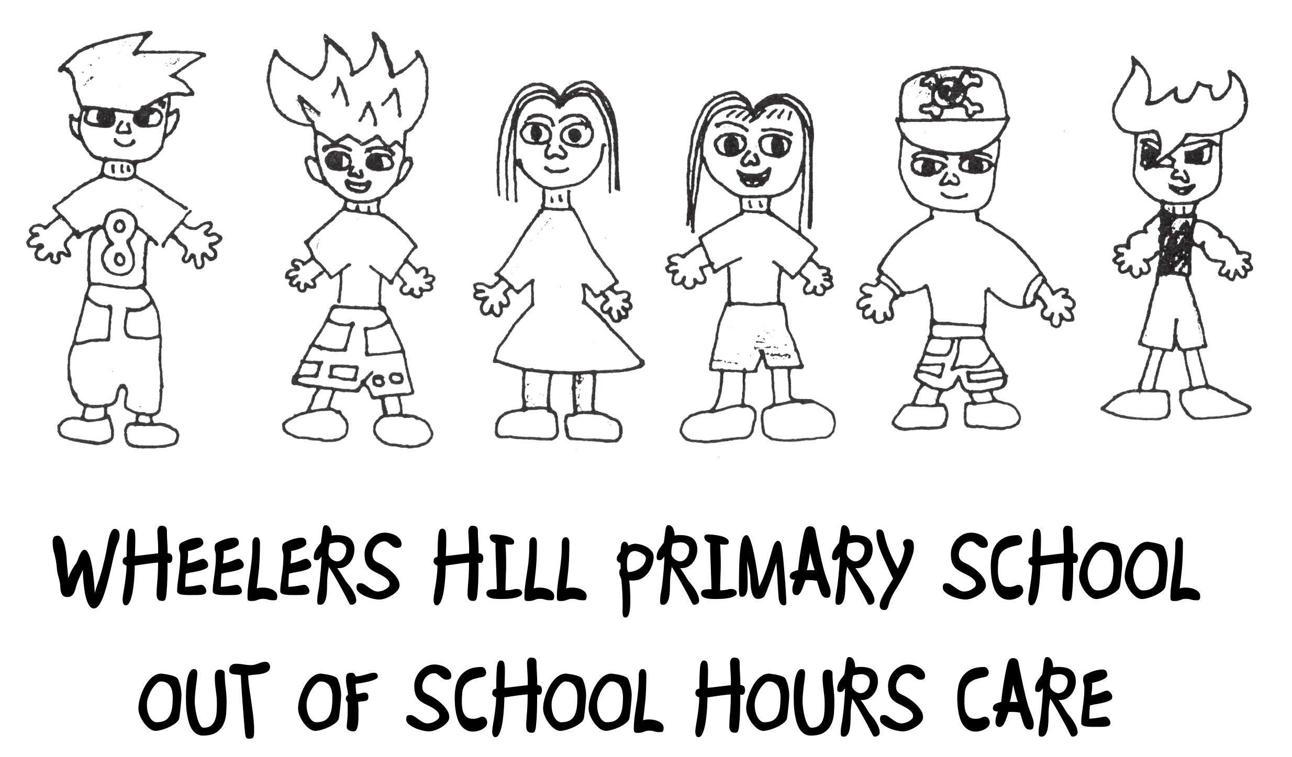

EXCURSION PERMISSION SLIP MUST BE RETURNED WITH BOOKING FOR CHILDREN TO ATTEND
All children require this form to attend any excursions and leave the premises to comply with legally binding regulations.

DATE VENUE & ADDRESS TIMES STAFF/CHILD RATIO

20th June Zone Bowling 9am – 1pm 1/8
1866 Princes Hwy Service Rd, Clayton VIC 3168

TRAVELLING BY SEAT BELTED BUS.

# Risk Assessments are available on request

I (the undersigned parent/guardian of the below named child/ren) agree to allow the below named child/ren to participate in the WHPS Curriculum Day Program & authorise the staff to take the above named child/ren on excursions. I agree to indemnify & keep indemnified & to hold Wheelers Hill Primary School, it’s employees from & against all actions, costs, claims, whatsoever which the above named child/ren & I may have against them or any of them arising out of or in relation to the Curriculum Day Program, other than where negligence attaches to them.

In the event of illness or injury to my child whilst attending the Curriculum Day Program; I authorise the Co-ordinator to consent, where the Co-ordinator is unable to contact me; to my child seeking such medical treatment as may be deemed necessary by a medical practitioner.

CHILD’S NAME ________________________________________________

DATE ______________

PARENT’S NAME _______________________________________

PARENT’S SIGNATURE ______________________________________

##PLEASE NOTE DUE TO TIME RESTRAINTS IF YOU HAVENT ARRIVED BY THE ABOVE TIMES THE SERVICE WILL ASSUME YOUR NON ATTENDANCE AND THE EXCURSION WILL LEAVE ON TIME. THANKYOU FOR YOUR UNDERSTANDING

