

**Term 1 Primary Road Safety 2025 Newsletter**

**Welcome back to 2025. Please share this Newsletter with all your schools.**

What is included in the newsletter this term?

* CSNSW PDHPE/Road Safety Symposium 2025 - Save the Date
* Transport NSW Road Safety Events Schedule 2025
* How to use Safety Town instructional video
* How to order FREE road Safety Resources
* Important information on e-bikes and e-scooters
* Promoting road safety in your school community
* Why should children learn about road safety?
* Key Road safety messages

|  |
| --- |

### IMPORTANT DATES FOR Term 1 and 2

**Transport NSW - Road Safety Events Schedule 2025**

| **Term 1** | School Zones are active during this time.  <http://roadsafety.transport.nsw.gov.au/stayingsafe/schools/flashinglights/index.html> | 31 January to 11 April |
| --- | --- | --- |
| **Bus Safety Week** | Raise awareness to improve bus safety for all road users.  <https://www.transport.nsw.gov.au/roadsafety/road-users/drivers/be-bus-aware> | 17 to 23 February |
| **Double**  **Demerits** | Easter Double Demerit period.  Additional penalties can apply for certain offences committed  in school zones.  <https://roadsafety.transport.nsw.gov.au/campaigns/double-demerits.html> | 17 April to 21 April |
| **Double**  **Demerits** | Anzac Day Double Demerit  period  <https://roadsafety.transport.nsw.gov.au/campaigns/double-demerits.html> | 24 April to 27 April |
| **Term 2** | School Zones are active during this time.  <http://roadsafety.transport.nsw.gov.au/stayingsafe/schools/flashinglights/index.html> | 28 April to 4 July |
| **National Road**  **Safety Week** | An annual initiative from the Safer Australian Roads and  Highways (SARAH) Group, partnering road safety  organisations and Government. The week highlights the impact of road trauma and ways to reduce it  <http://roadsafetyweek.net.au/> | 11 to 18 May |
| **Walk Safely to**  **School Day** | An initiative of the Pedestrian Council of Australia which  encourages all primary school children to walk and commute  safely to school.  <https://www.walk.com.au/WSTSD/> | 16 May |

**Now is a good time to remind parents to slow down with students around.**

[Road rules: school zones](https://www.youtube.com/watch?v=l7Le_k0R0PY&t=1s)

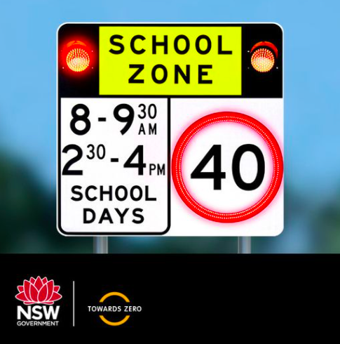

### [Safety Town](https://www.safetytown.com.au/accounts/login_register/?next=/accounts/profile/)

### Safety Town is a road safety education resource for teachers, students and families. It provides a variety of interactive learning activities for students from Kindergarten to Year 6. Teachers are provided with comprehensive teaching notes to support the use of the interactive activities, and support learning as part of PDHPE, English, Science and Mathematics. [www.safetytown.com.au](http://www.safetytown.com.au)

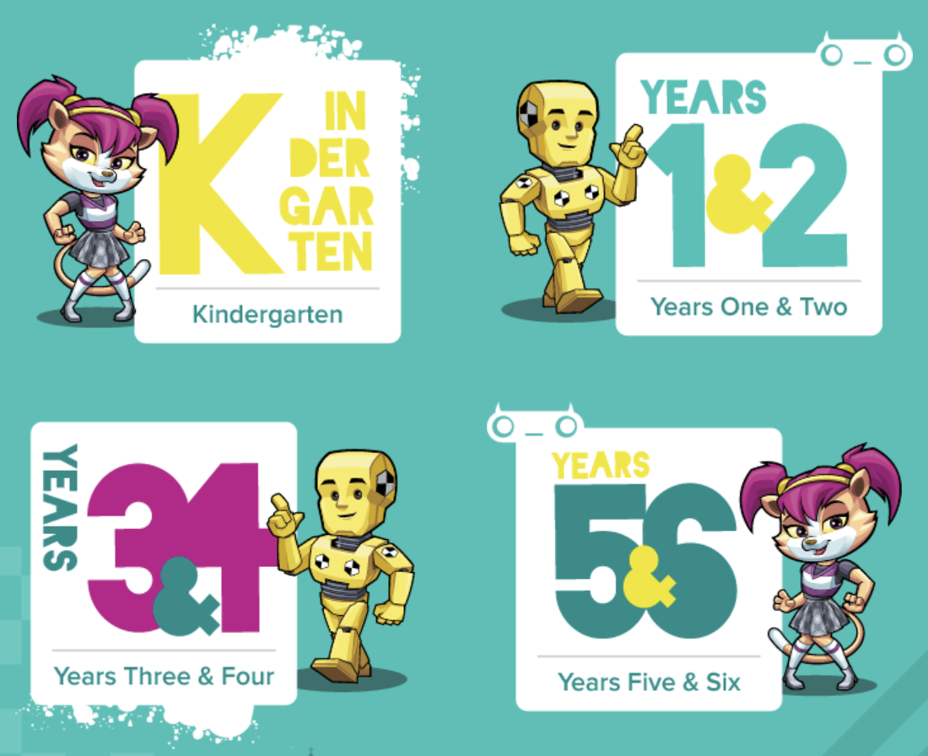

[**Safetytown Instructional video**](https://drive.google.com/drive/folders/1g8T3us8MynAlrXdCOU9VKZ_8adddJ-pr)

**Did you know you can order FREE road safety resources for your school through Transport NSW? Including Kindergarten Orientation Library bags**

<https://shout.finsbury.com.au/nswroadsafety/en-AU/home/>

Click on the grey box - Primary school use only. **Kindergarten Orientation**

**Road Safety Library Bag**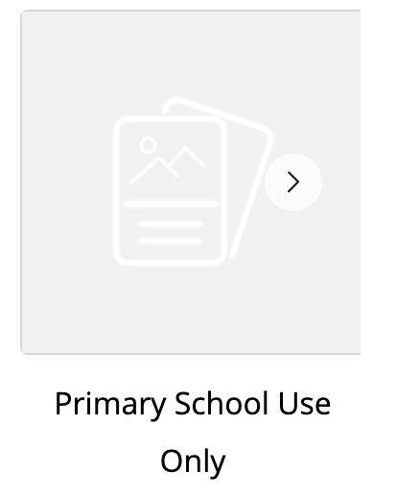

**QR Code**



**The Kindergarten Orientation Road Safety Library Bag is provided free of charge to NSW primary schools for use as part of their Kindergarten Orientation Day activities. It provides a range of road safety resources and information for families with children starting primary school. The library bag is designed for children to use at school and to help promote the key road safety message of “Hold a grown-up’s hand when you cross the road.”**

Information brochures are now available about **e-bikes and e-scooters**.

Link below to order copies of the brochures here:

<https://shout.finsbury.com.au/nswroadsafety/en-AU/category/3639/High-School-Use-Only/>

It is also on the CRS website at: <https://www.transport.nsw.gov.au/roadsafety/road-users/e-scooters>

**How to promote school road safety education within your school community**

* Take photos of students during road safety education activities. Email them home, share them in the school newsletter, website or blog.
* Display student work samples for families to see at drop-off and pick-up times.
* Display posters students have developed to promote road safety messages to the school community.
* Show students' road safety digital presentations and videos at assemblies and parent gatherings. Students can share road safety information with new families and students as part of kindergarten orientation visits.
* Distribute road safety information and notes to remind parents and carers to talk with children about road safety.
* Use the power of social media to promote road safety with short sharp messages.
* Involve local newspapers and other media. Share photos of students' road safety learning activities. Suggest that the newspaper supports safe school travel in the local community by publishing road safety articles written by students.

**Why should children learn about road safety?**

* It’s a significant health issue for young children. The l*eading cause* of accidental death and injury for children is road-related crashes. Road Safety Education in schools plays a major role in informing young people about the [key messages](https://www.safetytown.com.au/media/filer_public/29/12/291256b1-c511-442d-a989-94a70f596496/key-road-safety-messages.pdf) related to road casualty prevention. In 1988, Road Safety Education began in schools. This education has resulted in a dramatic and measurable decrease in casualties and fatalities.
* **Children's desire to explore can lead them into danger**. Children are more likely to be injured close to home, often in their own street or driveway. Adults need to talk to children about road safety in ways they will understand, keeping messages simple and clear.