Camelot Rise Primary School
Father’s Day Pizza Night – How to order.
Open Compass in Browser. Click on the 2 heads on the top bar then Canteen.
Then click Place order.
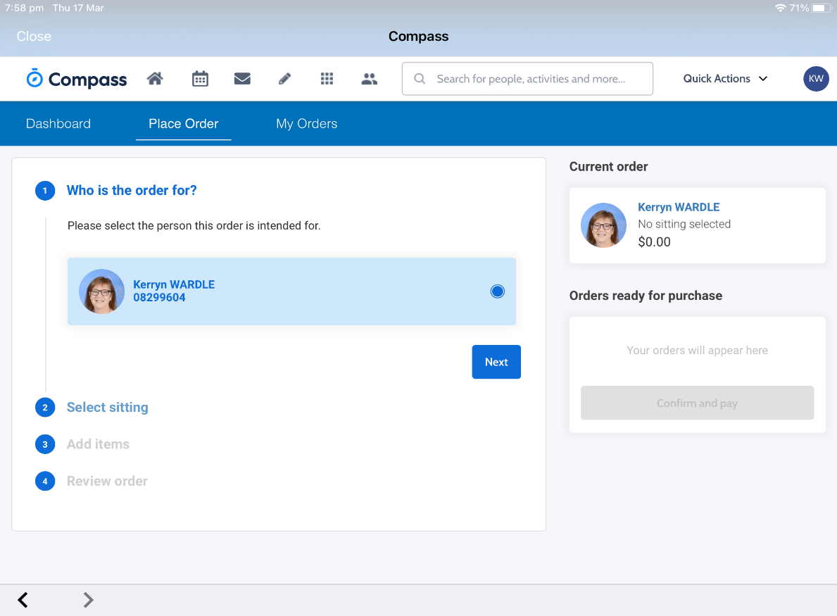
Click on the dot next to your child’s name then click next.

Select sitting – For this Father’s Day event please click on 7th September and then the dot describing the event.

Then next
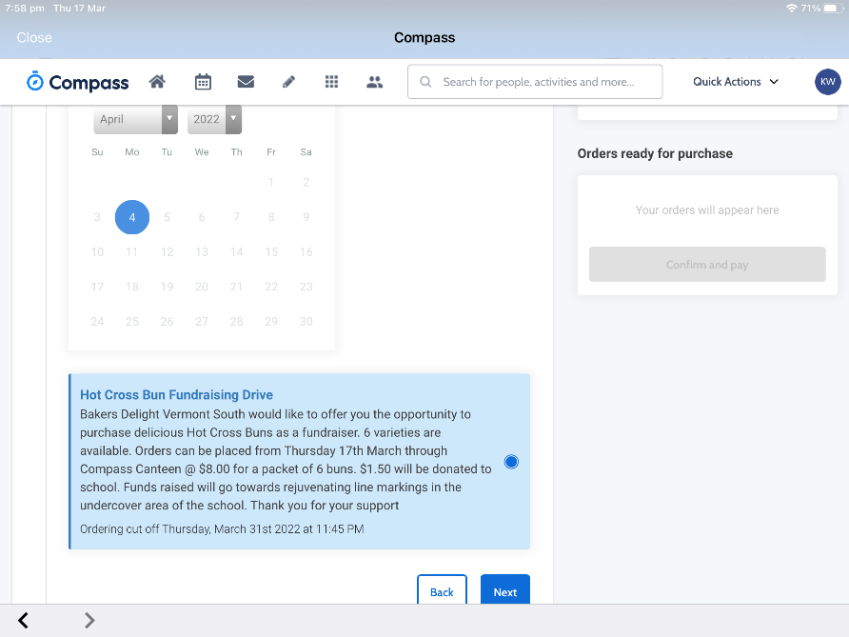

Add items you wish to order.
Click Proceed to review order.
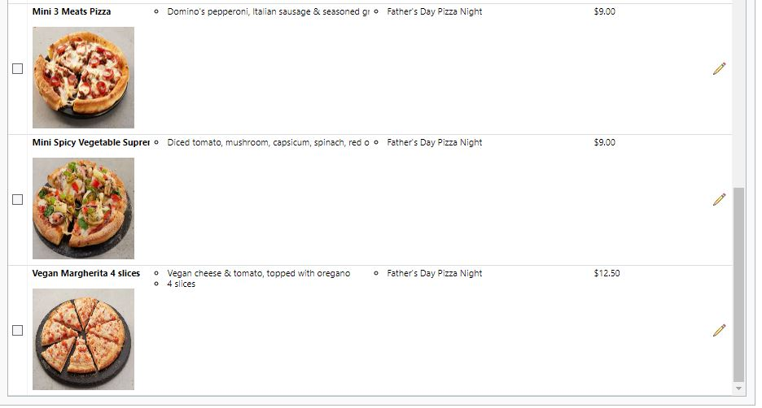
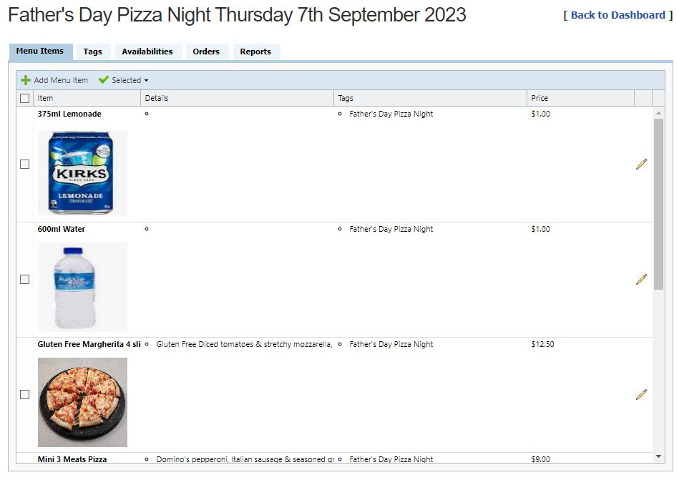

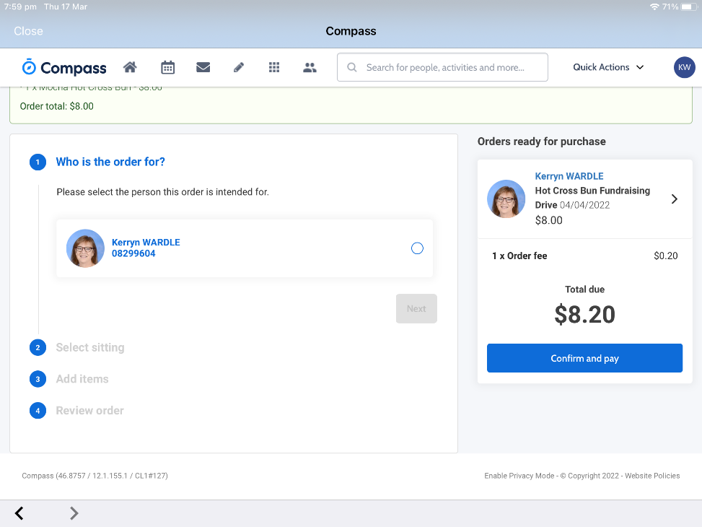
Check then click Add order. Click Confirm and pay

Select New Credit card

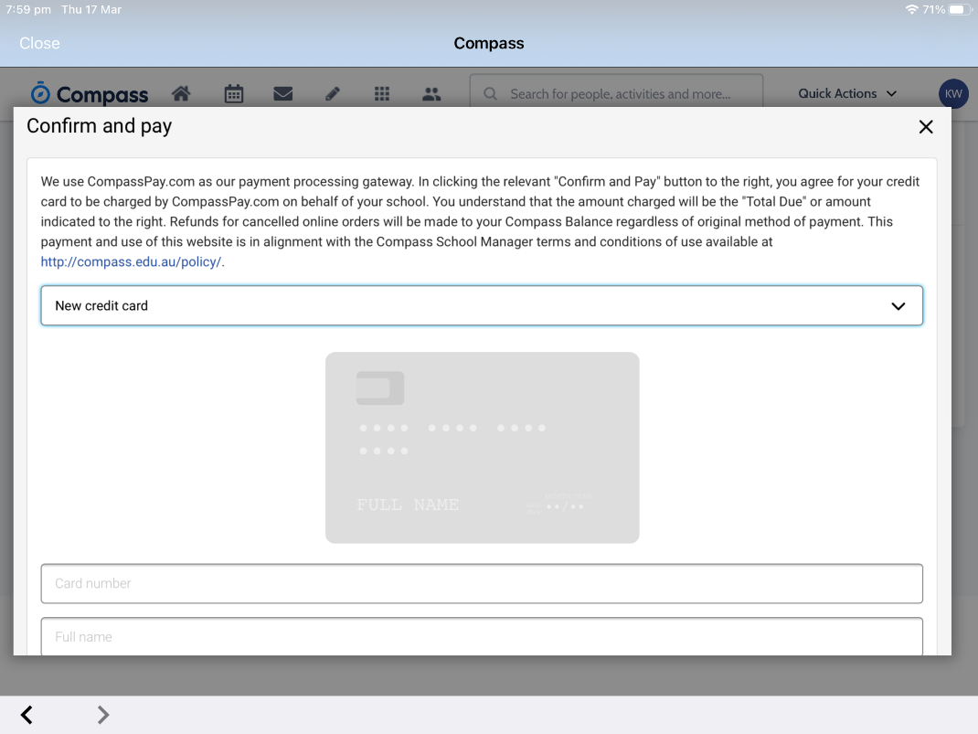
Thank you for your support

