School Principal | Anthony Hyde
OSHClub Coordinator | Stephanie Schembri
OSHClub Educator(s) | Milan Bulic
OSHClub Regional Operations Manager | Amanda Bell
OSHClub Partnership Manager | Sheryl Haskell
Corpus christi OSHClub
TErm 3 REPORT 2021

What have we been up to this Term?
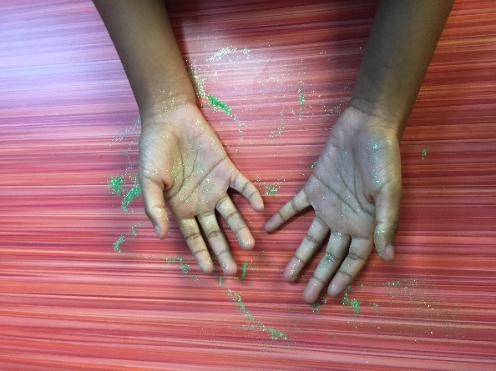
Hygiene and cleanliness
Due to the ongoing concern of health and hygiene stemming from the COVID-19 Pandemic, we made a point to focus on hygiene and cleanliness. Our aim was to imbed a routine with the children that they could embrace wholeheartedly. We found that with this routine, some of the younger students struggled to understand the importance of why we need to wash our hands so often. To overcome this, we put together a fun glitter activity to represent the ‘germs’ that they needed to wash away. In doing so, the younger children understood the importance of practicing hand hygiene and cleanliness.

Physical activity
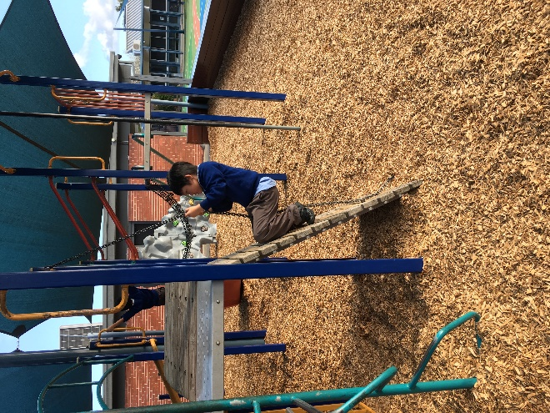
This term, we use the Moovosity and Sports Club resources. The children sometimes struggled with motivation after a long day at school, although when the activities were up and running, they thoroughly enjoyed them. The children here, although it has been a small group, love the competitive nature of these activities so we often expanded these activities with sports tournaments such as basketball around the world, furthest footy kick, and a tennis rally competition. To encourage all the students to participate, we often had the grade 4’s, 5’s and 6’s to help run the activities. It was great watching them interact with the younger kids and encourage them to do their best whilst teaching them new techniques. I believe these activities will be highly requested amongst the children once more children are attending after lockdown.
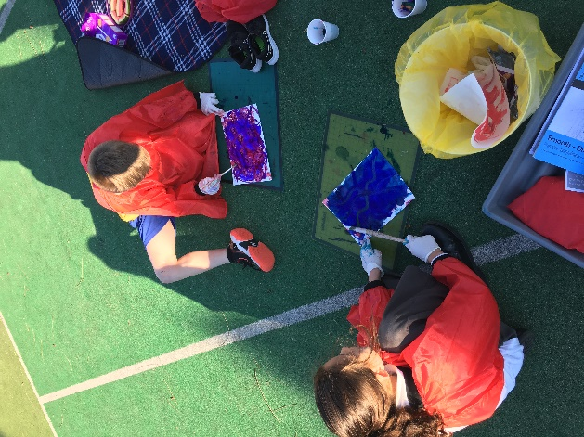

Arts & Craft
Term 3 produced some really great arts and craft works from our children. Thanks to the Art Club resources, there were many activities that the kids gained some great skills from. The activities we set out helped to support teamwork and inclusion as often the children opted to create their artworks together. To see their creativity flourish has inspired us to come up some new and fun activities for term 4.

Term 3 Photo Gallery
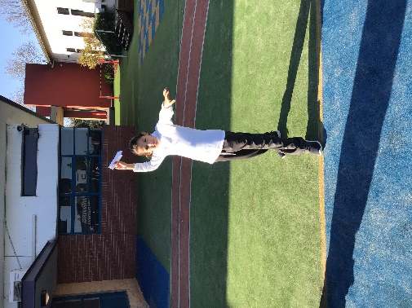
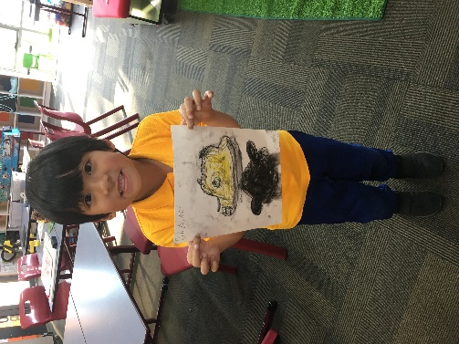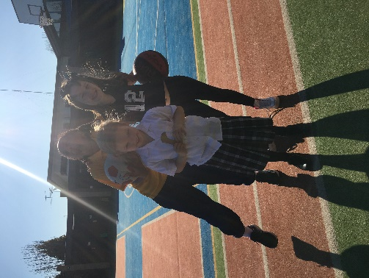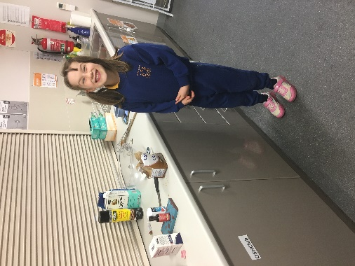
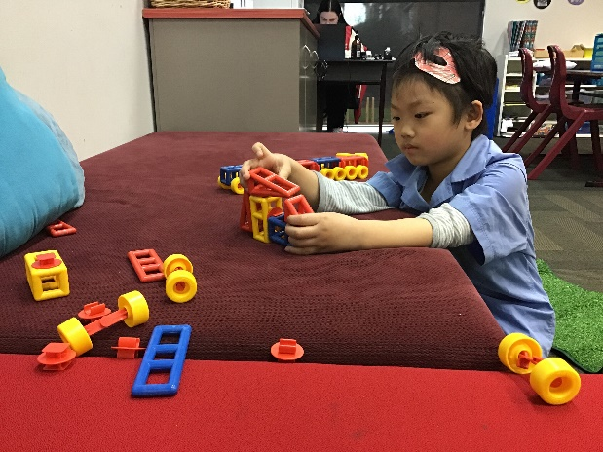
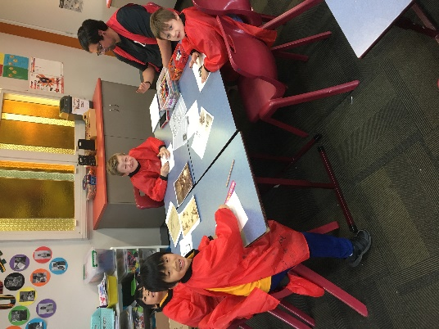
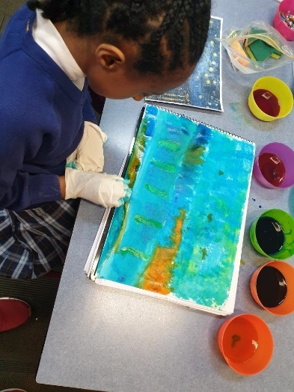

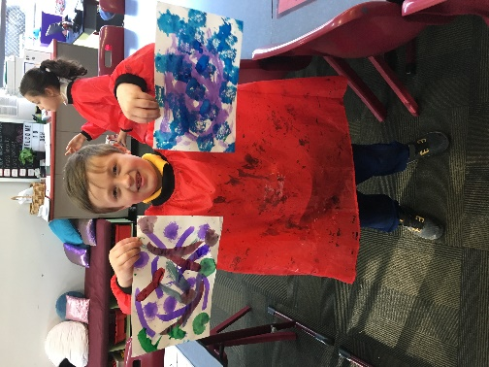
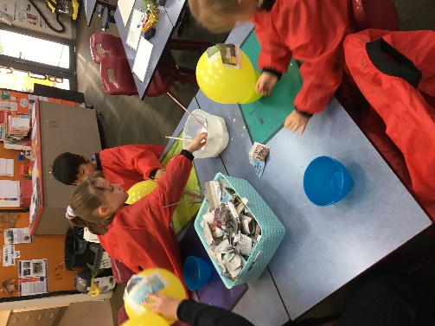
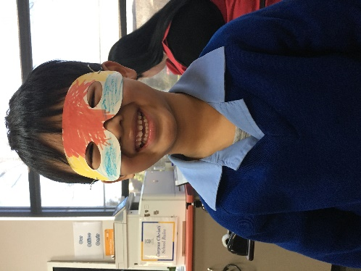
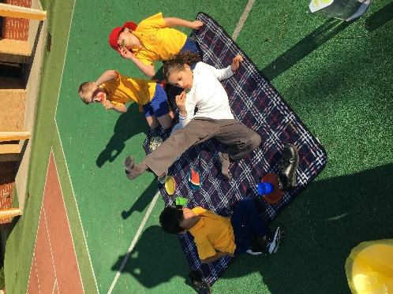

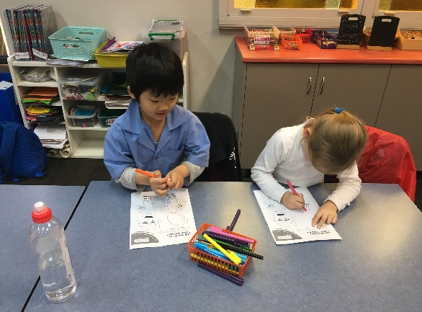
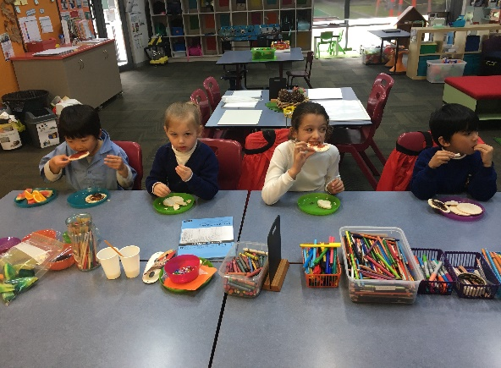

National Quality Standard assessment and rating reports
Our service at Corpus Christi OSHClub was last assessed in May 2019. We received a rating of Meeting within the National Quality Standard.

Policy updates
There have been changes to our Policies during Term 3

Formal complaints
Complaint | Action taken to resolve | Timeframe for resolution
None | N/A | N/A

Incidents
Incident |  | Action taken to resolve | Timeframe for resolution
Due to a disagreement with a peer, a child in attendance at Corpus Christi OSHClub absconded from the OSHC room and left the school grounds for approximately 13 minutes. During the entire duration of this time, an educator remained with the child and ensured that he was supported to come inside without heightening the situation further, whilst other children in attendance were supervised by another educator indoors. | Review wellbeing support strategies to further support children with additional needs. |  | Immediately

Breaches or non-compliances
Breach/non-compliance | Action taken to resolve | Timeframe for resolution
None | N/A | N/A

Attendances
BSC Program average attendances

ASC Program average attendances

Average daily attendance Past Year

