 Bird Profile No. 3
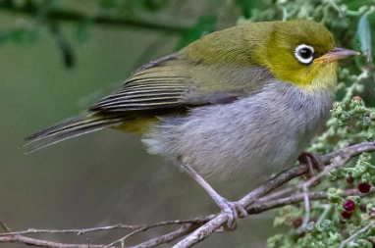
https://www.australiaswonderfulbirds.com.au/blog/2022/3/17/the-mobile-silvereye
Common Name | Silvereye
Scientific name | Zosterops lateralis
Description: What I look like. | A small bird, about 11 cm long, with a clear ring of whitish feathers around its eye. Olive-green wings and back and grey throat.
Distribution: Where I occur | 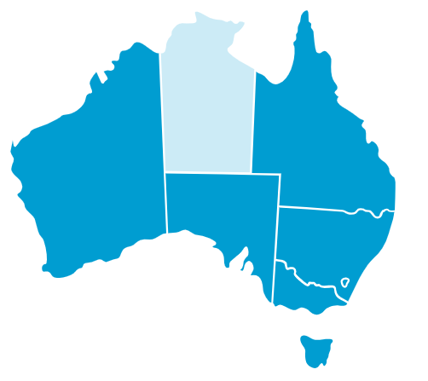
Habitat: Where I live. | Any wooded habitat, including commercial orchards and urban parks and gardens
Diet: What I eat. | Insect prey and large amounts of fruit and nectar
Breeding: | September to December.  They make a tiny cup-shaped nest from grass, moss, hair, spiderwebs, and thistledown in small trees or bushes.  2-4 pale blue eggs.
Call: What I sound like. | A thin “psip”, is given persistently.  https://birdlife.org.au/bird-profiles/silvereye/#songs-calls

