
LEVEL NEWSLETTER
2026  Term One  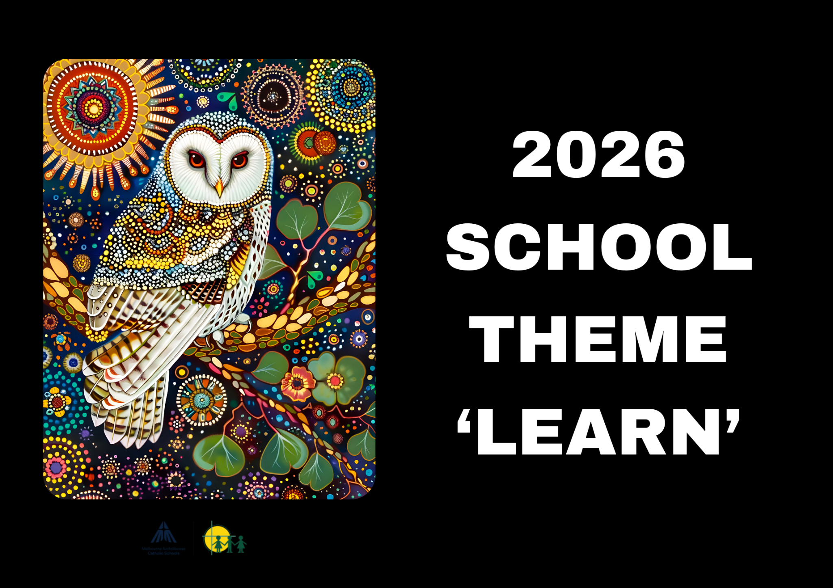 |  |   BIRTHDAYS  February  11th - Harley Tran  19th - Faith Kadenhe  March  23rd - Nyamal Deng  24th - Lachy Camilleri  April  7th - Paul Cao  8th - Ysabella Linnell
Staff Contact |  | Zac Flack - zflack@hfmw.catholic.edu.au
Specialist Classes | MONDAY | STEM
Specialist Classes | TUESDAY
Specialist Classes | WEDNESDAY | AUSLAN
Specialist Classes | THURSDAY | ART, PERFORMING ARTS, PHYS ED SPORT UNIFORM
Specialist Classes | FRIDAY | Year Level Sport SPORT UNIFORM
RELIGION   | TOPIC:  In Religion this term, students will explore God’s relationship with people and learn about belonging to God’s family through Scripture, prayer, and reflection. They will discover how God is revealed through images of love, care, beauty, and goodness, and how these connect to their own lives and local community. Children will also learn about the importance of family, Church traditions, and sacred places, while developing an understanding of how we can care for God’s creation. A strong focus will be placed on forgiveness, reconciliation, and the season of Lent, helping students reflect on their relationships with God, themselves, others, and the world around them.
SPELLING    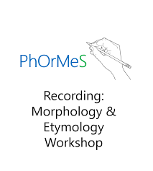 | Throughout our daily spelling sessions this term, students will develop their phonics skills by learning how to identify sounds and letter patterns, blend sounds to read words, and segment words into sounds to support accurate spelling. The focus will be on building strong foundational skills in recognising short vowel sounds, common spelling rules, and digraphs. These skills will help students become more confident and independent readers and writers as they continue to grow their literacy skills.  The sounds we will be focusing on for this term are:  Short /a/, /i/, /o/, /u/, /e/  FLSZ Rule  -all, -oll, -ull  ck /k/  sh /sh/  Voiced and unvoiced /th/  ch /ch/  wh /w/  ph /f/  ng /n/
LITERACY  (Reading/Writing)   | In Literacy this term, students will engage in a variety of reading, writing, and speaking activities, including a novel study of Joe and the Stars. Through this text, children will explore topics such as the Sun, Moon, and stars, while learning about Earth and space and developing an understanding of patterns in the sky. An important part of this unit includes an Indigenous perspective, where students will learn about the deep connection Aboriginal and Torres Strait Islander peoples have with the land, sky, and waterways. Students will also investigate plants and animals, focusing on how living things survive in different habitats and how their features help them meet their needs. These learning experiences will support students in building comprehension skills, expanding vocabulary, and making meaningful connections between texts and the world around them.
MATHEMATICS   | In Mathematics this term, students will develop their number skills by recognising, representing, and ordering numbers up to 120 using hands-on materials, number lines, and charts. They will learn to partition numbers into tens and ones and use skip counting to group and quantify collections. Students will also explore simple data concepts by collecting, recording, and representing information using tallies, drawings, objects, and other tools. Through practical problem-solving activities, including simple money situations, students will use modelling and calculation strategies to strengthen their understanding of how mathematics applies to everyday life.
KNOWLEDGE BASED/  INQUIRY   | In Inquiry this term, students will explore Earth and Space Science, focusing on observable changes in the sky and landscape. Children will learn about day and night, the Sun, the Moon, stars, and constellations, and how these change over time. They will participate in hands-on investigations, make predictions, record observations, and share their learning in a variety of ways.
BEHAVIOUR CURRICULUM   | Routines  This term, students will be learning and practising positive behaviour routines that support a calm, safe, and respectful learning environment. Our focus areas include:  - Lining up and sitting down calmly after break times  - Using a calm and orderly entrance and exit routine  - Walking in roll order quietly  - Walking around the school with a partner  - Understanding and following our classroom routines  - Using kind words and respectful behaviour towards others  - Listening to and following teacher instructions  - Taking responsibility for personal belongings and learning spaces  These routines help students develop independence, self-regulation, and a strong sense of responsibility within the school community.

 | Term One Important Dates (refer to our Google Calendar as well)  FEBRUARY  Wed 4 Prep Rest Day  Fri 6 Parent Welcome Event  Sun 8 Prep/New Family Welcome Mass (10am)  Mon 9 Children’s Mental Health Week (Wear an outfit that makes you feel confident and comfortable)  Tues 10 Safer Internet Day  P&F Meeting (6:30pm)  Meet the Teacher (Prep-Year 6)  Wed 11 Prep Rest Day  Meet the Teacher (Prep-Year 6)  Thur 12 District Swimming  Fri 13 Whole School Mass (9:15am)  FIRE Carrier Induction (10am)  Tues 17 Shrove Tuesday  Wed 18 Ash Wednesday (12pm Mass)  Prep Rest Day  Fri 20 Interschool Sport (1)  Mini Vinnies Soccer Event  Play Group commences (9:30am)  World Day of Social Justice  Wed 25 SAC Meeting (5:30pm)  Wed 25 Prep Rest Day  Fri 27 Interschool Sport (2)  MARCH  Wed 4 Prep Rest Day  Division Swimming  P&F Meeting (6:30pm)  Thur 5 Twilight Sports Day  Fri 6 School Closure Day (Vision for Engagement)  Sun 8 International Women’s Day (Give To Gain)  Mon 9 Labour Day Public Holiday (School Closed)  Wed 11 NAPLAN commences  Year 4 Reconciliation/Eucharist Info Night  Fri 13 Year 3-6 Athletic Trials  Sun 15 Catholic Education Week (Christ Beside Me-Walking in the Footsteps of St Patrick)  Tues 17 St Patrick’s Day  Wed 18 Open Day (all day) Everyone Welcome  Fri 20 Community Colour Run (Major Fundraiser)  Mass of St Patrick (St Patrick’s Cathedral)  Sat 21 Harmony Day  World Down Syndrome Day  Tues 24 Sacrament of Reconciliation (5pm)  Fri 27 Halogen Young Leaders Day  Summer Sport Gala Day (TBC)  Tues 31 EMR Swimming  APRIL  Thur 2 End of Term 1 (1pm finish)  Holy Thursday  Fri 3 Good Friday  Sun 5 Easter Sunday

