Negotiating Roles and Relationships in Play Episodes and Group Experiences
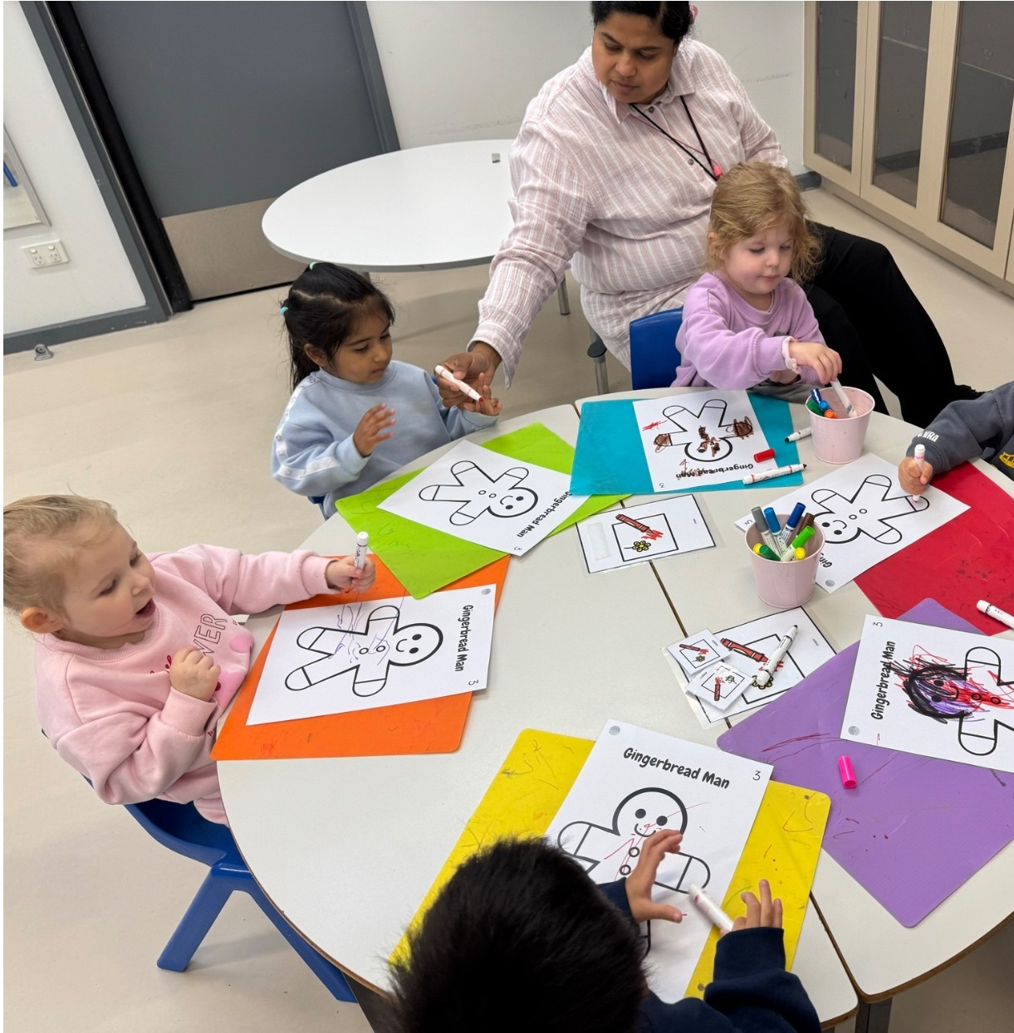

Group 1 has had a very busy yet productive Term 2 with lots of different activities and opportunities for social interaction. A focus for this term is cooperating with others and negotiating roles and relationships in group activities such as colouring in, choice-making routine and play on the floor. For the colouring in activity, we have been colouring in different animals from the books we have read and letter of the week. It was wonderful to see how they have all embraced this new routine and they have all done beautiful sharing of the learning space and the colouring resources. In choice-making routine and play on the floor, they have learnt important skills of communicating a choice, waiting for a turn, sharing and playing nicely. A new addition to our engagement station is the Let’s Play station where they get to share play materials or items with peers. It has been fantastic to see them noticing their peers more, seeking interaction from them and the blossoming friendships. They have indeed made our classroom a community.
This term’s theme on Books and Characters has brought joy and excitement to our young readers. This term they have engaged in reading different book every week. Few favourites are The Gingerbread Man, Brown Bear Brown Bear What Do You See, Sneaky Snappy Mr Croc and The Very Cranky Bear. Extension activities on reading were counting with 1:1 correspondence and recognising numbers. Counting has been exciting using animals and bugs toys, different animal worksheets, and food items such as M&M’s and tiny teddy biscuits.
To our awesome learners, we are very proud of you!
A huge thank you to our ever-supportive families! We value all your hard work for your child’s learning.
Have a safe and restful winter break! Looking forward to seeing you all in Term 3.

-Dibbie & Prabha

