Don’t Believe the Bears
Humpty Dumpty Thursday, 31, August

Yesterday the Bears were at court having a fair trial for the attempt of entrapment against Goldilocks. But Goldi locks had the evidence on hand.
On the 31st of August Goldilocks and the Bears were at court. “Yesterday morning I received a letter from the Bears inviting me to their house”, Goldilocks said. Although it turns out the letter was fake (according to the Bears). Goldilocks produced the letter to the Judge. Pappa Bear immediately started screaming, “that’s not my signature!” And all order in the court was lost. “Goldilocks what did you do when you arrived at the house?” Judge Gretel asked “well of course I did what the letter said to do, I sat on Baby Bears chair until I broke it and slept in Baby Bears bed.” Goldilocks confessed. “How do you know little Ms liar didn’t write the letter?” Mamma Bear demanded. “Goldilocks was with us the whole time” joined in Little Red Ridding hood. It was true Goldi was having a playdate with Pinocchio and Red when a letter arrived Goldi was so excited, she read the letter to her friends.
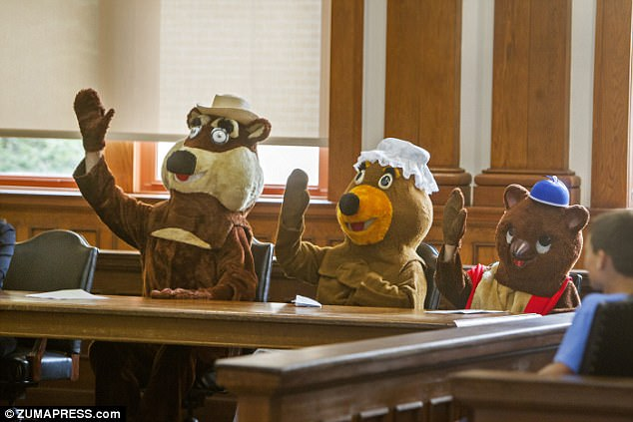
Mamma Bear confessed that it was her signature as they were being taken away “I was not in on this!!” Pappa bear screamed. Will Pappa and Baby Bear be excused?

