Calcium
Calcium, vitamin or mineral?
Calcium is a mineral your body needs to build and maintain strong bones and to carry out many important functions. Calcium is the most abundant mineral in the body. Almost all calcium in the body is stored in bones and teeth, giving them structure and hardness.

What food and drinks have calcium
Good sources of calcium include dairy foods like milk, yoghurt and cheese, calcium fortified foods (such as soy products) and, to a lesser degree, some leafy green vegetables and nuts and seeds

What happens to you when you don’t have enough calcium
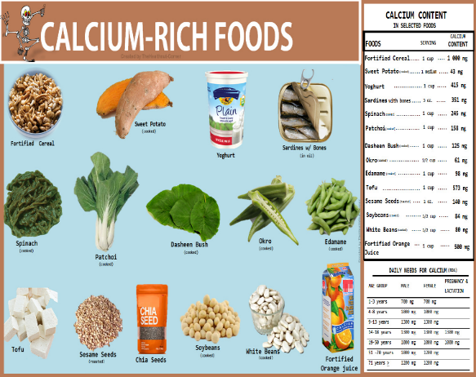
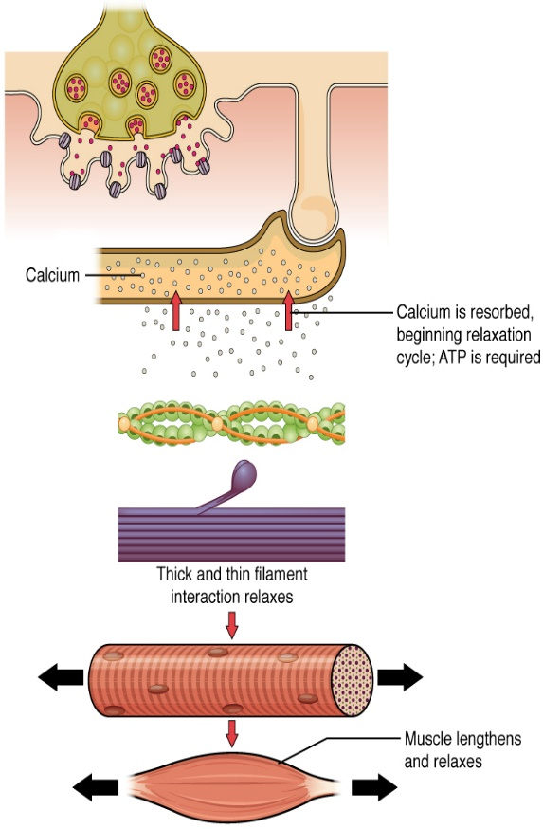
Getting too little calcium can cause several conditions, including the following: Osteoporosis, which causes weak, fragile bones and increases the risk of falls and fractures (broken bones) Rickets, a disease in children that causes soft, weak bones. Osteomalacia, which causes soft bones in children and adults.
This Photo by Unknown Author is licensed under CC BY-NC-ND
This Photo by Unknown Author is licensed under CC BY

