**MENTONE HOCKEY CLUB JUNIORS**

Welcome!

Mentone Hockey Club (Mentone Panthers) welcomes new players of all age groups and levels of experience. We field teams for all age groups in Hockey Victoria winter, summer and indoor competitions.

We are a family friendly club that has, as our vision, to ‘engage, inspire, guide and develop every player to greatness’.

We aim to provide an environment which promotes fun, enjoyment, teamwork and a positive attitude. One of our goals is to provide the highest level of coaching to enable members to continue to improve and reach their optimal level. The program combines individual development and team-oriented strategies and is designed to challenge athletes in a competitive but supportive environment. Training is based on a small game approach, which focuses on individual and team skills.

The training program is divided into two main areas:

* Preparation of the Panthers Teams to compete in the Hockey Victoria Competition.
* Development of individual athletes’ skills throughout the year.

There is a strong commitment from the leadership group of both our senior Men’s and Women’s sections to support and mentor junior players making their transition into the Senior Section. Players will attend training sessions and matches as well as give advice and inspiration to players in the junior grades.

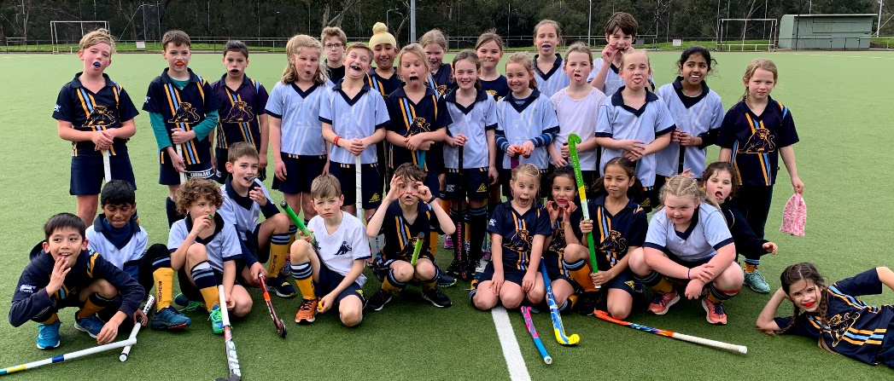

**Location**

Keysborough Playing Fields at Mentone Grammar

732-742 Springvale Rd

Braeside VIC 3195

**Contact**

[juniors@mentonehockey.org.au](mailto:Juniors@mentonehockey.org.au)

[www.mentonehockey.org.au](http://www.mentonehockey.org.au)

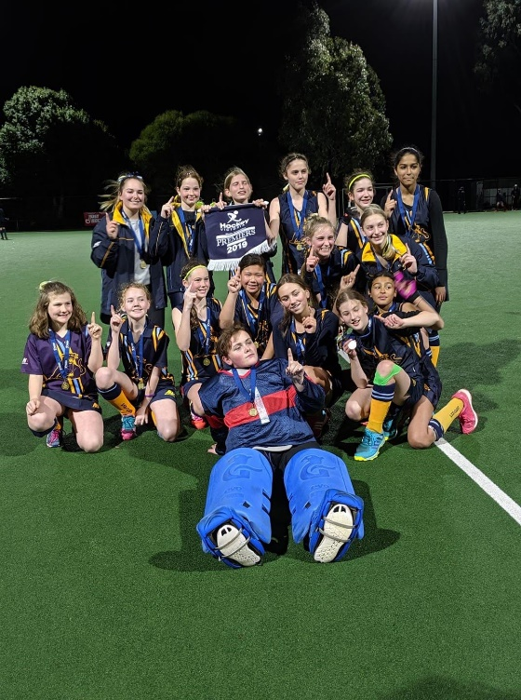

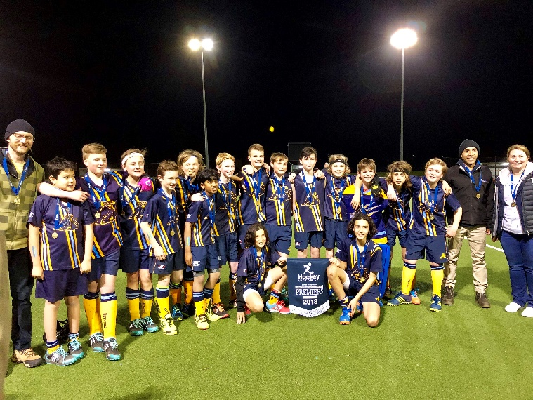

**SEASONS**

**Winter – Term 2 and 3**, with training starting 4-6 weeks prior to round 1

U8 play Sunday mornings (Keysborough)

U10-U12 play Saturday mornings (various venues)

U14-U18 play Friday nights (various venues)

**Indoor – Term 4 and 1**

** varies on competition

U11-U13 play Sunday mornings (Dandenong)

U12 play Sunday mornings (Braeside)

U14 play Thursday evenings (Braeside)

U16 play Tuesday evenings (Braeside)

U18 play Wednesday evenings (Braeside)

**APPAREL REQUIREMENTS**

* Runners/sneakers
  + Hockey specific shoes - player discretion
* Training – comfortable clothes
  + recommend - t-shirt, shorts/skort, footy socks
* Games – MHC Uniform as per below

|  |  |  |
| --- | --- | --- |
|  | Home / Traditional | Away / Alernative |
| Shirt | MHC Blue | White |
| Shorts/Skort/Skirt | MHC Blue | MHC Blue |
| Socks | MHC Gold/Yellow | MHC Blue |

* Purchase uniforms from **Hockey World**, 467 South Rd, Bentleigh

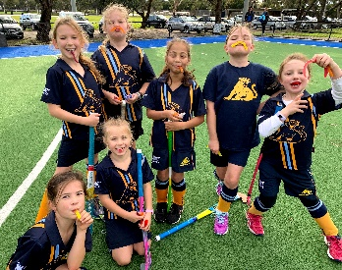

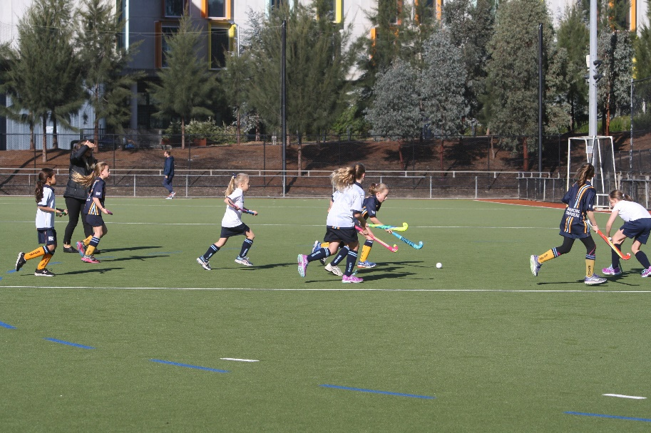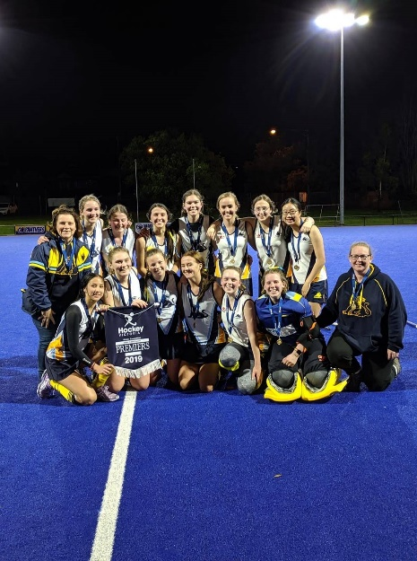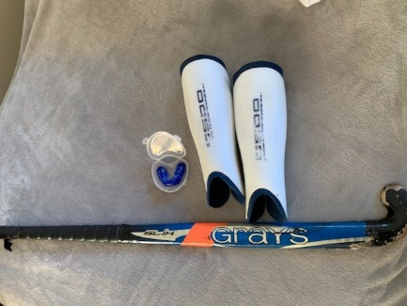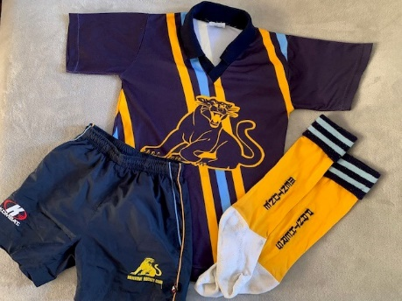

**EQUIPMENT REQUIREMENTS**

* Hockey stick
* Shins - compulsory
* Mouthguards - compulsory
* Gloves – player discretion
* Water drink bottle
* Indoor additional requirements
  + Indoor hockey stick
  + Full hand glove – compulsory for left-hand
* Goalkeepers required to wear full goalkeeper kit, including helmet

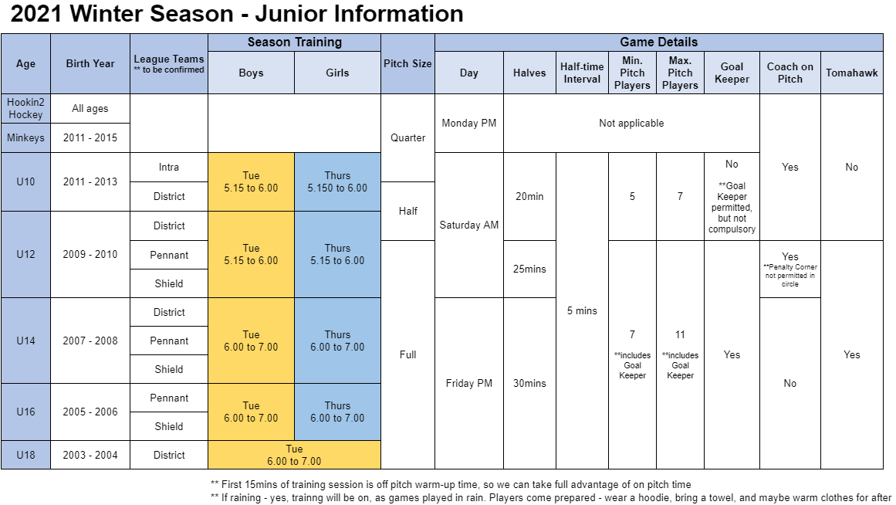

**MENTONE HOCKEY CLUB**

**Fees Table 2022**

Register to play

Step 1. Hockey Victoria Registration

<https://www.revolutionise.com.au/mentonehockey/registration/>

Choose appropriate registration option

Step 2. Club Fees

On receipt of club invoice, pay by Credit/Debit or Direct Deposit as per details on Mentone Hockey Club invoice.

|  |  |  |  |
| --- | --- | --- | --- |
| **Mentone Fees 2021 Table** | | Discounted Fee if paid before Round 3 | Fee if paid after Round 3 |
| ***(HV registration fee paid separately)*** | |
| **Category** | **Description** |  |  |
| Game On! | # Minkey Hockey (Sunday mornings) | $125.00 | $125.00 |
| # Intraclub (qtr Field) (Saturday mornings) | $125.00 | $125.00 |
| U10’s | # Junior playing Under 10 competition – Saturday Mornings (half field) | $180.00 | $180.00 |
| Juniors only | # Junior playing in either Under 12, Under 14, Under 16 or Under 18 competition | $320.00 | $420.00 |
| # Junior Goal Keeper with Own Goal keeping gear | $150.00 | $250.00 |
| Juniors & Seniors | # **  Junior Playing in Juniors and Seniors competitions (Jnr plus $220) | $525.00 | $625.00 |
| # ** Junior Goal Keeper playing Juniors & Seniors competitions with own gear | $250.00 | $350.00 |
| Seniors Only | ** Senior – Male or Female | $625.00 | $725.00 |
| ** Senior – Student/concession – Male or Female (*Full-time Student, Health Card Holder)* | $525.00 | $625.00 |
| ** Senior Goal Keeper – with own Gear Playing Men’s or Women’s competition | $250.00 | $350.00 |
| Seniors & Masters | ** Senior – Male or Female playing Senior and Masters comps (Snr plus $200) | $825.00 | $925.00 |
| ** Senior Goal Keeper – with own gear playing Senior and Masters Comp (Snr GK plus $100) | $350.00 | $450.00 |
| Masters Only | Masters – Male or Female playing in Masters comp only | $455.00 | $555.00 |
| Master Goal Keeper – with own gear playing Masters only | $250.00 | $350.00 |
| Social | Social Member –   For friends, relatives, past players who would like to be a non-playing member, with full voting rights, and to help contribute to ongoing running of the club. | $50.00 |  |

Players who are not fully registered with both HV and Mentone Hockey Club or have any outstanding fees will be ineligible for selection, so if you have any questions about the Registration process, Fees or need any assistance, please contact our Treasurer: [treasurer@mentonehockey.org.au](mailto:treasurer@mentonehockey.org.au)