SUPPORT SERVICES
Service/Organisation  Contact Details | Service Details
  24 hours a day, 7 days a week  Phone: 000 | If you are in immediate danger, call 000 for Police, Fire and/or Ambulance help.
  24 hours a day, 7 days a week  Phone: 13 11 14  Text: 0477 13 11 14  Online chat: https://www.lifeline.org.au/crisis-chat/ | Website: https://www.lifeline.org.au/  - National charity providing all Australians experiencing emotional distress with access to 24-hour crisis support and suicide prevention services.  - Provide free, confidential, one-to-one short-term support with a trained Lifeline telephone crisis supporter for people who are feeling overwhelmed or having difficulty coping or staying safe.
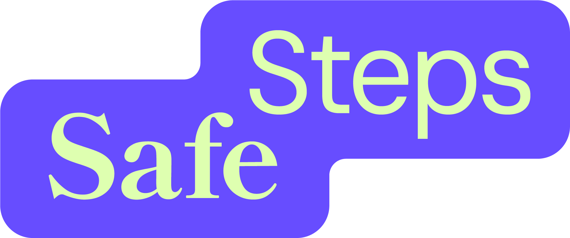  24 hours a day, 7 days a week  Response Centre  Phone: 1800 015 188  Email:  safesteps@safesteps.org.au  (support worker will reply ASAP)  Live Chat: https://safesteps.org.au/live-chat/ | Website: https://safesteps.org.au/  - Provides the only statewide 24/7, inclusive and confidential, family and domestic violence crisis support service  - Provide immediate, free, practical and compassionate support, information and accommodation for individuals and families experiencing family and domestic violence including:  - conduct risk assessments and safety planning  - provide pathways into safe, emergency and supported accommodation across Victoria (including short-term pet-friendly options)  - collaborate with animal shelters to provide temporary housing for pets and health and well-being support  - collaborate with agencies to provide financial and material aid  - provide accessible and inclusive assistance and advice for people with a disability through the Disability Family Violence Crisis Response Initiative  - offer social support and advice in the family courts
  24 hours a day, 7 days a week  Phone: 1800 737 732  Text: 0458 737 732  Online chat and video call services:  www.1800respect.org.au | Website: https://1800respect.org.au/  - National domestic, family and sexual violence counselling, information and support service.  - Free, confidential service, providing information, referrals and counselling support for:  - people experiencing, or at risk of experiencing, domestic, family and sexual violence  - people and/or professionals supporting someone experiencing, or at risk of experiencing, domestic, family and sexual violence
  Operates during business hours 9-5pm weekdays. Closed public holidays.  The Orange Door offices are located across Victoria.  Croydon Phone: 1800 271 150  Address (in person support):  4-16 Devon St, Croydon, VIC 3136  Email: oema@orangedoor.vic.gov.au | Website: https://www.orangedoor.vic.gov.au/  - Free service that provides support for:  - adults, children and young people who are experiencing or have experienced family violence  - families who need support with the care and wellbeing of children and young people  - perpetrators of family violence wanting to change their behaviour  - Each location provides access to women’s and children’s family violence services, child and family services, Aboriginal services and men’s family violence services, with services including:  - service information, advice and support  - risk and needs assessment  - safety planning  - crisis support  - referral to other services, and family services  - support with the wellbeing and development of children and young people  - connecting individuals with services if they want help to change their violent or controlling behaviour
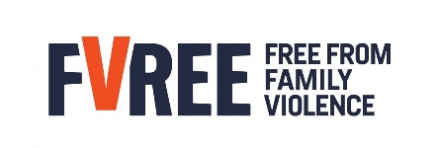  Phone: (03) 9259 4200  Email: getintouch@fvree.org.au  PO BOX 698 Ringwood VIC 3134  Free From Family Violence (FVREE) operate from The Orange Doors in Croydon (see above) and Box Hill, with satellite services in Yarra Junction and Belgrave. | Website: https://fvree.org.au/  - FVREE (formerly EDVOS) is the specialist family violence service in Melbourne’s eastern metropolitan region (EMR).  - A not-for-profit organisation, primarily funded by the State Government of Victoria  - Work in The Orange Doors and can provide:  - Risk assessments  - Safety planning  - Child safety and well-being support  - Financial support and material-aid  - Crisis response including emergency accommodation  - Provide specialist support and recovery case management from their service in Ringwood
  Operates 5pm weeknights – 9am the next day and throughout weeknights and public holidays.  The Sexual Assault Crisis Line Victoria (SACL)  Phone: 1800 806 292  Please call on the above line if you have experienced sexual assault within the last 2 weeks throughout Victoria. | Website: https://www.sacl.com.au/  - A state-wide, after-hours, confidential, telephone crisis counselling service for people who have experienced both past and recent sexual assault.  - Is the central after-hours coordination centre for all recent sexual assaults and provides immediate crisis responses throughout Victoria.  - SACL provide:  - After-hours telephone crisis counselling support, information, advocacy and referral to anyone living in Victoria who has experienced any form of sexual assault at any point in their lives.  - Co-ordination of a crisis care response to recent victim/survivors of sexual assault within the last 2 weeks throughout Victoria. This involves an immediate face to face response with a Counsellor/Advocate from CASA.  - Support and information to non-offending family and friends.  - Information on legal and medical rights/options  - Advocacy with service providers and secondary consultation to professionals  - Information and referral for people who have experienced family violence
  Open 8am-7pm Monday to Friday, 8am-5pm Saturday, Sunday and public holidays  Phone: 1800 819 817  Text: 0427 767 891 | Website: https://www.victimsofcrime.vic.gov.au/  - The Victims of Crime Helpline is the official Victorian Government service that offers free information, advice and support for people affected by crime.  - The helpline provides information about victim entitlements and the criminal justice system; information about the legal process, including after the offender is in jail; and connections to other support services such as the Victims Assistance Program
  Child Protection  During business hours (8.45am – 5pm Monday – Friday):  Ring the number covering the local government area (LGA) where the child lives:  East Division Phone: 1300 360 452  5pm to 9am Monday to Friday, 24 hours on weekends and public holidays:  After hours Child Protection Emergency Service  Phone: 13 12 78 | Website: https://services.dffh.vic.gov.au/child-protection  - A state-wide after-hours emergency service that receives new reports, as well as concerns for existing child protection clients who are considered to be at immediate risk of significant harm as a result of abuse or neglect and require urgent after hours service.  - The main functions of Child Protection are to:  - Investigate matters where it is alleged that a child is at risk of significant harm.  - Refer children and families to services that assist in providing the ongoing safety and wellbeing of children.  - Make applications to the Children's Court if the child's safety cannot be ensured within the family.  - Administer protection orders granted by the Children's Court.
  24 hours a day, 7 days a week  Phone: 1800 55 1800  WebChat: https://kidshelpline.com.au/get-help/webchat-counselling | Website: https://kidshelpline.com.au/  - Provide free, private, and confidential support and phone and online chat counselling (talking through problems) service to people aged 5 -25 years, anywhere in Australia, anytime, for any reason.  - Website resources available for the adults who care about these children, anywhere in Australia
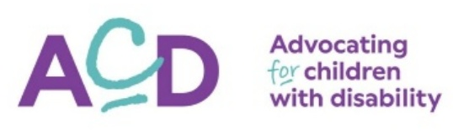  Monday to Friday, 9am – 5pm  Support Line  Phone: (03) 9880 7000, 1800 654 013 (regional) | Website: https://acd.org.au/  Note: previously known as Association for Children with Disability.  - Free support line service for families of children aged 0 to 18 with any type of disability and developmental delay in Victoria.  - Can assist with helping to understand your child’s rights and support you to advocate for your family.  - Professionals who work with children with disability and their families can also call.
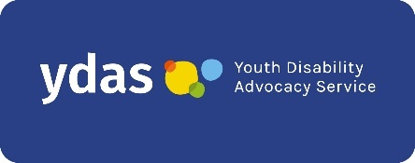  General enquiries:  Phone/Text: 0455 621 849  Email: info@ydas.org.au  Advocacy enquiries:  Phone/Text: 0438 638 734  Email: intake@ydas.org.au | Website: https://ydas.org.au/  - Youth Disability Advocacy Service (YDAS) is a Victorian advocacy organisation that provides free individual support and advocacy for young people with disability aged 12 – 25 years of age to achieve their human rights.
  24 hours a day, 7 days a week  Phone: 1300 78 99 78  Online Counselling and Video Counselling Chat:  https://mensline.org.au/phone-and-online-counselling/ | Website: https://mensline.org.au/  - Free professional telephone and online counselling support service for men with concerns about mental health, relationships, anger management, family violence (using and experiencing), stress, wellbeing and suicidal thoughts.
  24 hours a day, 7 days a week  Men’s Referral Service  Phone: 1300 766 491  Chat online: https://ntv.org.au/mrs/getting-support/ | Website: https://ntv.org.au/  - No to Violence provides a range of services operated by qualified and experienced counsellors and family violence experts to support men who use violence and/or are concerned about their behaviour to change what they are doing and keep women, children and communities safer, including the Men’s Referral Service.  - Men’s Referral Service:  - Free, national counselling, information and referral service for men who use violence and abuse to change their behaviour  - Support men who are seeking support to change their behaviour; family members impacted by a man’s use of violent and abusive behaviours; friends, family or colleagues of men who may be using family violence and wanting to know how best to support them, and professionals working with men who are using violence or family members impacted by violence and seeking secondary consultation.
  24 hours a day, 7 days a week  Phone: 13 92 76 | Website: https://www.13yarn.org.au/  - 13YARN is a National service for Aboriginal & Torres Strait Islander people in crisis.  - Offer a free, confidential 24/7 one-on-one over the phone yarning opportunity and support with a trained Lifeline Aboriginal & Torres Strait Islander Crisis Supporter for mob who are feeling overwhelmed or having difficulty coping.
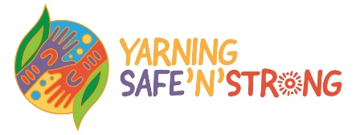  24 hours a day, 7 days a week  Phone: 1800 959 563  Email: ysns@vahs.org.au | Website: https://www.vahs.org.au/yarning-safenstrong/  - Yarning SafeNStrong (YSNS) A free and confidential phone counselling service for Aboriginal and Torres Strait Islander people and families who need to have a yarn with someone about their wellbeing; established by Victorian Aboriginal Health Service (VAHS).
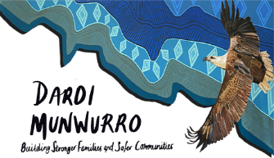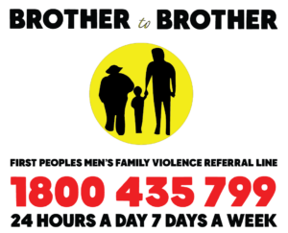  24 hours a day, 7 days a week  Brother to Brother 24 Hour Crisis Line  Phone: 1800 435 799 | Websites: https://dardimunwurro.com.au/  https://dardimunwurro.com.au/brother-to-brother-crisis-line/  - Dardi Munwurro (Strong Spirit) is a specialist Aboriginal family violence service that run the Brother to Brother crisis line.  - Brother to Brother crisis line:  - provides free phone support for Aboriginal men who need someone to talk to about relationship issues, family violence, parenting, drug and alcohol issues or who are struggling to cope for other reasons.  - staffed by Aboriginal men, including Elders, who have a lived experience in the issues that the line offers support for.
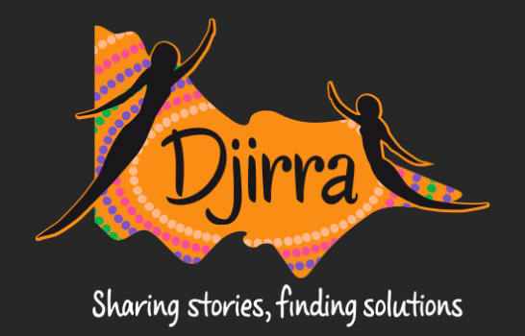  9am – 5pm, Monday to Friday  Phone: 1800 105 303  Email: info@djirra.org.au  Melbourne Metro (Head Office):  292 Hoddle Street, Abbotsford, 3067 | Website: https://djirra.org.au/  - Djirra - Aboriginal Family Violence Response & Support Service provide both telephone and face to face legal and non-legal practical support to Aboriginal women and people who are experiencing or have experienced family violence.
  Operating 10am – 5pm, everyday  Phone: 1800 729 367  Text: 0480 017 246  Email: support@rainbowdoor.org.au | Website: https://www.rainbowdoor.org.au/  - A free helpline and specialist support service for LGBTIQA+ (Lesbian, Gay, Bisexual, Transgender and Gender Diverse, Intersex, Queer, Asexual, BrotherBoys, SisterGirls) Victorians, their friends and families.  - Supports people of all ages and identities with a range of issues including suicidal thoughts, family and intimate partner violence (including elder abuse), alcohol and other drugs, relationship issues, sexual assault, social isolation, mental health & wellbeing.
  Open every day, including holidays.  As of 01/12/25 will open 3pm – 9pm in each State & Territory’s local time.  Phone: 1800 184 527  Webchat: www.qlife.org.au | Website: https://qlife.org.au/  - QLife is a free and anonymous peer-support and referral service run by LGBTIQA+SB people for LGBTIQA+SB people in Australia wanting to talk about sexuality, gender, bodies, feelings, relationships, mental health and wellbeing, or are wanting to connect with a peer.  - People who support LGBTIQA+SB people (including professionals, family members and friends) and want to talk about someone they care about are also welcome.
  Phone: 1300 291 071  Book online through the Converge International portal (https://portal.converge-online.com/), using the organisational code: mywellbeing  Can arrange to speak with practitioner  - over the phone  - via video  - in person (subject to availability)  Six dedicated specialist helplines for staff who identify or are:  - Experiencing domestic and or family violence: 1300 338 465  - Person with disability, or caring for a person with disability: 1300 243 543  - Aboriginal and Torres Strait Islander: 1300 287 432  - LGBTIQA+: 1300 542 874  - Caring for elderly loved ones: 1300 035 337  - Seeking spiritual and pastoral care: 1300 772 435  Specialist helplines are all available to book online, except for the Spiritual and Pastoral care helpline, which is phone booking only. | Website: https://convergeinternational.com.au/  - The Victorian Department of Education’s external provider of Employee Wellbeing Support Services (EWSS).  - Provide free, practical, confidential mental health and wellbeing support and advice to proactively support the wellbeing of eligible Department of Education staff, helping them to remain resilient, productive and engaged.  - Support services available:  - Employee Counselling provides support and counselling for personal and work-related issues.  - Manager Support provides dedicated coaching support and advice to people managers on staff wellbeing matters, having difficult conversations, leading through change, developing leadership competencies and any other people management matters.  - Career Coaching provides career development advice, interview skills support and vocational counselling.  - Nutrition Support provides specialist advice on nutrition, sleep, mindfulness, addictive behaviours and positive lifestyle changes.  - Conflict Support provides strategies, tools and coaching to deal with difficult workplace and personal situations. This is not a replacement for the conflict resolution support service available to staff currently.  - Financial Coaching provides money management coaching to help staff address their financial wellbeing.  - Legal Support provides confidential legal advice for personal and non-work-related issues in the following areas of law: personal family law, wills/probate, tenancy/renting, real estate and consumer disputes.  - Family Counselling provides counselling for eligible staff and their immediate family members (aged 18 and over) needing support with personal concerns. Short-term counselling for small family groups (aged 18 and over) or couples is also available.
  Early Intervention Program  Phone: 1300 090 924  Email: eiprogram@cogentthinking.com.au  Sessions can be in person, over the phone, or by secure video conferencing app. | For principal class, specialist and small school staff:  - The Early Intervention program provides free and confidential support for emerging health and wellbeing risks to prevent them from escalating into more serious health concerns.  - The program can be used to address work and non-work-related matters (excluding workers’ compensation claims).  - It offers access to comprehensive professional services, including:  - dedicated care coordinator  - psychology  - physiotherapy  - exercise physiology  - dietetics  - referral pathways: to other support services within the Department of Education to improve health and wellbeing.

