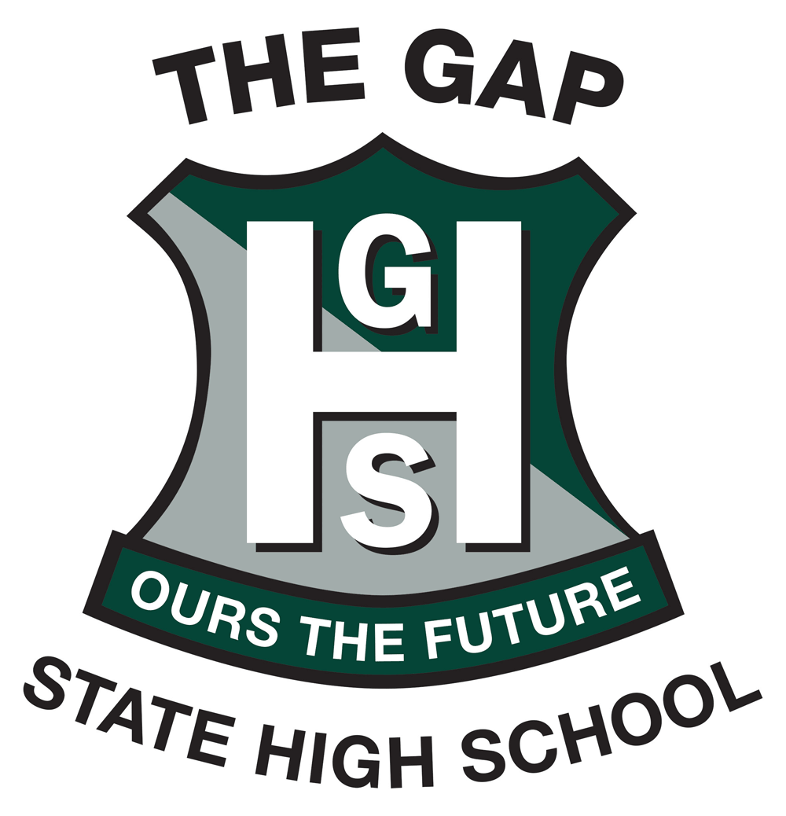
VISUAL ART STUDIO—ARTIST IN RESIDENCE – TERM 2
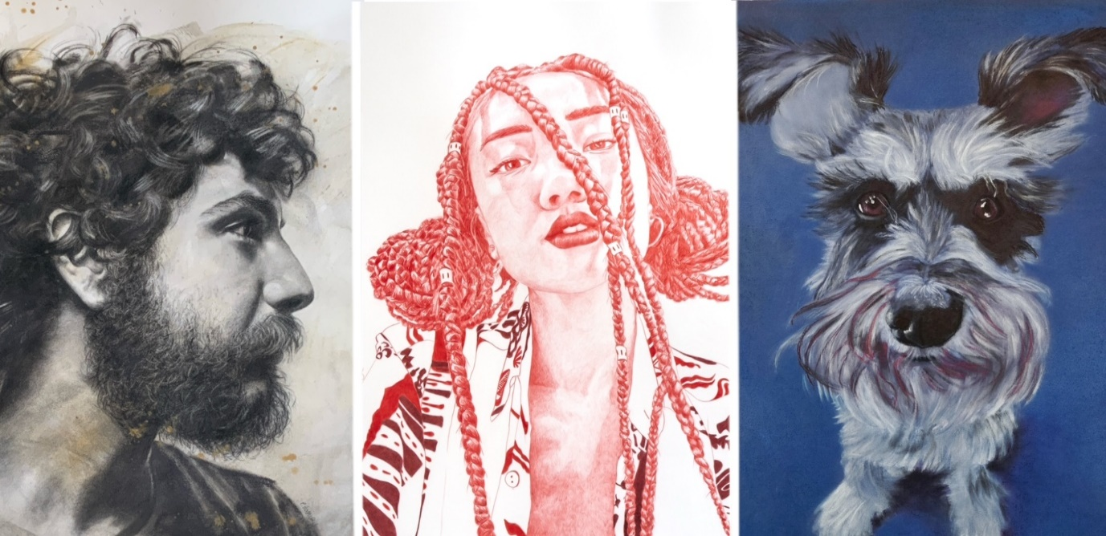

PETA HARVEY — The Art of Pencil
Fundamentals of drawing with graphite, charcoal, colour and pastel
Term 2 / 2025/ Fridays / 2.45—4.15 / $190
In this program, students will explore essential drawing techniques to achieve realism and create the illusion of form through light and shadow. They’ll begin by learning how to establish tonal values with graphite, mastering basic shading techniques. Charcoal pencils and toned paper will demonstrate the power of shadow and highlight. The program will also cover colour theory, demonstrating how to effectively blend and layer with coloured pencils and pastels to bring drawings to life.
Peta Harvey is a visual artist based in The Gap, specializing in drawing and the fusion of pen or pencil with brushwork and mixed media. She actively participates in group exhibitions and has been featured in several curated showcases. Notably, Peta has been a finalist in prestigious events such as the PLC Signature Art Prize 2024, the Ravenswood Australian Women’s Art Prize 2022, the Brisbane Portrait Prize Salon des Refusés in 2023 and 2020, and the Lethbridge 2000 Small Scale Art Award (2020-23), where she received a Highly Commended award in 2021.
___________________________________________________________________________________________
Visual Art Studio 2025 - INVITATION TO ENROL
Term 2 Peta Harvey – The Art of Pencil
Classes run on Friday 2:45pm – 4:15pm and are $190 per student for the 7-week course.
Visual Art Building, G2 commencing, TERM 2 Week 2
Enrolment Application
Name: _____________________________________________________________________
Class: _____________________________________________________________________
Parent Name : _______________________________________________________________
Parent Email : _______________________________________________________________
Parent Mobile : _________________________________________________________
Please complete and return to: visualartextension@thegapshs.eq.edu.au

