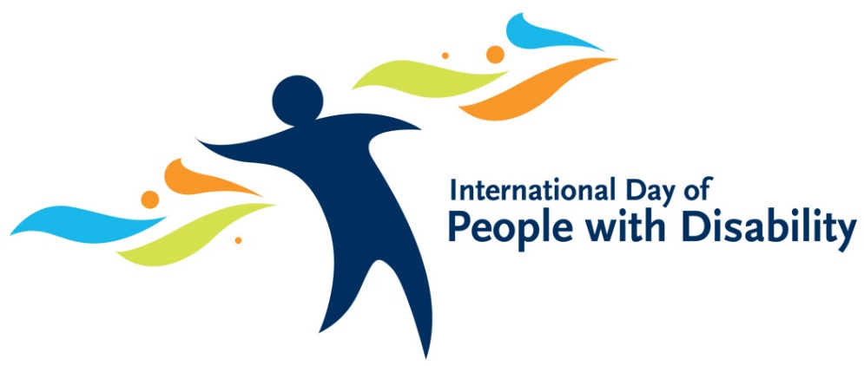

Gippsland Southern Health Service - Art Show
We are seeking a range of art for our 5th annual
“Everyone Matters”
Our Art Show this year
Do you paint, draw, sculpt, write poems, create interesting pieces of art?
Then we are looking for you!
Ideally art delivered to GSHS Primary Health department before or at the latest by 4th November 2022, unless arrangements are made otherwise.
This year we are planning to exhibit in both Leongatha and Korumburra campuses and throughout the main entrance and halls – we will also have an online presence. At this stage our display is planned from 7th November to 31st December 2021.
A formal morning tea for the International Day of People with Disability, will be held at 11am on the 2nd December, to launch, enjoy and celebrate all of our fabulous artists!
Entry Form
Artists Name: __________________________________
Contact telephone: __________________________________
Name of art piece: __________________________________
Price (if for sale): __________________________________
Are you happy for publicity / photos of your art? We are intending taking our Art show, online this year, with a ‘virtual display’ via a dedicated webpage and a social media presence (Facebook, Instagram). Do you consent?
Yes / No (please circle)
Artist / Guardian Signature: _________________________________

Gippsland Southern Health Service - Art Show

Entry Instructions:
- Please have all artwork ready to hang with cord or wire, before delivery
- All artwork should be signed or acknowledged by the artist
- We need clients to provide contact details
- Please label each art piece with title and artist
- There is no requirement for items to be for sale, if an item is to be displayed but not for sale – place NFS in the price point on the entry form.
- If the item is for sale, please list the price.
Our art show has 0% commission and no entry fee for artists, please consider this when setting prices for items
- Collection and possible online sales will be arranged closer to the art show dates.
We are planning to take our art show ‘on-line’ to enable as many people as possible to view the fantastic art display. We will have a dedicated webpage and social media presence.

For more information about this event please contact:

Michelle O’Loughlin, NDIS Service Coordinator – 5667 5662
michelle.o’loughlin@gshs.com.au

