 |  | Extend is the place for your children to thrive, learn and play, so what are you waiting for? Book and enrol at www.extend.com.au
 |  | Hours of Operation  Before School Care: 7.00am – 8:45am  After School Care: 3:30pm – 6.00pm |  |  |  | Contact Details  0498 786 707  launchingplace@extend.com.au
Monday | Tuesday |  |  | Wednesday | Thursday |  |  | Friday
Basketball tournament | Slime time experiment |  |  | Solider imagination station | Colour drip paintings |  |  | Lego creations
Monday | Tuesday |  |  | Wednesday | Thursday |  |  | Friday
Cubby creations | Cosmic yoga |  |  | Sock puppets | Super explosions |  |  | Game time
DISCOVER |  |  | LEARN |  |  |  | PLAY
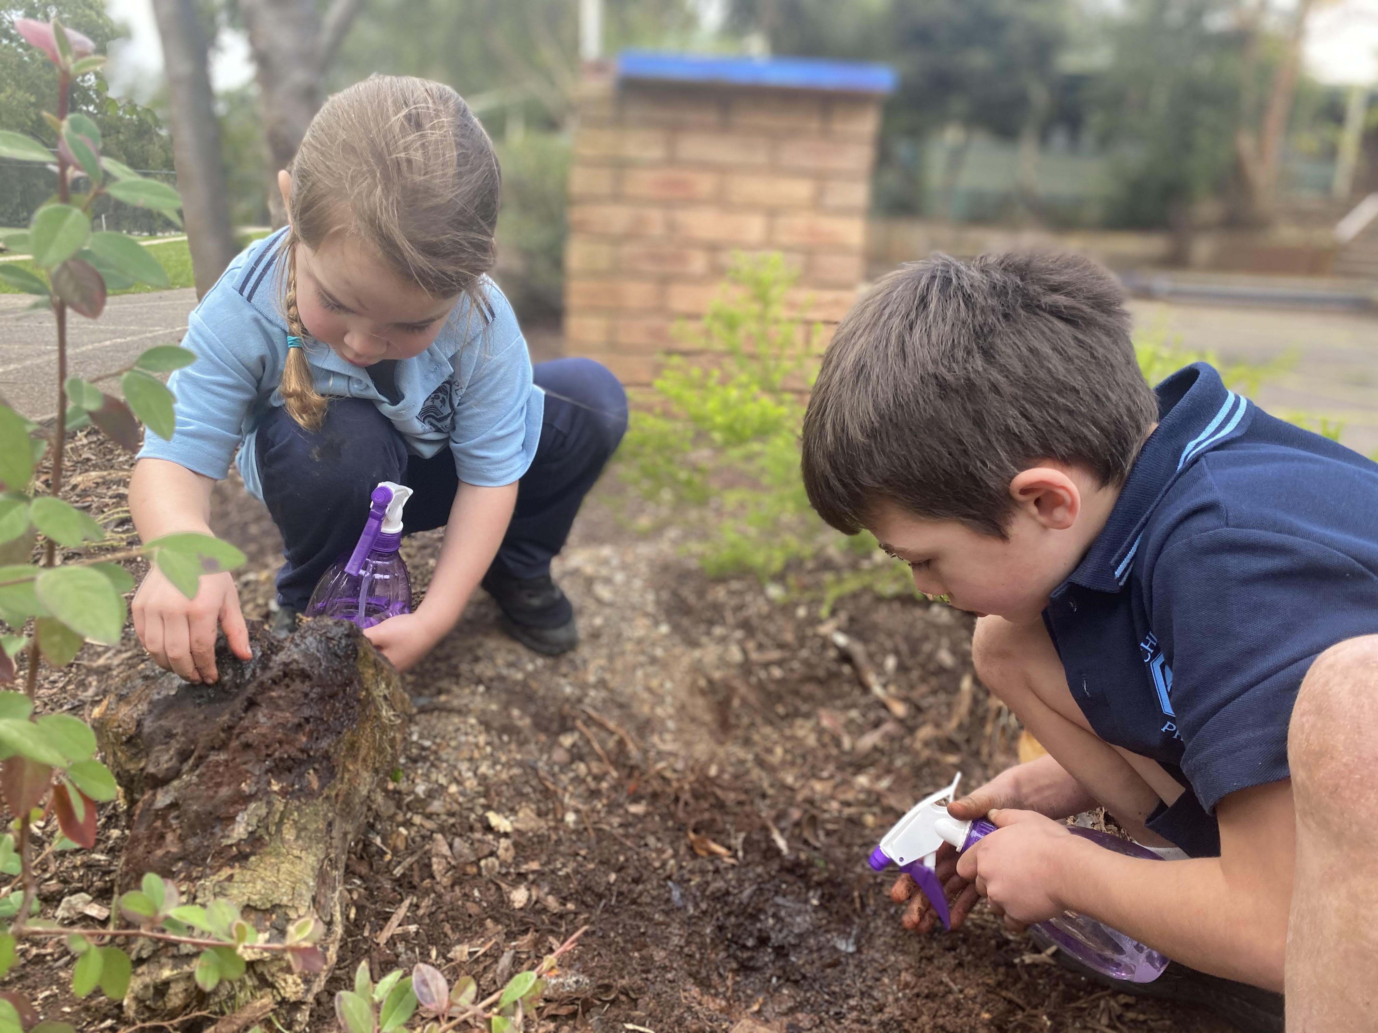 |  |  | 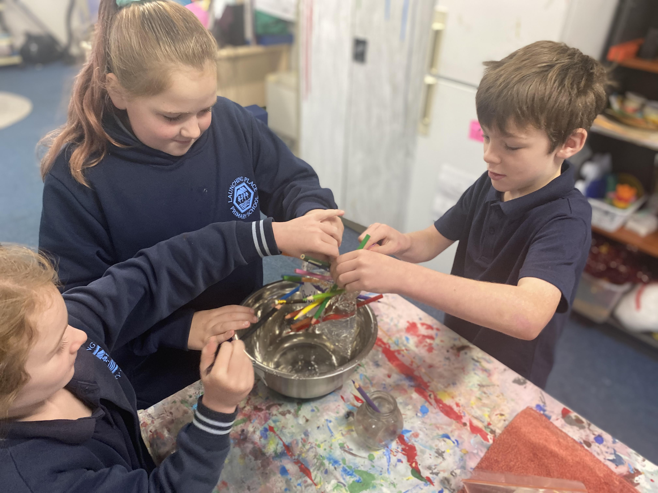 |  |  |  | 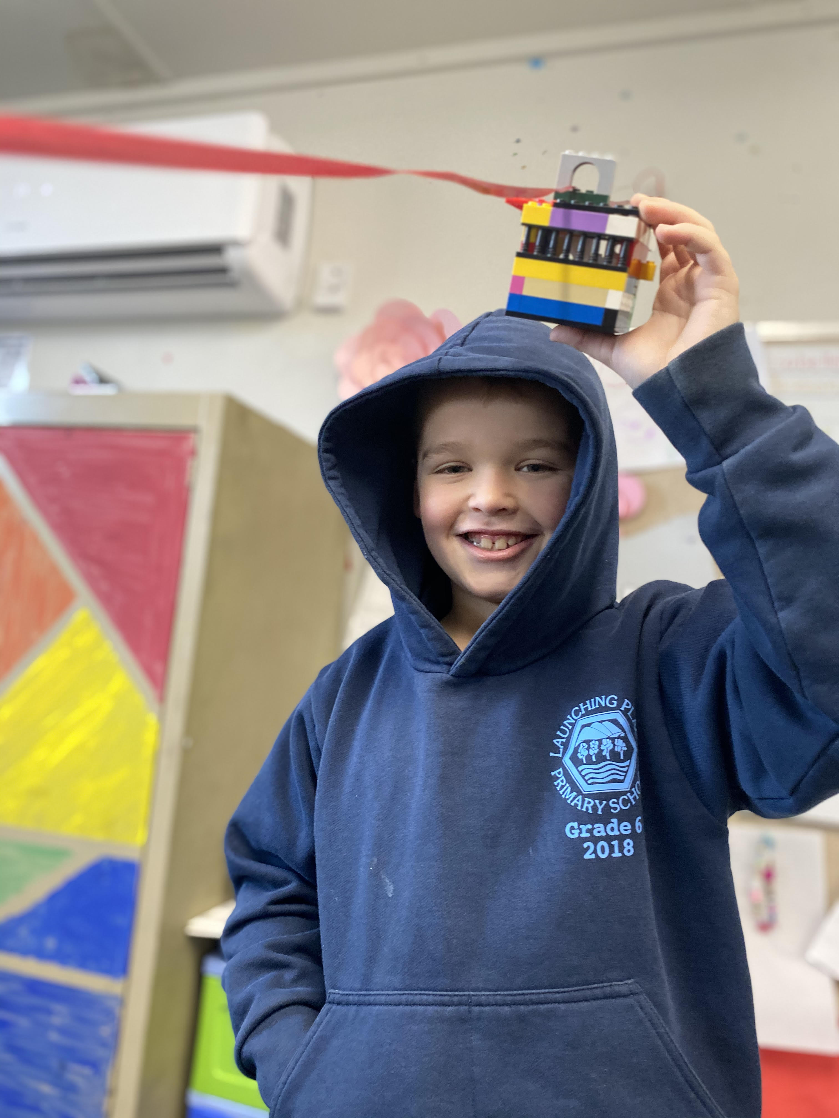
Heidi and Archie shared an interest in bugs! Together they set off to find butchy boy’s and create them a new home! |  |  | Weekly science experiment!  Josh, Ella and Alisha doing the never leaking bag experiment. They took turns pushing pencils through a zip lock bag filled with water seeing how many they could fit before it leaked! |  |  |  | Here is Jordy with his awesome Lego creation which he made for our zip line!
STAR OF THE WEEK!  Heidi  For always bringing her positive attitude and joyfulness each morning and afternoon to share with her friends! |  |  | At before and after school care, we have been sharing our interests and following them with curiosity, creativity and imagination! From bug searching, to weekly science experiments such as lava lamps, bouncing eggs and much more! Our favourite experience has been our Lego zip line, the children have worked hard creating showing their skills of problem solving, experimentation and hypothesising as they made these structures.  We have spent our afternoons outside from the playground to group games of basketball and tiggy too.  In the upcoming weeks we are excited to continue our weekly science experiments!  Taylor Lee  Service Coordinator

