|  |
| --- |
| SCHOOL MURAL |

**CAN YOU HELP?**

**We are after a quote or slogan to further promote our positive school culture as a mural on the bike shed wall facing the basketball courts.**

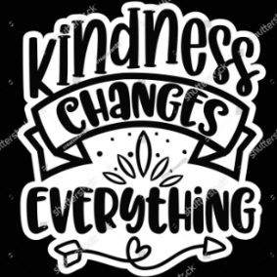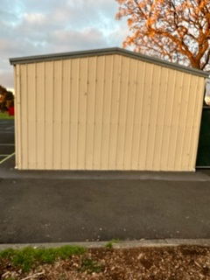

**I would like to see something about being KIND and that KINDNESS matters!**

**So, think of some words and pass them onto me because our mural artist Shaun will be coming in, to design something for us.**

**He will design a few options and then we will choose as a whole community.**

***Some designs of murals for other community groups***

