



Cranbourne South PS

Hey, all families we have made it halfway through term 3

***Week 3 – Under the Sea***

We started this week with a theme of Under the Sea, we continue to get out in the garden when the weather permits with some watering and composting. Other activities this week are, we got creative with making crabbies out of paper and google eyes, we did some colour ins about the ocean of Aerial and other sea creatues, we made octopus out of recycled materials. We got physical with some games of Dead fish, crab soccer, the dice game, bowling, twister and some fresh air with some outdoor play.

***Kieran: I like it when we have noodle soup!***

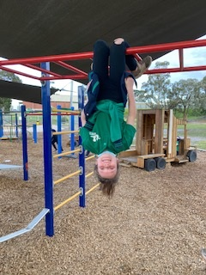 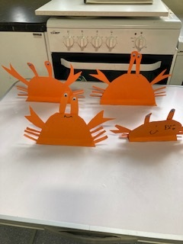 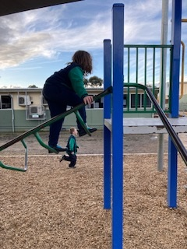

**For all family’s enquiries:**

I can be contacted on the service

phone number Monday – Thursday 8.50am – 9.30am

2.30pm – 3.30pm

**Things to Remember:**

Pupil free Day Friday 16th September

***Week – 4 Games Week!***

We continue garden club where each morning weather

permitting, we help the school community look after the garden

by giving a daily morning water and compost our scrap food. We are

starting this week in conjunction with the Commonwealth Games, we

played Musical poles which is our version of musical chairs, musical statues, bowling, giant’s treasure, Mr wolf, obstacle course and some free time outdoors.

***Mikayla: Thanks for the sleeping bags when arrive early in the mornings!***

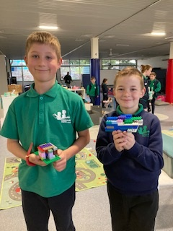 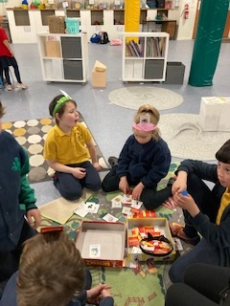 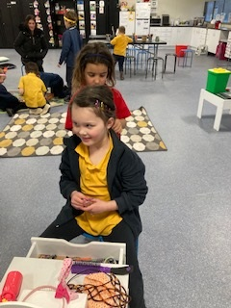

***Week 5 – Music Week***

We started this week with a rehearsal of our dance’s we were performing for our school concert that is on this week, we pretended to be the audience while each grade did their practice to help take away the nerves. We continue to try and get to the garden where the weather permits. We did a music colour in, played the dice game, musical statues, we did bowl to music, danced to our favourite tunes and did outside free play. We cooked some vanilla, milo rainbow cupcakes.

***Grace: I’m excited and scared about the concert!***



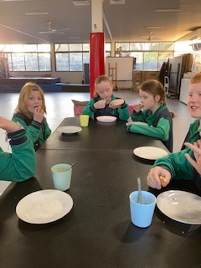 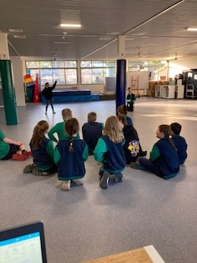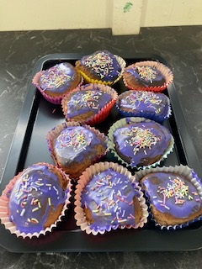

**Donna Moore**

**Cranbourne South PS**

**Coordinator TheirCare**

**0498 520 339**

**Cranbournesouth@theircare.com.au**

