Service Name: Barwon Heads | Week Beginning: 31st October to 4th November 2022 (Term 4. WEEK 5)
Community Involvement/ Service planned for the week:
- Following the schools’ Mental Health & well-being topic which is Creativity. Creativity means thinking of new ways to do things. When faced with a problem, creative people define the issue clearly and then come up with multiple solutions.
- Doing the compost and completing the task of putting the chickens in their chicken coop.
- Take children to the library to select two books.
- Celebration of DAYS: The week of 4th Diwali-India and National Others week.
Projects to be undertaken or planned:
- Enhance the new Junior Leadership Program and system in the coming weeks
Team Goals for this Week:
- Talk with the children about the Junior Leadership Program, what is it? What have they been doing to participate? What would they like to change?
Theme or Main Focus for this Week’s Planner: Cartoons/Animation Week! This week we will explore everyone’s favourite cartoons, cartoon characters and animated movies through creative and physical experiences. We will discover what makes the movies & characters so special and explore some of the important themes about friendship, being true to yourself and doing what is right.
Learning Outcomes:
- 1.1 Children are open to new challenges and discoveries
- 2.1 Children broaden their understanding of the world in which they live
- 3.2 Children seek out positive experiences that support their wellbeing and cognitive development.
- 4.1 Children develop dispositions such as curiosity, cooperation, confidence, creativity, commitment, enthusiasm, persistence, imagination and reflexivity
- 5.3 Children collaborate with others, express ideas and make meaning using a range of media and communication technologies
School Holiday Program
We have an amazing School Holiday program coming up. Like all our holiday programs, we have an awesome time with the children, full of fun packed experiences that I am sure they will always remember. Please complete your booking forms as soon as possible and if you have any questions, come and speak to one of the staff at our program who will be happy to help.
Big Childcare Philosophy
Big Childcare is a leader in the out of school hour’s industry. Our team is professional, experienced, nurturing and committed to providing a supportive and transparent environment for families where their feedback and support is highly valued. We provide exceptional quality out of school hours care for school aged children which meets the health, safety and wellbeing needs of the children and families in the community. We believe in making our programs engaging, diverse, physically active and fun, where children’s learning can be scaffolded, so they can reach their full potential. Through these experiences’ children will develop a range of life long skills including building on their social and emotional capacity. Children are valued and respected as individual are central to our programs. The programs we offer are developed in conjunction with educators, schools the community, children and families. They are critically reflected upon and evaluated to ensure we are providing positive experiences that are age appropriate and extend every child.
We encourage all children and parents to provide us with feedback on the running of our service
All children are given the freedom to choose and change the activities they participate in

 | Monday | Tuesday | Wednesday | Thursday | Friday
Before Care  Creative Experiences | Creative Experiences  Pokemon Collection – Make an Origami Poke-ball  Accept this challenge of making your own Poke-ball.  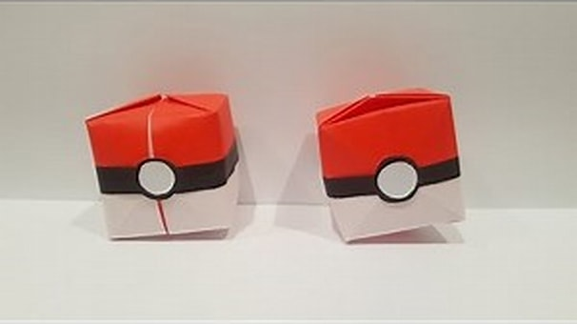  L/O: 1.1, 2.1, 3.2, 4.1, 5.3  NQS: 1.2.1  Current Interest of:  17.10.22 Max G | Creative Experiences  Cartoon character shadow  Trace your shadow and then use your imagination to create a carton.  L/O: 1.1, 4.1, 5.3  NQS: 1.2.1  Current Interest of:  18.10.22 Jack and Sophie | Creative Experiences  Loony recipes booklet  Create a menu with the dishes that you would eat if you were a cartoon.  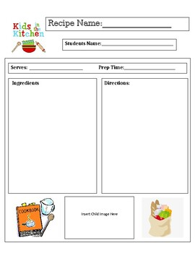  L/O: 3.1, 4.1  NQS: 1.1.2, 2.13  Current Interest of  24.10.22 Goldic | Creative Experiences  Super heroes beads  Make a super cool creation with the iron beads. Chose your favourite character.  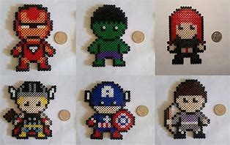  L/O: 1.1, 2.1, 4.4  NQS: 1.2.1  Current Interest of:  13.10.22 Brodhi | Creative Experiences  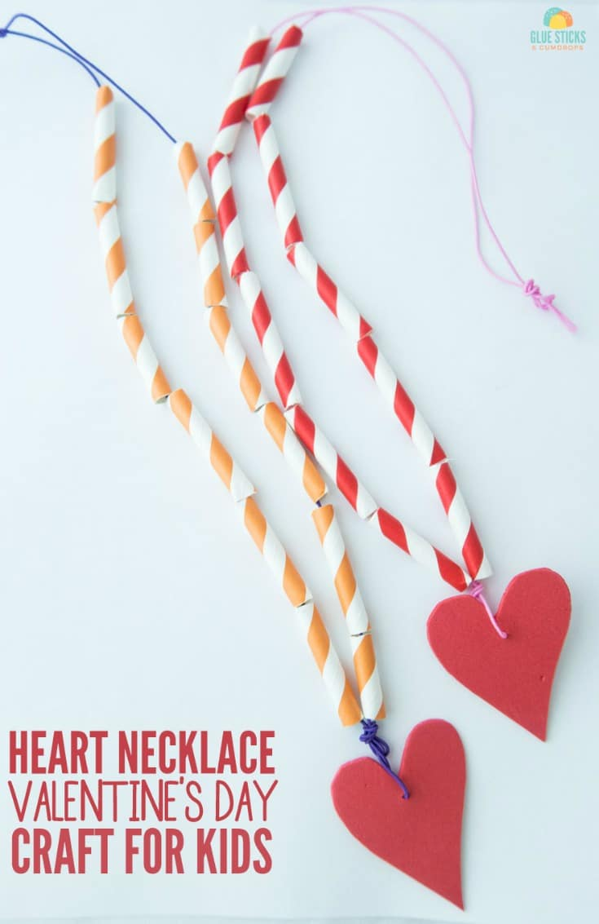  Anime jewelry  Make your own necklaces and bracelets with your favourite anime cartoon.  L/O:1.1, 2.1, 4.1, 3.1, 5.3  NQS:1.1.2  Current Interest of:  12.10.22 Goldic, Thom, Brodhi

Before Care  Physical Experiences | 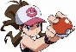  Physical Experiences  Pokemon in the middle  Same rules to Piggy in the middle, children will pass the pokemon ball and avoid that the team Rocket catches it.  L/O: 3.2  NQS: 2.1.3  Current interest of  6/08/22  Max, Tom and Will  2/09/22 Raff and Sonny | Physical Experiences  Musical SEARCH  Listen to the music and try to search for the speaker that is playing it.  L/O: 4.2  NQS: 1.2.1  Current Interest of:  Educator’s suggestion to see if children will be interested in this new game. | Physical Experiences  Non- Elimination MUSICAL CHAIRS/Hoops  More than one participant can use a chair/hoop. So as hoops are removed, students aren't eliminated but more are forced to share the hoops that remain.  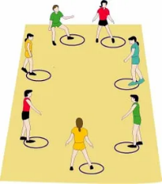  L/O: 3.2 NQS: 2.1.3 Current Interest of: 10/10/22 Dotty and Emma | Physical Experiences  Basquetball  Children will lead and agree to the rules of the basketball game.  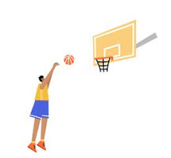  L/O: 3.2 NQS: 2.1.3  Current Interest of: 12.10.22 Thom and Lola.  12.10.22 Brodhi | Physical Experiences  Musical BALL  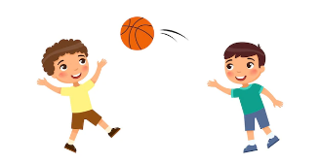  Just like passing the parcel however we are using a ball. If the music stops whilst you are holding the ball, you are out of the game  L/O: 3.2  NQS: 2.1.1  Current Interest of:  Educator
Before Care Intentional Teaching or Discussion | Topic: Creativity  How do you think cartoons are made? Why do you think cartoon characters wear the same clothes every day?  Tell me about a question that you would like to be ask.Delivered by: Azucena  (*13.09.22 Will’s idea) | Topic: Creativity  What would you do if you were a cartoon? Why do you think cartoon characters wear the same clothes every day?  Tell me about a question that you would like to be ask.Delivered by: Azucena  (*13.09.22 Will’s idea) | Topic: Creativity  How do you think cartoons are made? Why do you think cartoon characters wear the same clothes every day?  Tell me about a question that you would like to be ask.Delivered by: Azucena  (*13.09.22 Will’s idea) | Topic: Creativity  What would you do if you were a cartoon? Why do you think cartoon characters wear the same clothes every day?  Tell me about a question that you would like to be ask.Delivered by: Azucena  (*13.09.22 Will’s idea) | TTopic: Creativity  What would you do if you were a cartoon? Why do you think cartoon characters wear the same clothes every day?  Tell me about a question that you would like to be ask.Delivered by: Azucena  (*13.09.22 Will’s idea)
 | Monday | Tuesday | Wednesday | Thursday | Friday
After Care  Creative Experiences | Creative Experiences  Pokemon Collection – Make an Origami Poke-ball  Accept this challenge of making your own Poke-ball.  L/O: 1.1, 2.1, 4.1, 5.3  NQS: 1.2.1  Current Interest of:  17.10.22 Max G | Creative Experiences  Trace and draw challenge  Select your favourite cartoon then trace it on paper and add some decoration on it.  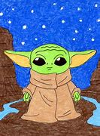  L/O: 1.1, 4.1, 5.3  NQS: 1.2.1  Current Interest of:  18.10.22 Max and Will | Creative Experience  Frozen-Rice Bubble and Oat Slice  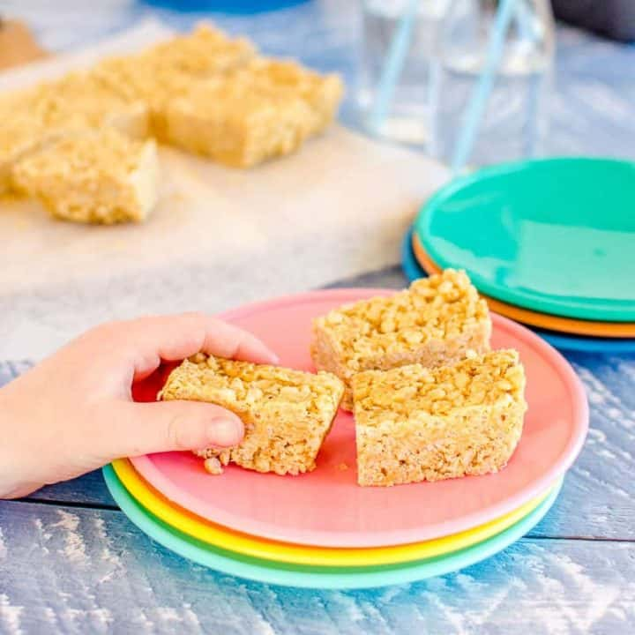  No-bake Rice Bubble Oat Slice - Healthy Rice Krispie Treat Recipe (mykidslickthebowl.com)  L/O: 1.1, 4.1, 5.3  NQS: 1.2.1  Current Interest of:  10.10.22 Emma  12.10.22 Brodhy | Creative Experiences  Diwali Crafts  Diwali, which translates to ‘Festival of Lights’ is one of the major annual Indian festivals and is celebrated over a period of five days by Hindus, Jains and Sikhs across the globe. Choose the art that you would like to make.  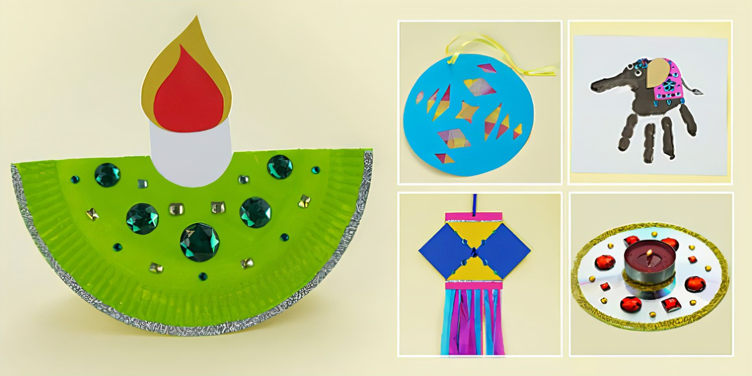  L/O: 1.1, 2.1, 4.1, 5.3  NQS: 1.2.1  Current Interest of: 12.10.22 Goldic (extension of her interest in jewellery) | Creative Experiences  Pokemon beads  Do your own pokemon with beads.  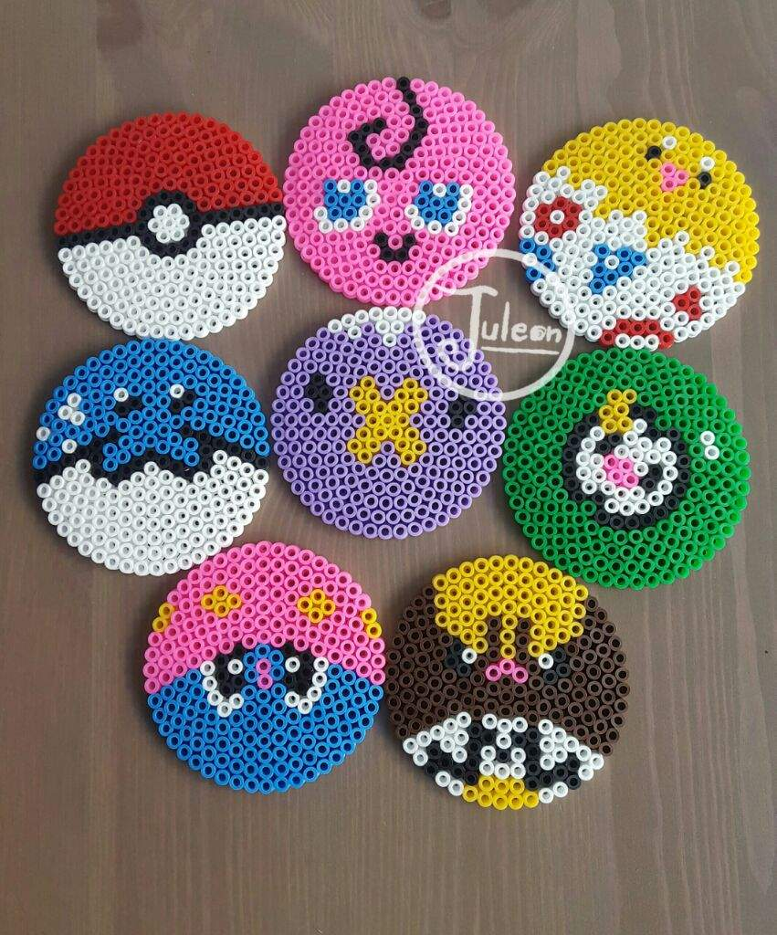  L/O: 1.1, 2.1, 4.4  NQS: 1.2.1  Current Interest of:  13.10.22 Brodhi
After Care  Physical Experiences | Physical Experiences  Pokemon in the middle  Same rules to Piggy in the middle, children will pass the pokemon ball and avoid that the team Rocket catches it.  L/O: 3.2  NQS: 2.1.3  Current interest of  19/10/22  Charlotte and Thom | Physical Experiences  GAGA BALL GAME  Using the Gaga pit outside, children will play a game of Gaga trying to get everyone out and become the winner.  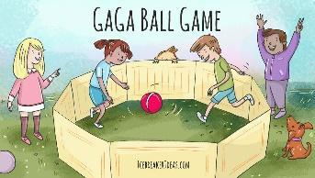  L/O: 3.2  NQS: 2.1.3  Current Interest of:  Max G. | Physical Experiences  Copy CAT Silent ball  Don’t talk at all, just copy the movement of the leader. Use your body language to communicate.  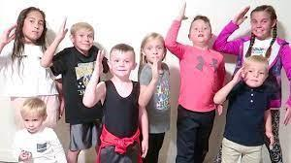  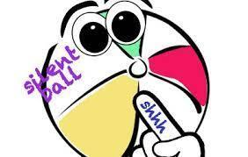  L/O: 3.2  NQS: 2.1.3  Current Interest of:  19.10.22 Charlotte and Thom | Physical Experiences  Dancing our favorite music  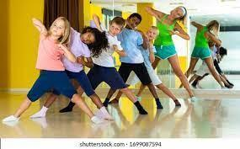  L/O: 3.2  NQS: 2.1.3  Current Interest of:  19.10.22 Peggy and Will. | Physical Experiences  Elimination Tag  Run and be the first to get the ball, then eliminate the rest of the players by throwing the ball to them. Agree on three rules with your educators and peers.  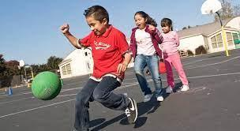  L/O: 3.2  NQS: 2.1.3  Current interest of  11.10.22 Sony and Bodhi
After Care Intentional Teaching or Discussion | Topic: Creativity  What would you do if you were a cartoon? Why do you think cartoon characters wear the same clothes every day?  Tell me about a question that you would like to be ask.Delivered by: Azucena  (*13.09.22 Will’s idea) | Topic: Creativity  How do you think cartoons are made? Why do you think cartoon characters wear the same clothes every day?  Tell me about a question that you would like to be ask.Delivered by: Azucena  (*13.09.22 Will’s idea) | opic: Creativity  What would you do if you were a cartoon? Why do you think cartoon characters wear the same clothes every day?  Tell me about a question that you would like to be ask.Delivered by: Azucena  (*13.09.22 Will’s idea) | Topic: Creativity  How do you think cartoons are made? Why do you think cartoon characters wear the same clothes every day?  Tell me about a question that you would like to be ask.Delivered by: Azucena  (*13.09.22 Will’s idea)Topic: Meaning | Topic: Creativity  What would you do if you were a cartoon? Why do you think cartoon characters wear the same clothes every day?  Tell me about a question that you would like to be ask.Delivered by: Azucena  (*13.09.22 Will’s idea)

Diwali
4 November
Diwali, which translates to ‘Festival of Lights’ is one of the major annual Indian festivals and is celebrated over a period of five days by Hindus, Jains and Sikhs across the globe. It is a highly anticipated celebration and is renowned for its beautiful and bright illuminations which bring the community together, instilling friendship, hope and togetherness.
To join the festivities, students of all ages across Australia can participate in our virtual Bollywood Infusion program which celebrates Indian culture through film, music and dance. Students will have the opportunity to learn dance routines and gain an appreciation for rich cultural symbols.
Additionally, for students in South Australia, we have a Classical Indian Dance program, where students will be able to experience an amazing performance. Afterwards, students will learn from the presenter by engaging in the deeper meanings behind the dance.

1-7 November
(date to be confirmed)
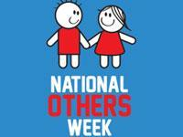

National Others Week
Organisation: Global Care
Held from the first Sunday in November, NOW encourages people to find a way to help someone, whether it's a random act of kindness or a planned activity. Because as the NOW motto says - life is a team sport!
National/State: National

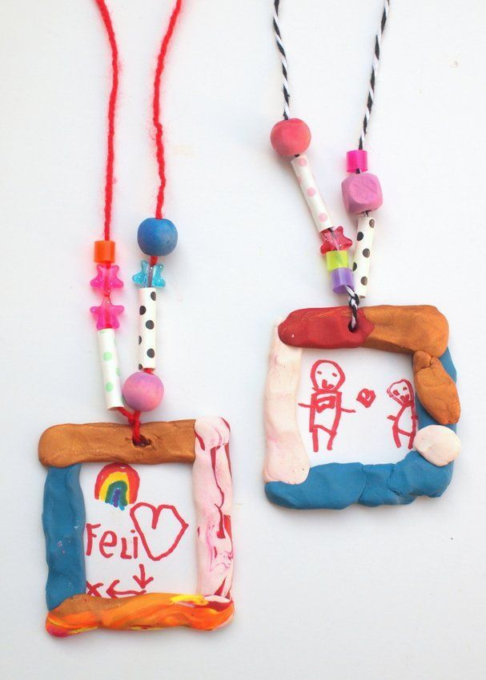

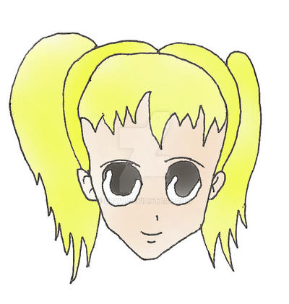
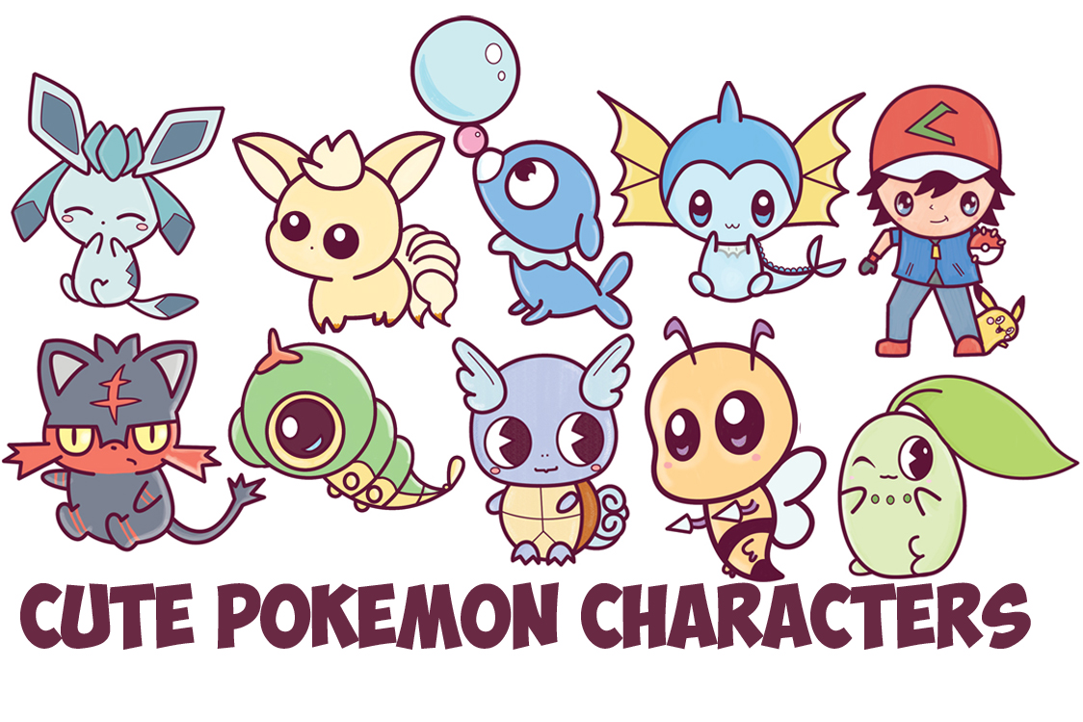

Recipe Cooking Template by JohnsonCreationsUS | Teachers Pay Teachers

