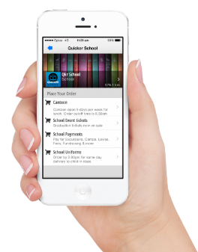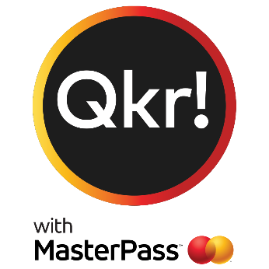

**EASY > SECURE > CONVENIENT**

Accept payments 24 hours a day, 7 days a week

**Introducing Qkr!** (pronounced 'quicker')

by Mastercard, the secure and easy way to order and pay for items from your phone at a time and place that suits you.

With the Qkr! App you can now pay for:

- **Subway** **School Lunches**

**- School Fees**

**- Out of Hours School Care**

You can also place uniform orders and have them delivered directly to school for easy collection.

- See your receipts on the app and get them sent by email if required.

**Step 1. Download QKR!**

On your Android phone or iPhone.

(iPad users must download the iPhone app.

**Step 2. Register**

Select your Country of Residence as ‘Australia’

and follow the steps to register.

**Step 3. Find our School**

Our school will appear in ‘Nearby Locations’ if you’re

within 10 km of our school or search for our school by name.

*‘St Brigid’s School Kilburn’*.

**Step 4. Register your child**

When first accessing our school, you will be

prompted to add a student profile for your

child/children. This allows you to make orders

and payments for them.